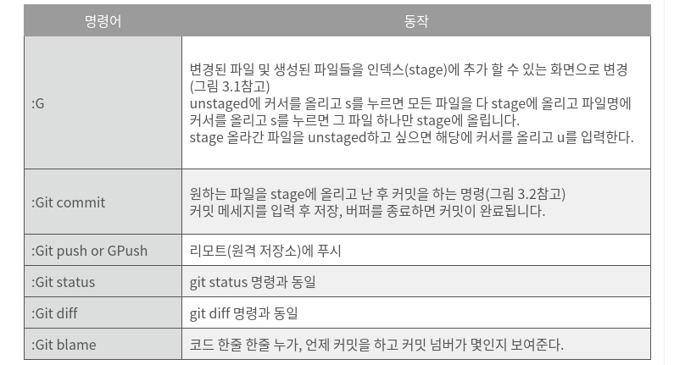
Vim-fugitive 명령어

0. terminal cli 단축키
sudo !! (뱅뱅) : 이전 명령을 sudo 명령어 자동 첨부

ctrl+a : 명령줄 맨 앞으로 커서이동 ALT+f : 다음 한단어로 커서이동
ctrl+e : 명령줄 맨 뒤로 커서이동 ALT+b : 이전 한단어로 커서 이동
ctrl+l : clear와 같은 단축키 ctrl+d : 현재 커서 위치 글자 지우기
ctrl+k : 커서 뒤쪽 잘라내기(지우기) ALT+d : 현재커서에서 그 단어 끝부분까지 지우기
ctrl+u : 커서 앞쪽 잘라내기 ALT+backspace : 현재커서에서 그단어 앞부분 지우기
ctrl+y : 붙여녛기 ctrl+XX :현재 커서위치와 명령줄 맨 앞을 반복토글
ctrl+w : 앞쪽 한 글자씩 지우기

1. archinstall 실행하기전에
pacman -Sy archinstall 로 새로받아서 실행한다.

Hostname 등의 네트워크 관련 명령어는 inetutils를 깔아야됨.

2. pbo2.service 내용

[Unit]
Description=Set the voltage offset to -30 for all cores

[Service]
ExecStart=python <path to ruv.py> -c 8 -o -30

[Install]
WantedBy=multi-user.target
--------------이후 등록 방법 :https://medium.com/codex/setup-a-python-script-as-a-service-through-systemctl-systemd-f0cc55a42267 (/etc/systemd/system폴더에 생성)

3. 내 아이피주소 (네이버에 내아이피 라고 치면 나온다)
125.129.121.118

Bash Prompt Escape Sequences
출처: https://tldp.org/HOWTO/Bash-Prompt-HOWTO/bash-prompt-escape-sequences.html

When executing interactively, bash displays the primary
prompt PS1 when it is ready to read a command, and the
secondary prompt PS2 when it needs more input to complete
a command. Bash allows these prompt strings to be customized
by inserting a number of backslash-escaped special
characters that are decoded as follows:
\a an ASCII bell character (07)
\d the date in "Weekday Month Date" format
(e.g., "Tue May 26")
\e an ASCII escape character (033)
\h the hostname up to the first `.'
\H the hostname
\j the number of jobs currently managed by the
shell
\l the basename of the shell's terminal device
name
\n newline
\r carriage return
\s the name of the shell, the basename of $0
(the portion following the final slash)
\t the current time in 24-hour HH:MM:SS format
\T the current time in 12-hour HH:MM:SS format
\@ the current time in 12-hour am/pm format
\u the username of the current user
\v the version of bash (e.g., 2.00)
\V the release of bash, version + patchlevel
(e.g., 2.00.0)
\w the current working directory
\W the basename of the current working directory
\! the history number of this command
\# the command number of this command
\$ if the effective UID is 0, a #, otherwise a
$
\nnn the character corresponding to the octal
number nnn
\\ a backslash
\[ begin a sequence of non-printing characters,
which could be used to embed a terminal control
sequence into the prompt
\] end a sequence of non-printing characters
giles@nikola giles> PS1="[\t][\u@\h:\w]\$ "
[21:52:01][giles@nikola:~]$ ls
bin mail
[21:52:15][giles@nikola:~]$

4. Bash의 5가지 escape sequence

출처 : https://mug896.github.io/bash-shell/escape_sequences.html
다음과 같은 경우에서 escape 문자가 처리됩니다. (처리되다 : 아래 표의 represented == escape 되지 않고 escape 문자가 발현된다)
모두 동일하게 처리되는 것은 아니고 조금씩 다른 부분이 있습니다.(적용 부분에 적힌 경우에만 적용된다.
Echo -e “abc \cdef” 와 printf “abc \cdef\n”은 결과값이 다르다)
- echo -e " " or ' ' 에서
참고) echo -e ‘I’\’’\tKing!’ single quotes 안에서 single quote를 쓰려면 ‘\’’로 써야함.
- $' ' = ${parameter@E}
- printf " " or ' ' 모두에서 escape문자가 처리됨. quotes의 고유기능도 그대로 유지되므로 “ “에서 변수확장, 명령치환이 된다.
- printf %b 옵션으로도 escape 문자가 처리된다.
sh 에서는 echo 명령을 사용할때 기본적으로 " " , ' ' 에서 모두 escape 문자가 처리 됩니다.
따로 명령에 -e 옵션이 없습니다.
Escape Sequence | Character represented(interpolation) | 적용
\\ | \ 문자 | *
\a | alert (bell) | *
\b | backspace | *
\e | escape (ASCII 033) | *
\f | form feed | *
\n | newline | *
\r | carriage return | *
\t | horizontal tab | *
\v | vertical tab | *
\' | single quotes | printf  $' '
\" | double quotes | *
\? | question mark | printf  $' '
\<NNN> | 8 비트 문자로 N은 8 진수 값입니다. ( 1 ~ 3 개 ) | printf  $' '
\0<NNN> | 8 비트 문자로 N은 8 진수 값입니다. ( 1 ~ 3 개 ) | echo
\x<HH> | 8 비트 문자로 H은 16 진수 값입니다. ( 1 ~ 2 개 ) | *
\u<HHHH> | 유니코드 문자 입니다. H는 16 진수 값입니다. ( 1 ~ 4 개 ) | *
\U<HHHHHHHH> | 유니코드 문자 입니다. H는 16 진수 값입니다. ( 1 ~ 8 개 ) | *
\c | 이후의 스트링은 출력에서 제외됩니다. | echo
\cx | Ctrl-x 문자, 가령 $'\cz'는 Ctrl-z (^Z) | $' '
적용의 * 문자는 모두를 뜻합니다.(Globbing)

Quotes 에 따른 escape 문자 처리 비교
echo 명령에서 -e 옵션 사용에 따른 escape 문자 처리를 해석할 때는 먼저 -e 옵션을 제거한 후에 명령을 실행해 보고 출력 결과에 대해서 escape sequence 를 적용하면 됩니다.

No Quotes
# < -e 옵션 제거 > < -e 옵션 추가 >

$ echo 111\t222\t333 $ echo -e 111\t222\t333
111t222t333 111t222t333

$ echo 111\\t222\\t333 $ echo -e 111\\t222\\t333
111\t222\t333 111 222 333

$ echo 111\\\t222\\\t333 $ echo -e 111\\\t222\\\t333
111\t222\t333 111 222 333

$ echo 111\\\\t222\\\\t333 $ echo -e 111\\\\t222\\\\t333
111\\t222\\t333 111\t222\t333
Double Quotes
$ echo "111\t222\t333" $ echo -e "111\t222\t333"
111\t222\t333 111 222 333

$ echo "111\\t222\\t333" $ echo -e "111\\t222\\t333"
111\t222\t333 111 222 333

$ echo "111\\\t222\\\t333" $ echo -e "111\\\t222\\\t333"
111\\t222\\t333 111\t222\t333

$ echo "111\\\\t222\\\\t333" $ echo -e "111\\\\t222\\\\t333"
111\\t222\\t333 111\t222\t333

$ echo "111\\\\\t222\\\\\t333" $ echo -e "111\\\\\t222\\\\\t333"
111\\\t222\\\t333 111\ 222\ 333
Single Quotes
$ echo '111\t222\t333' $ echo -e '111\t222\t333'
111\t222\t333 111 222 333

$ echo '111\\t222\\t333' $ echo -e '111\\t222\\t333'
111\\t222\\t333 111\t222\t333

$ echo '111\\\t222\\\t333' $ echo -e '111\\\t222\\\t333'
111\\\t222\\\t333 111\ 222\ 333

$ echo '111\\\\t222\\\\t333' $ echo -e '111\\\\t222\\\\t333'
111\\\\t222\\\\t333 111\\t222\\t333

sh 과 bash 에서의 8 진수 16진수 처리
- 먼저 sh 에서는 echo, printf 문에서 16 진수 형식을 사용할 수 없습니다.
- bash 의 경우 echo, printf, $' '에서 조금씩 차이가 있습니다.
그러므로 sh 과 bash 에서 공통적으로 사용하려면 8 진수 형식을 사용해야 합니다.
################# sh 은 8 진수 형식만 사용가능 #################

sh$ echo '\101\102\103'
ABC
sh$ echo '\0101\0102\0103'
ABC
sh$ echo '\x41\x42\x43' # \x<HH> 16 진수 안됨
\x41\x42\x43
.............................................................

sh$ printf '\101\102\103\n'
ABC
sh$ printf '\0101\0102\0103\n' # \0<NNN> 8 진수 안됨
3
sh$ printf '\x41\x42\x43\n' # \x<HH> 16 진수 안됨
\x41\x42\x43
.............................................................

sh$ printf '%b' '\101\102\103\n'
ABC
sh$ printf '%b' '\0101\0102\0103\n'
ABC
sh$ printf '%b' '\x41\x42\x43\n' # \x<HH> 16 진수 안됨
\x41\x42\x43

###################### bash 의 경우 #########################

bash$ echo -e '\101\102\103' # \<NNN> 8 진수 안됨
\101\102\103
bash$ echo -e '\0101\0102\0103'
ABC
bash$ echo -e '\x41\x42\x43'
ABC
.............................................................

# $' ' quotes 의 경우
bash$ echo $'\101\102\103'
ABC
bash$ echo $'\0101\0102\0103' # \0<NNN> 8 진수 안됨
3
bash$ echo $'\x41\x42\x43'
ABC
.............................................................

bash$ printf '\101\102\103\n'
ABC
bash$ printf '\0101\0102\0103\n' # \0<NNN> 8 진수 안됨
3
bash$ printf '\x41\x42\x43\n'
ABC
.............................................................

bash$ printf '%b' '\101\102\103\n'
ABC
bash$ printf '%b' '\0101\0102\0103\n'
ABC
bash$ printf '%b' '\x41\x42\x43\n'
ABC

Escape sequences are a special type of terminal input. They're designed to make it possible for you to enter characters or events that you may not have on your physical keyboard. Here are my favorite escape sequences for the Bash shell.
1. Backspace
You can enter a backspace character as part of a command, more or less loading it to trigger once the command executes. For instance, looking casually at this command, you might expect its output to be ab, but take a look at the actual output:
$ echo a$'\b'b
b
Technically, the shell did output ab (you can confirm that by appending | wc -m to the command) but part of the total output was the \b backspace event. The backspace removed a before outputting b, and so the viewable output is just b.

2. Newline
A newline character is a signal for your shell to go to column 0 of the next line. This is essential when using a command like printf, which doesn't assume that you want a newline added to the end of your output, the way echo does. Look at the difference between a printf statement without the \n newline character and one with it:
$ printf "%03d.txt" 1
001.txt$
$ printf "%03d.txt\n" 1
001.txt
$

3. Form feed
A \f form feed signal is like a newline character, but without the imperative to return to column 0. Here's a printf command using a form feed instead of a newline:
$ printf "%s\f" hello
hello
$
Your shell prompt is on the next line, but not at the start of the line.

4. Tab
There are two tab escape sequences: the \t horizontal tab and the \v vertical tab. The horizontal tab is exactly what you'd expect.
$ echo a$'\t'b
a b
The vertical tab is, in theory, the same principle but in vertical space. On most consoles, though, the vertical spacing of a line isn't variable, so it usually ends up looking a lot like a form feed:
$ echo a$'\v'b
a
b

5. Unicode
There are a lot of characters available in the Unicode standard, and your keyboard only has about 100 keys. There are a few ways to enter special characters on Linux, but one way to enter them into the terminal is to use the Unicode escape sequence. You start this escape sequence with \u followed by a hexadecimal value. You can find many Unicode values in the file /usr/share/X11/locale/en_US.UTF-8/Compose, or you can look at the Unicode specification at https://www.unicode.org/charts/.
This can be a useful trick for entering common symbols like Pi (the ratio of a circle's circumference to its diameter):
$ echo $'\u03C0'
π
There are lots of other symbols and characters, too.
$ echo $'\u270B'
✋
$ echo $'\u2658'
♘
$ echo $'\u2B67'
⭧
There's Braille notation, musical notation, alphabets, electrical symbols, mathematical symbols, emoji, game symbols, and much more. In fact, there are so many available symbols that sometimes you need the \U (note the capital letter) Unicode escape sequence to access Unicode in the high ranges. For instance, this 5-of-Hearts playing card only appears with the \U escape sequence:
$ echo $'\U1F0B5'
✪
Have a look around on the Unicode specification to find your niche, and use \u and \U to access all the special symbols you need.

Escape the shell
There are 18 escape sequences listed in the man page for the Bash shell, and some I find more useful than others. I've covered my favorites in this article, and Don Watkins talked about the metacharacters he uses most often in his article, yet there's still more to be discovered. There are ways to encode ranges of letters and numbers, subshells, mathematical equations, and more. For a good overview of metacharacters available for the shell, download our metacharacter cheat sheet and keep it handy as you get better at using the most powerful application on your computer: the Linux terminal.

5. Bash Metacharacter

BASH Metacharacters and Their Meanings
Symbol: | Meaning and Usage examples:
< | Redirection: Get input for the command to the left from the file listed to the right of this symbol. Example:  sort < filename.txt # This will print out the contents of filename.txt with the lines sorted.
> | Redirection: Send the output of the command on the left into the file named on the right of this symbol. If the file does not exist, create it. If it does exist, overwrite it (erase everything in it and put this output as the new content). Example:  cal > filename.txt # This puts a current calendar into filename.txt
>> | Redirection: Send the output of the command on the left to the end of the file named on the right of this symbol. If the file does not exist, it will be created. If it does exist, it will be appended. Example:  date >> filename.txt # This adds the current date and time to the end of filename.txt
| | Pipe: This sends the output of the command to the left as the input to the command on the right of the symbol. Example:  cat filename.txt | grep it # This will print the lines in filename.txt that contain the string "it"
? | Matching. This symbol matches any single character. Example:  ls e?.txt # This will list all files that start with e, end with .txt and have any 1 character inbetween (like e2.txt)
* | Matching. This symbol matches any number of any characters. Example:  ls e*.txt # This will list all files that start with e, end with .txt and have any characters inbetween (like e24ldf.txt)
[ ] | Matching, listing. One of the characters within the square brackets must be matched. Example:  ls -l e[abc].txt # This will give a long listing of ea.txt, eb.txt and/or ec.txt
$ | Denotes that a string is a variable name. Not used when assigning a variable. Example:  prompt: my_variable="this string" # Assigning the variable  prompt: echo $my_variable # Referring to the contents of the variable  Also used in parameter substitution to check if a variable is defined and determine a value. Example:  echo ${my_variable-other} # Print the value of my_variable if defined, otherwise print "other"
\ | Escape. Ignore the shell's special meaning for the character after this symbol. Treat it as though it is just an ordinary character. Example:  echo "I have \$300.00" # Print the $ instead of using it to look up a variable name.  Also used to put commands on mulitple lines. Example:  prompt1: cat filename.txt \ # Don't run yet...  prompt2: date \ # Still don't do anything...  prompt2: cal # No backslash on the last one, so run all the commands
( ) | Grouping commands. If you want to run two commands and send their output to the same place, put them in a group together. Example:  (cal; date) > filename.txt # Put a calendar and the date in filename.txt
{ } | Used in special cases for variables with the $. One use is in parameter substitution (see the $ definition, above), the other is in arrays. Example:  numbers=( 1 2 3 4 5 )  echo ${numbers[1]}
" | Quoting. Used to group strings that contain spaces and other special characters. Example:  my_variable="This is a test." # Assign a string to the variable
' | Quoting. Used to prevent the shell from interpretting special characters within the quoted string. Example:  my_variable='This is a backslash: \' # Assign the string to the variable
` | Unquoting. Used within a quoted string to force the shell to interpret and run the command between the backticks. Example:  my_variable="This is the date: `date`" # Store the string AND the output of the date command
&& | Run the command to the right of the double-ampersand ONLY IF the command on the left succeeded in running. Example:  mkdir stuff && echo "Made the directory" # Print a message on success of the mkdir command
|| | Run the command on the right of the double pipe ONLY IF the command on the left failed. Example:  mkdir stuff || echo "mkdir failed!" # Print a message on failure of the mkdir command
& | Run the process in the background, allowing you to continue your work on the command line. Example:  john /etc/passwd & # Try to crack the passwords - this takes a couple hours, so do it in the background.  Also used in redirection when copying one stream into the same location as another stream. Example:  cat filename.txt > file2.txt 2>&1 # Send Standard Error (2) to the file2.txt where Standard Output (1) is going
; | Allows you to list multiple commands on a single line, separated by this character. Example:  date;john passwd; date # Print the date, crack the passwords and print the date again afterwards - cheap benchmarking
= | Assignment. Set the variable named on the left to the value presented on the right. Example:  my_variable="Hello World!" # Note that there is NO SPACE between the variable name and the string.

zsh의 경우 :
-→>> echo “\n is new line” 을 그냥 실행하면
한칸띄고
is new line 이라고 출력된다. \n이라는 글자까지 포함시켜서 출력하려면

--→>> echo “\\\n is new line” 이라고 실행해야한다.

** bash 에서는 echo “\n is new line” 은 줄바꿈 없이 출력된다.

** expr 10 “*” 5
expr 10 ‘*’ 5
expr 10 \* 5
모두 50을 계산해준다. (셋다 *를 메타케릭터가 아니라 곱하기 표시 * 로 인식한다)

6 .Bash shell script에서 [ 와 [[ 의 차이점
https://www.infracody.com/2023/05/bash-shell-script.html 내용
리눅스의 Bash Shell Script에서 [ 와 [[ 의 차이점에 대해 알아봅니다.
인프라코디
4 개월 전 1 분 읽기
리눅스의 Bash Shell Script에서 [ 와 [[의 차이점에 대해 알아봅니다.
- [ 와 [[ 의 차이점
- [ 와 [[ 의 사용 예제
- 마무리

[ 와 [[ 의 차이점
- [ 는 sh 기반의 명령어로, 테스트나 조건식을 평가할 때 사용합니다. [ 는 실제로 /usr/bin/[ 라는 실행 파일이며, if나 while 등의 제어문과 함께 사용됩니다. [ 를 사용할 때는 공백과 따옴표에 주의해야 합니다. 예를 들어, [ $a = $b ] 는 에러가 발생하지만, [ "$a" = "$b" ] 는 정상적으로 작동합니다.
- [[ 는 bash 기반의 키워드로, [ 보다 확장된 기능을 제공합니다. [[ 는 실행 파일이 아니라 쉘의 구성 요소이므로, 공백과 따옴표에 덜 민감합니다. 예를 들어, [[ $a = $b ]] 는 정상적으로 작동합니다. [[ 는 &&, || 등의 논리 연산자를 사용할 수 있으며, 패턴 매칭이나 정규식을 지원합니다. 예를 들어, [[ str= [0−9]+ ]] 는 $str이 숫자로만 이루어져 있는지 검사합니다.

[ 와 [[ 의 사용 예제

다음은 [ 와 [[ 를 이용하여 문자열이 비어있는지 검사하는 쉘 스크립트입니다.
#!/bin/bash

str="Hello World"

# [를 사용하는 경우
if [ -z "$str" ]; then
echo "str is empty"
else
echo "str is not empty"
fi

# [[를 사용하는 경우
if [[ -z $str ]]; then
echo "str is empty"
else
echo "str is not empty"
fi
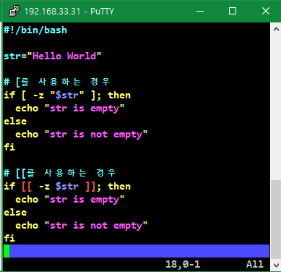
위의 스크립트를 실행하면 다음과 같은 결과가 나옵니다.
str is not empty
str is not empty

마무리
[ 와 [[ 모두 -z 옵션을 사용하여 문자열의 길이가 0인지 검사할 수 있습니다. 하지만 [ 를 사용할 때는 변수에 따옴표를 붙여야 하고, 공백도 잘 지켜야 합니다. [[ 를 사용할 때는 따옴표와 공백을 신경쓰지 않아도 됩니다. 주의 : [[ 도 공백은 띄워야한다.

7. [] [[]] () (()) 차이

https://www.baeldung.com/linux/bash-single-vs-double-brackets

Differences Between Single and Double Brackets in Bash
Last updated: July 25, 2022

Written by: Burak Gökmen
- Scripting
- bash

1. Overview
While comparing variables in Bash, we generally use single brackets ([ ]) and double brackets ([[ ]]) interchangeably.
For example, we can use the expressions [ 3 -eq 3 ] or [[ 3 -eq 3 ]] while checking whether 3 is equal to 3. Both will be successful in performing the comparison. So, what’s the difference between them?
In this tutorial, we’ll discuss the differences between single and double brackets in Bash.

2. Main Differences
In this section, we’ll briefly discuss the main differences between single and double brackets.

2.1. Single Brackets
[ is a shell built-in command that has always been available in Unix and Linux to evaluate expressions. It still exists for backward compatibility and POSIX compliance.
Let’s verify that [ is a shell built-in command using the type command:
$ type [
[ is a shell builtin
[ is an alternative command for the test built-in command. We can use them interchangeably:
$ [ 3 -eq 3 ] && echo “Numbers are equal”
Numbers are equal
$ test 3 -eq 3 && echo “Numbers are equal”
Numbers are equal
The only difference between [ and test is that we must use the closing ] for surrounding the comparison.

2.2. Double Brackets
The double brackets, [[ ]], were introduced in the Korn Shell as an enhancement that makes it easier to use in tests in shell scripts. We can think of it as a convenient alternative to single brackets.
It’s available in many shells like Bash and zsh. However, double brackets aren’t POSIX compliant.
[[ is a shell keyword. Let’s check it using the type command:
$ type [[
[[ is a shell keyword

3. Other Differences
In this section, we’ll discuss the other differences between single and double brackets.

3.1. Comparison Operators
It’s possible to use the comparison operators with the double brackets. Let’s use the less than operator (<) for string comparison:
$ [[ 1 < 2 ]] && echo “1 is less than 2”
1 is less than 2
Here, we checked whether 1 is less than 2 using the less than operator. The comparison was successful. However, using single brackets instead of double brackets will give a syntax error:
$ [ 1 < 2 ] && echo “1 is less than 2”
bash: 2: No such file or directory
In this case, Bash treated the < operator as a file redirection operator. Therefore, we must use the escape character (\) before the < operator for a successful comparison within single brackets:
$ [ 1 \< 2 ] && echo “1 is less than 2”
1 is less than 2
Now, the comparison using single brackets was successful.
Similarly, we must use the escape character before the greater than operator (>) for string comparison within single brackets.
The usage of the integer comparison operators such as -eq, -ne, -gt, -lt, -ge, and -le is the same for both.
3.2. Boolean Operators
We must use the && operator for the logical AND operation and the || operator for the logical OR operation while using the double brackets.
Let’s check that 3 is equal to 3, and 4 is equal to 4:
$ [[ 3 -eq 3 && 4 -eq 4 ]] && echo “Numbers are equal”
Numbers are equal
However, we must use the -o and -a test operators for the logical OR and logical AND operations, respectively, while using single brackets.
Let’s repeat the last comparison we performed using single brackets this time:
$ [ 3 -eq 3 -a 4 -eq 4 ] && echo “Numbers are equal”
Numbers are equal
The comparison is again successful. But we used -a instead of && because of single brackets.

3.3. Grouping Expressions
We can group expressions within the double brackets using parentheses. One reason for grouping may be reading the expressions more easily:
$ [[ 3 -eq 3 && (2 -eq 2 && 1 -eq 1) ]] && echo “Parentheses can be used”
Parentheses can be used
Here, we grouped the expression, 2 -eq 2 && 1 -eq 1, using the parentheses. Then, we used the grouped expression, (2 -eq 2 && 1 -eq 1), as the second expression of && within the double brackets. The first expression of && was 3 -eq 3. The grouping was successful.
Now, let’s use the same expression using single brackets:
$ [ 3 -eq 3 -a (2 -eq 2 -a 1 -eq 1) ] && echo “Parentheses can be used”
bash: syntax error near unexpected token ‘(‘
We used -a instead of && because of single brackets. However, we got a syntax error.
We must use the escape character before the opening and closing parentheses for a successful grouping. There must also be a space after and before the opening and closing parentheses:
$ [ 3 -eq 3 -a \( 2 -eq 2 -a 1 -eq 1 \) ] && echo “Parentheses can be used”
Parentheses can be used
Grouping the expressions using the parentheses within single brackets was successful in this case.

3.4. Pattern Matching
It’s possible to use pattern matching with the double brackets. For example, we can use the wildcard * (asterisk) within the double brackets:
$ name=”Alice”
$ [[ $name = *c* ]] && echo “Name includes c”
Name includes c
$ echo $?
0
Here, we first assigned the value Alice to the shell variable name using the statement name=”Alice”. Then, we checked whether the variable name includes the letter c using [[ $name = *c* ]]. * means zero or more characters. The result was successful, as expected.
However, it isn’t possible to use pattern matching within single brackets:
$ name=”Alice”
$ [ $name = *c* ] && echo “Name includes c”
$ echo $?
1
In this case, the only difference between the previous example is the single brackets. We replaced the double brackets in the previous example with the single brackets. There weren’t any syntax errors, but pattern matching was unsuccessful as the exit status of [ $name = *c* ] && echo “Name includes c” was 1.

3.5. Regular Expressions
It’s also possible to use regular expressions within the double brackets:
$ name=”Alice”
$ [[ $name =~ ^Ali ]] && echo ”Regular expressions can be used”
Regular expressions can be used
We first assigned the value Alice to the shell variable name using the statement name=”Alice”. Then, we checked whether the variable name starts with Ali using [[ $name =~ ^Ali ]]. The =~ built-in operator is used for matching the regular expressions. The caret (^) matches the beginning of a word. Hence ^Ali means the words beginning with Ali. As it’s apparent from the output, we could detect that the value of the shell variable starts with Ali.
Let’s try the same regular expression pattern using single brackets:
$ name=”Alice”
$ [ $name =~ ^Ali ] && echo ”Regular expressions can be used”
bash: [: =~: binary operator expected
Now, we got an error. So, it isn’t possible to use regular expressions within single brackets.

3.6. Word Splitting
Bash doesn’t perform word splitting inside double brackets. For example, if a variable has a string value containing spaces, Bash doesn’t split the string into words:
$ filename=”nonexistent file”
$ [[ ! -e $filename ]] && echo ”File doesn’t exist”
File doesn’t exist
Here, we checked the existence of the file nonexistent file. The filename includes a space. We could directly use the variable, filename, within the double brackets as the double brackets didn’t split the filename.
Let’s try it with single brackets:
$ filename=”nonexistent file”
$ [ ! -e $filename ] && echo ”File doesn’t exist”
bash: [: nonexistent: binary operator expected
We got an error in this case since the filename nonexistent file was split into two words, nonexistent and file. This is related to the IFS variable. If IFS isn’t set, the shell splits the string when it encounters a space, tab, or newline.
We must put the variable in double quotes if we want to prevent the word splitting within single brackets:
$ filename=”nonexistent file”
$ [ ! -e “$filename” ] && echo ”File doesn’t exist”
File doesn’t exist
Now, checking the existence of a filename containing spaces was successful within single brackets.

4. Conclusion
In this article, we discussed the differences between single and double brackets in Bash.
The single bracket is a built-in command that’s older than the double bracket. The double bracket is an enhanced version of the single bracket. If we want the portability of scripts, we should prefer single brackets. However, using the double brackets is generally more convenient.
We saw that we could use comparison operators and boolean operators in both, apart from a few differences. The same thing is valid for grouping expressions and word splitting. However, using pattern matching and regular expressions is only possible in the double brackets.

예:) [[]]도 명령어창에 단독으로 쓸 수 있다. (== test)

[kimnux@archlinux ~]$ [[ 5 -gt 3 ]] && echo 'wow'
wow
[kimnux@archlinux ~]$ [[ 5 -lt 3 ]] && echo 'wow'
[kimnux@archlinux ~]$

8. 쉘 특수문자: 공백,{} 하나의 명령,[], exit, return, ${} 확장, (( )) let 산술연산, $()

https://velog.io/@markyang92/bash-shell-special-variable

$의 변수 확장시 parameter들
(참고: https://www.gnu.org/software/bash/manual/html_node/Shell-Parameter-Expansion.html )
For those who arrive here looking for information on a different expansion operator, here's a quick list of the available expansion characters and their effects.
${varname@Q} returns a single-Quoted string with any special characters (such as \n, \t, etc.) escaped. 즉 escape sequence들이 제 기능을 못한다.
Examples:
$ foo="one\ntwo\n\tlast"
$ echo "$foo"
one\ntwo\n\tlast

$ echo ${foo@Q}
'one\ntwo\n\tlast'
${varname@E} returns a string with all the escaped characters Expanded (e.g. \n -> newline). $’…’ 와 같은 쿼팅메카니즘이지만, “${varname@E}”로 써야 같은 결과가 나온다.
Examples:
$ foo="one\ntwo\n\tlast"
$ echo "${foo}"
one\ntwo\n\tlast

$ echo "${foo@E}"
one
two
last
${varname@P} returns a string that shows what the variable would look like if it were used as a Prompt variable (i.e. PS1, PS2, PS3)
Example:
$ bar='host: \h'
$ echo ${bar@P}
host: myhost1
(There are many more escape sequences that can be applied in prompt variables. See the bash documentation.)
${varname@A} returns a string that can be used to Assign the variable with its existing name, value, and declare options if any.
Example:
$ foo="test1"
$ echo ${foo@A}
foo='test1'

$ declare -i foo=10
$ echo "${foo@A}"
declare -i foo='10'
${varname@a} returns a string listing the Attributes of the variable.
Example:
$ declare -ir foo=10
$ echo ${foo@a}
ir
(The available declare options are: -r readonly, -i integer, -a array, -f function, -x exportable.)

$’….’, $”….”의 차이점

$’…’ ${varablename@E}와 같다.
Dollar-sign single quote is a special form of quoting:
ANSI C Quoting (escaped character)
Words of the form $'string' are treated specially. The word expands to string, with backslash-escaped characters replaced as specified by the ANSI C standard.
예제) foobar=$’foo\nbar’
echo ${foobar} 혹은 ${foobar@E} 은 foo bar를 출력하는 반면
echo “${foobar@E}” 또는 echo “${foobar}”는 foo
bar 를 제대로 출력한다.
큰 따옴표를 꼭 붙일것!!!!!
예제) echo $’foo\nbar’ 혹은 echo $’foo\vbar’ , echo $’foo\0bar’등은 제대로 출력한다. 반면, echo “$’foo\nbar’” 혹은 echo $’foobar’는 $’foo\nbar’를 그대로 출력해버린다.

$”…..”
Dollar-sign double-quote is for localization:
Locale translation
A double-quoted string preceded by a dollar sign (‘$’) will cause the string to be translated according to the current locale. If the current locale is C or POSIX, the dollar sign is ignored. If the string is translated and replaced, the replacement is double-quoted. 리눅스는 설정 언어들 중에 POSIX가 있어서 $가 무시되는듯하다.
$() = `command` : `command`는 옛날 방식이라 $()를 권장한다.

$ echo "I am in $PWD"
I am in /var/shared/home/southworth/qed
$ echo $"I am in $PWD"
I am in /var/shared/home/southworth/qed
$ echo $"I am in ${PWD}"
I am in /var/shared/home/southworth/qed
$ echo "I am in ${PWD}"
I am in /var/shared/home/southworth/qed
$ echo 'I am in ${PWD}'
I am in ${PWD}
$ echo $'I am in ${PWD}'
I am in ${PWD}
$ echo $'I am in $PWD'
I am in $PWD

What is the difference between ${var}, "$var", and "${var}" in the Bash shell?
출처 : https://stackoverflow.com/questions/18135451/what-is-the-difference-between-var-var-and-var-in-the-bash-shell

Bash Arithmetic Operation
출처 : https://linuxhint.com/bash_arithmetic_operations/
2 years ago
by Fahmida Yesmin
Doing arithmetic operations in bash is not similar to other standard programming languages. One of the limitations of bash is that it can’t handle floating point or double numbers like other scripting languages. Another command tool is used in bash to solve this problem. Different types of arithmetic operations are shown in this tutorial by using different examples.

Example – 1: Using ‘expr’ Command
The oldest command for doing arithmetic operations in bash is ‘expr‘. This command can work with integer values only and prints the output directly in the terminal. You have to use space with each operand when you want to use the ‘expr’ command to do any mathematical operations. Create a bash file named expr.bash with the following script to know the use of ‘expr’ command.
#!/bin/bash
# Works as the string
expr '10 + 30'
# Works as the string
expr 10+30
#Perform the addition
expr 10 + 30
#Find out the remainder value
expr 30 % 9
#Using expr with backtick
myVal1=`expr 30 / 10`
echo $myVal1
#Using expr within command substitute
myVal2=$( expr 30 – 10 )
echo $myVal2
Run the following command to execute the script.
$ bash expr.bash
Output:
The output shows that arithmetic operators worked only when space is used with each numeric value and no single quotation is used with the expr command. You can also assign the output of the expr command into a variable and print the variable later by using backtick or command substitute. 30/10 is calculated by using backtick and 30-10 is calculated by using command substitute.
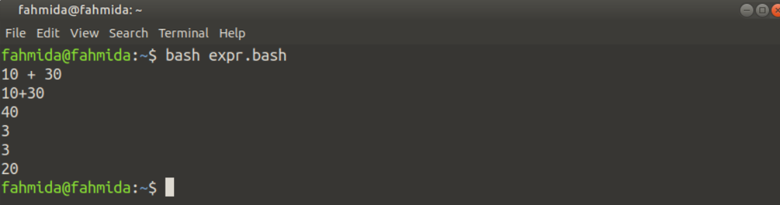

Example – 2: Using ‘let’ Command
‘let’ is another built-in command to do arithmetic operations in bash. ‘let’ command can’t print the output to the terminal without storing the value in a variable. But the ‘let’ command can be used to remove the other limitations of the ‘expr’ command. Create a bash file named let.bash with the following script to know the use of the ‘let’ command.
#!/bin/bash
# Multiplying 9 by 8
let val1=9*3
echo $val1
# Dividing 8 by 3
let "val2 = 8 / 3"
echo val2
# Subtracting 3 from 9
let val3=9-3
echo $val3
# Applying increment
let val4=7
let val4++
echo $val4
# Using argument value in arithmetic operation
let val5=50+$1"
echo $val5
Run the following command to execute the script.
$ bash let.bash 50
Output:
The output shows that the ‘let’ command is more flexible than the ‘expr’ command. You can evaluate any arithmetic expression with or without quotations. But you can’t use space within any mathematical expression. The increment or decrement operator can be used in the ‘let’ command. How the arithmetic operation can be done with the argument values using the ‘let‘ command is shown in the last part of the example.
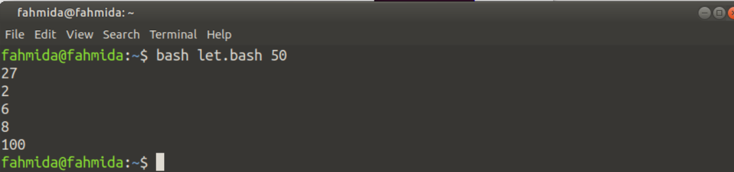

Example – 3: Using Double Brackets
Any arithmetic operation can be done in bash without using any command. Here, double brackets are used to do the arithmetic tasks, and using double brackets for executing mathematical expressions is more flexible than the command like the ‘expr’ or ‘let’. Create a bash file named dbl.bash with the following script to test the arithmetic operations by using double brackets.
#!/bin/bash
# Calculate the mathematical expression
val1=$((10*5+15))
echo $val1
# Using post or pre increment/decrement operator
((val1++))
echo $val1
val2=41
((--val2))
echo $val2
# Using shorthand operator
(( val2 += 60 ))
echo $val2
# Dividing 40 by 6
(( val3 = 40/6 ))
echo $val3
Run the following command to execute the script.
$ bash dbl.bash
Output:
The output shows that double brackets can execute any mathematical expression with space or without space and you can also use increment/decrement and shorthand operators in double brackets expressions.
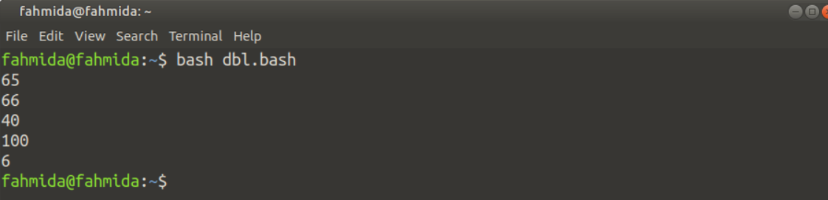

Example – 4: Using ‘bc’ Command for Float or Double Numbers
One of the major limitations of the above ways of doing arithmetic operations in bash is that ‘expr’ or ‘let’ or double brackets expressions are not able to produce floating-point or double numbers. The output of division operations of the above examples are integers. ‘bc’ command can be used to solve this problem and it works as a basic calculator for the Linux operating system. Create a bash file named bc.bash with the following script to know the use of the ‘bc’ command in arithmetic operations.
#!/bin/bash
# Dividing 55 by 3 with bc only
echo "55/3" | bc
# Dividing 55 by 3 with bc and -l option
echo "55/3" | bc -l
# Dividing 55 by 3 with bc and scale value
echo "scale=2; 55/3" | bc
Run the following command to execute the script.
$ bash bc.bash
Output:
The output shows that the simple ‘bc’ command produces integer value like other options when any division expression is executed. ‘bc -l’ command generates the exact output of the division and you can limit the fractional part by using scale value. Here, scale=2 is used. So the output shows 2 digits after the decimal point.
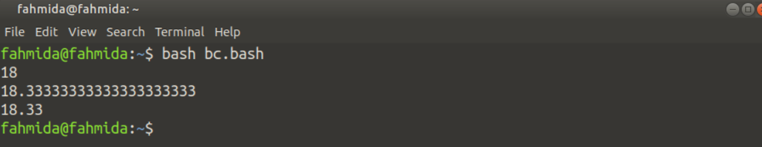

Example-5: Using the printf Command for Float or Double Number
The `printf` command is another way to work with fractional data. This command can be used to generate the floating-point value more efficiently than the `bc` command after the arithmetic operation. This command can also be used to calculate the power of a number. The uses of the `printf` command for different arithmetic operations have shown in this example. Create a bash file named prn.bash with the following script to check the use of the `printf` command for the fractional output of the division of two numbers.
#!/bin/bash
# Take the dividend value from the user
read -p "Enter the dividend value: " n1
# Take the divisor value from the user
read -p "Enter the divisor value: " n2
# Find the division using `echo` and `bc`
echo "scale=2; $n1/$n2"|bc
# Find the division using `printf`
printf "%.2f\n" "$((10**2 * $n1/$n2))e-2"
Run the following command to execute the script.
$ bash prn.bash
Output:
The following output shows that the division value generated by the `bc` and `printf` commands of two integer numbers are the same.
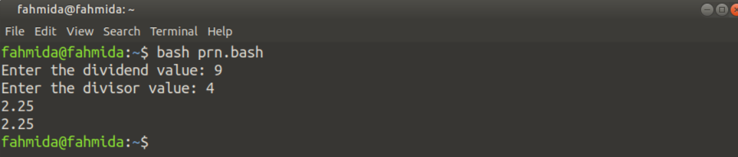
The following output shows that when the dividend value is a floating-point number then the division value generated by the `bc` command is correct but the `printf` command generated an error.
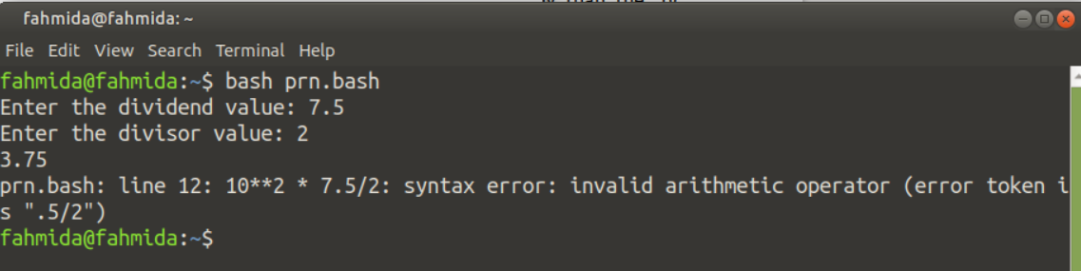
Create a bash file named prn2.bash with the following script to know the use of the `printf` command for the correct fractional output when the dividend value is a floating-point number.
#!/bin/bash
# Take the dividend value from the user
read -p "Enter the dividend value: " n1
# Take the divisor value from the user
read -p "Enter the divisor value: " n2
# Find the division using `printf`, `echo` and `bc`
printf "%.2f\n" `echo $n1/$n2|bc -l`
Run the following command to execute the script.
$ bash prn2.bash
Output:
The output shows that the `printf` with ‘`bc` command generates the correct output.
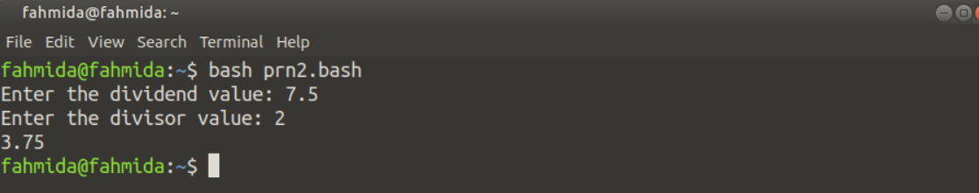

Example-6: Using the awk Command for Arithmetic Operation
Using the `awk` command is another way to perform the arithmetic operation that can generate output properly for floating-point numbers. The arithmetic operations using the `awk` command without formatting and with formatting have shown in this example. Create a bash file named awk.bash with the following script to check the use of the `awk` command for arithmetic operation.
#!/bin/bash
# Initialize the dividend value
n1=90
# Initialize the divisor value
n2=43
# Print the output without formating
awk "BEGIN {print $n1/$n2}"
# Print the output with formatting
awk "BEGIN {printf "%.2f\n", $n1/$n2}"
Run the following command to execute the script.
$ bash awk.bash
Output:
The output shows that the `awk` command can generate appropriate fractional output.
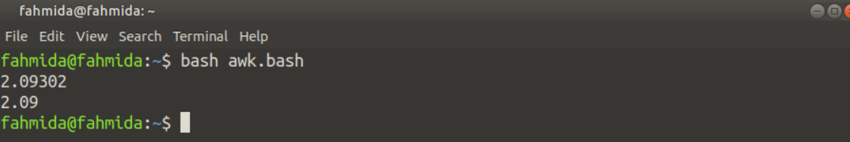

Example-7: Calculate the Percentage of a Value
Sometimes we need to calculate the percentage value of particular criteria. The percentage can be calculated in bash by using the `printf` command and `echo` command. Suppose, we need to find out the percentage of passed students on an exam based on the total number of students and total passed students. The solution to this problem has shown in this example. Create a bash file with the following script to calculate the percentage value of passed students using the `printf` command.
#!/bin/bash
# Take the total number of students from the user
read -p "Total number of students: " total_std
# Take the total number of passed students from the user
read -p "Total number of passed students: " passed_std
# Calculate the percentage of passed students
printf "The percentage of passed students: %.2f%%\n” “$((10**3 * 100 * $passed_std/$total_std))e-3"
Run the following command to execute the script.
$ bash percentage.bash
Output:
The output shows the percentage of passing students based on the total number of students and passed students.
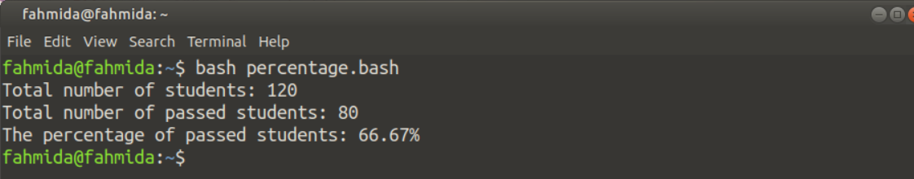

Conclusion
The uses of different arithmetic operators in bash and the ways to perform the arithmetic operations using different commands have shown in this tutorial by using multiple examples to help the bash users.
expr, $(()), (())
참고 : https://www.networkworld.com/article/965568/how-to-do-math-on-the-linux-command-line.html

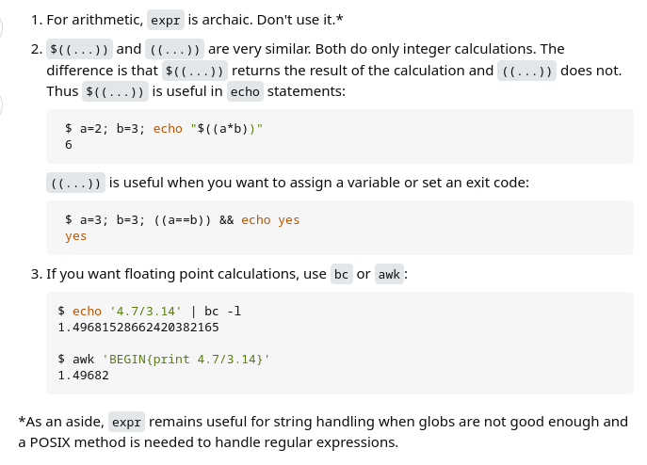

ex) echo $((2+3))
5
ex) a=2.1; b=3; echo “$a+$b” | bc
5.1
ex) a=3; b=4; echo “$((a+b))”
7
ex) $(( 1 + 2 ))를 단독으로 실행하면 그냥 3이 expansion되어
bash: 3: 명령어를 찾을 수 없음. Error 127이 뜬다.

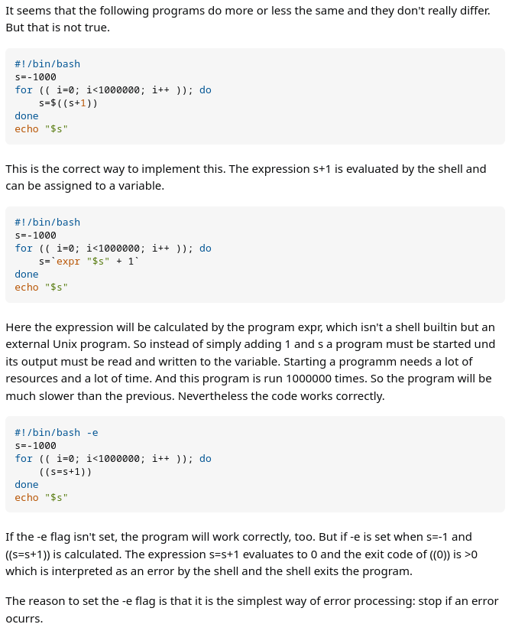

정규 표현식의 용어들정규 표현식에서 사용되는 기호를 Meta문자라고 표현한다. 표현식에서 내부적으로 특정 의미를 가지는 문자를 말하며 간단하게 정리하면 아래의 표와 같다.

출처 : https://hamait.tistory.com/342

표현식 | 의미
^x | 문자열의 시작을 표현하며 x 문자로 시작됨을 의미한다.
x$ | 문자열의 종료를 표현하며 x 문자로 종료됨을 의미한다.
.x | 임의의 한 문자의 자리수를 표현하며 문자열이 x 로 끝난다는 것을 의미한다.
x+ | 반복을 표현하며 x 문자가 한번 이상 반복됨을 의미한다.
x? | 존재여부를 표현하며 x 문자가 존재할 수도, 존재하지 않을 수도 있음을 의미한다.
x* | 반복여부를 표현하며 x 문자가 0번 또는 그 이상 반복됨을 의미한다.
x|y | or 를 표현하며 x 또는 y 문자가 존재함을 의미한다.
(x) | 그룹을 표현하며 x 를 그룹으로 처리함을 의미한다.
(x)(y) | 그룹들의 집합을 표현하며 앞에서 부터 순서대로 번호를 부여하여 관리하고 x, y 는 각 그룹의 데이터로 관리된다.
(x)(?:y) | 그룹들의 집합에 대한 예외를 표현하며 그룹 집합으로 관리되지 않음을 의미한다.
x{n} | 반복을 표현하며 x 문자가 n번 반복됨을 의미한다.
x{n,} | 반복을 표현하며 x 문자가 n번 이상 반복됨을 의미한다.
x{n,m} | 반복을 표현하며 x 문자가 최소 n번 이상 최대 m 번 이하로 반복됨을 의미한다.
Meta 문자들 중에서 좀 더 특수하게 사용되는 문자들이 존재한다. '[]' 는 내부에 지정된 문자열의 범위 중에서 한 문자만을 선택하다는 특수한 의미를 가진다. 그리고 내부에서 Meta문자를 사용하면 다른 의미를 가지고 동작할 수 있으므로 잘 확인하고 사용해야 한다. 좀 더 특별한 용도로 사용되는 것들은 아래의 표와 같다.

표현식 | 의미
[xy] | 문자 선택을 표현하며 x 와 y 중에 하나를 의미한다.
[^xy] | not 을 표현하며 x 및 y 를 제외한 문자를 의미한다.
[x-z] | range를 표현하며 x ~ z 사이의 문자를 의미한다.
\^ | escape 를 표현하며 ^ 를 문자로 사용함을 의미한다.
\b | word boundary를 표현하며 문자와 공백사이의 문자를 의미한다.
\B | non word boundary를 표현하며 문자와 공백사이가 아닌 문자를 의미한다.
\d | digit 를 표현하며 숫자를 의미한다.
\D | non digit 를 표현하며 숫자가 아닌 것을 의미한다.
\s | space 를 표현하며 공백 문자를 의미한다.
\S | non space를 표현하며 공백 문자가 아닌 것을 의미한다.
\t | tab 을 표현하며 탭 문자를 의미한다.
\v | vertical tab을 표현하며 수직 탭(?) 문자를 의미한다.
\w | word 를 표현하며 알파벳 + 숫자 + _ 중의 한 문자임을 의미한다.
\W | non word를 표현하며 알파벳 + 숫자 + _ 가 아닌 문자를 의미한다.
정규표현식을 사용할 때 Flag 라는 것이 존재하는데 Flag를 사용하지 않으면 문자열에 대해서 검색을 한번만 처리하고 종료하게 된다. Flag는 다음과 같은 것들이 존재한다.

Flag | 의미
g | Global 의 표현하며 대상 문자열내에 모든 패턴들을 검색하는 것을 의미한다.
i | Ignore case 를 표현하며 대상 문자열에 대해서 대/소문자를 식별하지 않는 것을 의미한다.
m | Multi line을 표현하며 대상 문자열이 다중 라인의 문자열인 경우에도 검색하는 것을 의미한다.
S single line.
사용 예제
개별 숫자- /[0-9]/g
전체에서 0~9사이에 아무 숫자 '하나' 찾음
개발 문자 - /[to]/g
전체에서 t 혹은 o 를 모두 찾음

단어 - /filter/g
전체에서 f 따로 i 따로 찾는게 아니라 'filter' 라는 단어에 매칭되는것을 찾음
단어 제외 - /\b(?:(?!to)\w)+\b/g
전체에서 'to' 라는 단어를 빼고 다른 단어매칭 / 확인결과 "Tutorial" 도 제외됨.
단어 제외 -\b(?!\bto\b)\w+\b
전체에서 'to' 라는 단어를 빼고 다른 단어매칭 / 확인결과 "Tutorial" 는 제외 안됨. 이게 더 정확하다고 볼수있을듯.
이메일 - /^[0-9a-zA-Z]([-_\.]?[0-9a-zA-Z])*@[0-9a-zA-Z]([-_\.]?[0-9a-zA-Z])*\.[a-zA-Z]{2,3}$/i
'시작을' 0~9 사이 숫자 or a-z A-Z 알바펫 아무거나로 시작하고 / 중간에 - _ . 같은 문자가 있을수도 있고 없을수도 있으며 /
그 후에 0~9 사이 숫자 or a-z A-Z 알바펫중 하나의 문자가 없거나 연달아 나올수 있으며 / @ 가 반드시 존재하고 /
0-9a-zA-Z 여기서 하나가 있고/중간에 - _ . 같은 문자가 있을수도 있고 없을수도 있으며 /그 후에 0~9 사이 숫자 or a-z A-Z 알바펫중 하나의
문자가 없거나 연달아 나올수 있으며/ 반드시 . 이 존재하고 /[a-zA-Z] 의 문자가 2개나 3개가 존재 / 이 모든것은 대소문자 구분안함
전화번호 - /^\d{3}-\d{3,4}-\d{4}$/
시작을 숫자 3개로하며 / 중간에 하이픈 - 하나 존재 / 숫자가 3~4개 존재하며 / 하이픈 하나 존재 / 숫자 4개로 끝남

핸드폰 번호 - /^01([0|1|6|7|8|9]?)-?([0-9]{3,4})-?([0-9]{4})$/
시작을 숫자 01로 시작하며 그 후에 0,1,6,7,8,9 중에 하나가 나올수도 있으며 / 하이픈 - 하나 존재할수도 있으며 / 숫자 3~4개 이어지고 /
또 하이픈 - 하나 존재할수도 있으며 / 숫자 4개가 이어짐

URL - ^(https?):\/\/([^:\/\s]+)(:([^\/]*))?((\/[^\s/\/]+)*)?\/?([^#\s\?]*)(\?([^#\s]*))?(#(\w*))?$
^(https?):\/\/
([^:\/\s]+)
(:([^\/]*))?
((\/[^\s/\/]+)*)?\/?([^#\s\?]*)(\?([^#\s]*))?(#(\w*))?$
출처: https://hamait.tistory.com/342 [HAMA 블로그:티스토리]

9. Flag 의 의미
프로그래밍에서, 플래그는 무엇인가를 기억해야하거나 또는 다른 프로그램에게 약속된 신호를 남기기 위한 용도로 프로그램에 의해 사용되는 미리 정의된 비트를 말한다.
플래그들은 컴퓨터 프로그래밍에서 매우 자주 사용된다.
http://terms.co.kr/flag.htm
위 본문에는 이해 하기 어려운 글이 있어서 일부 삭제 했습니다.
두가지 부울 값을 가지는 상태를 표현 할 때에 플래그를 많이 사용 합니다.
예를들면
스위치가 1이면 팬을 동작 시키고
스위치가 0이면 팬을 정지 시킨 다고 할 때에
bit sw_flag=0; //초기값

if(sw==0)sw_flag=1; // 스위치가 눌리면 플래그를 set
else sw_flag=0;

if(sw_flag)FAN=1; // 스위치 플래그가 1이면 팬 ON
else FAN=0;
이런 식으로 사용 합니다.
물론 AVR 컴파일러에서도 코드비젼만 비트 변수를 지원 하므로
타 컴파일러에서는 비트 변수 대신 char 나 int를 사용 해서 플래그 변수를 만듭니다.

두가지 상태가 아닌 여러가지 상태를 가질 때에는
status 라는 이름의 변수를 많이 사용 합니다.
예) key_status, led_status등

flag 변수명으로 status 처럼 사용 하는 사람도 있고
status 변수명으로 flag 처럼 사용 하는 사람도 있습니다.

특수 변수 $0, $1, $2, $*,$@

개요
- Shell에서 $0, $1, $2, $*, $@, $# 는 특별한 의미를 갖음
특수 변수 | 설명
$0 | Script를 실행시킬 때 프로그램의 이름이 포함된 첫 번째 문자열을 저장
$1, ...$N | 입력 값들이 순서대로 저장되며, 위치 매개변수(Positional Parameter)라고 표현
$* | 모든 위치 매개변수를 담고 있는 단일 문자열
$@ | $* 과 비슷하나 $@는 "$1", ..."$N"을 의미
$# | 위치 매개변수의 개수를 저장
$? | 쉘에서 최근 실행한 명령어의 종료 상태를 담은 변수
$$ | 쉘 스크립트의 프로세스 ID를 저장
$_ | 마지막 인수를 출력하는 변수를 저장

실습

$0, $1, $2, $*, $@, $#
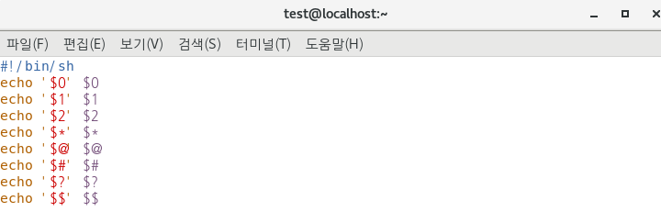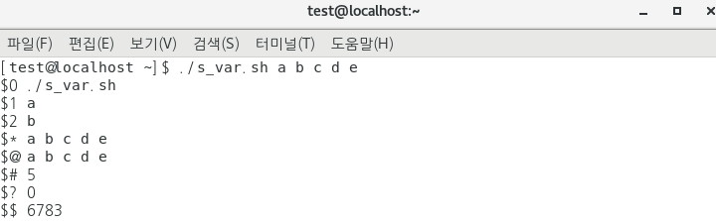
- $0 : 첫번째 문자열이 저장되기 때문에 실행 명령어인 ./s_var.sh를 저장
./s_var.sh a b c d e
- $1, $2 : 실행 명령어를 제외, 차례대로 위치에 따라 매개변수를 저장
./s_var.sh a b c d e
- $* : 모든 위치 매개변수를 담은 문자열 저장
./s_var.sh a b c d e
- $@ : $1 ~ $N 위치의 매개변수를 저장
./s_var.sh a b c d e
- $# : 위치 매개변수 개수 5개를 저장
./s_var.sh a b c d e
- $? : 최근 명령어의 종료 상태 저장
(0) -> 명령어 종료 상태 정상
- $$ : 스크립트의 PID 저장

' ' 구분자
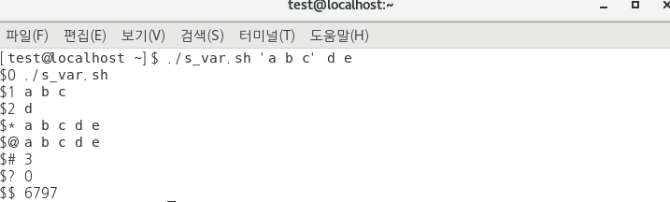
- 띄어쓰기를 구분자로 위치 매개변수를 저장
- 변수 내 띄어쓰기가 필요한 경우 구분자인 ' ' 사용
./s_var.sh 'a b c' d e
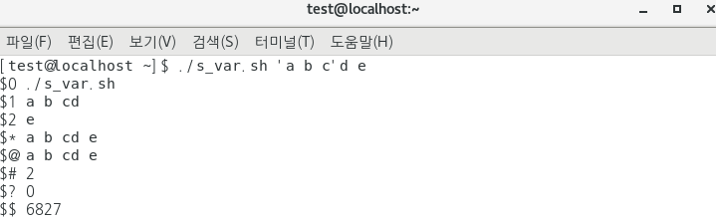
- 띄어쓰기를 구분자로 'a b c'와 d 사이 띄어쓰기가 없어 a b cd로 $1에 저장됨

$?
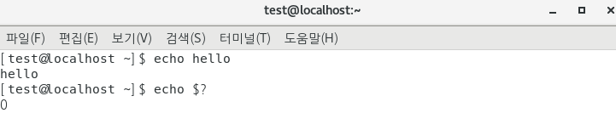
- 최근 명령어의 종료 상태가 정상(0)일 경우
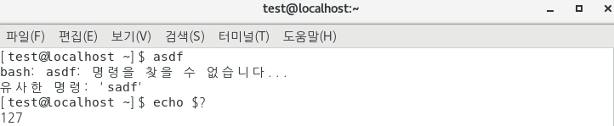
- 최근 명령어의 종료 상태가 비정상 일 경우
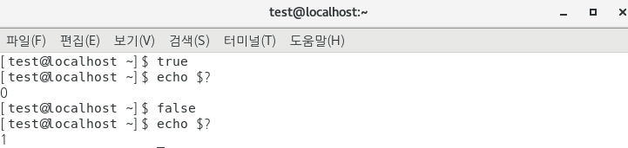
- true / false에 대한 명령어 상태 (0) / (1)

$_
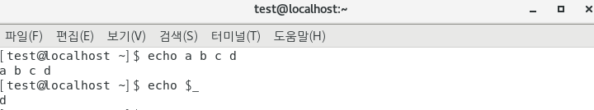
- 마지막 위치 매개변수 저장
./s_var.sh a b c d
Configuration files

File | Description | Login shells (see note) | Interactive, non-login shells
/etc/profile | Sources application settings in /etc/profile.d/*.sh and /etc/bash.bashrc. | Yes | No
~/.bash_profile | Per-user, after /etc/profile. If this file does not exist, ~/.bash_login and ~/.profile are checked in that order. The skeleton file /etc/skel/.bash_profile also sources ~/.bashrc. | Yes | No
~/.bash_logout | Per-user, after exit of a login shell. | Yes | No
/etc/bash.bash_logout | Depends on the -DSYS_BASH_LOGOUT="/etc/bash.bash_logout" compilation flag. After exit of a login shell. | Yes | No
/etc/bash.bashrc | Depends on the -DSYS_BASHRC="/etc/bash.bashrc" compilation flag. Sources /usr/share/bash-completion/bash_completion. | No | Yes
~/.bashrc | Per-user, after /etc/bash.bashrc. | No | Yes

History Command
- 설정
- 사용
- References
Command line에서 명령을 실행하면 해당 명령이 기록에 남는다. 이 기록을 살펴보는 명령이 history다.
설정
이 설정은 bash기준이며 다른 쉘에서는 약간 다를 수 있다.
export HISTTIMEFORMAT='%F %T ' # 로그에 날짜와 시간 출력
export HISTIGNORE="pwd:ls:ls -ltr:" # pwd, ls, ls -ltr명령은 로그에 기록하지 않는다.
export HISTCONTROL=ignorespace # 명령 실행시 처음 스페이스가 포함되면 로그에 기록하지 않는다.
export HISTCONTROL=ignoredups # 명령이 중복되면 무시 (pwd를 연속으로 여러번 입력하면 로그에는 pwd하나만 기록된다)
export HISTCONTROL=erasedups # 중복로그를 삭제하고 최근로그만 남긴다.
export HISTSIZE=450 # 저장할 로그 개수 지정 (0을 지정하면 history 기능이 disable된다)
export HISTFILESIZE=450 # 저장할 로그 개수 지정
export HISTFILE=/root/.commandline_warrior # 히스토리 로그 파일 변경
사용
- Ctrl+R을 사용하여 history명령을 활용할 수 있다. Enter를 치면 검색한 명령이 수행된다. Backspace로 검색어를 삭제한뒤 재검색할 수 있다. 수정이 필요하면 esc나 화살키를 사용한다.
  - (reverse-i-search)`':
- 키보드의 Up키나 Down키 또는 Ctrl+P나 Ctrl+N으로 이전명령 다음명령을 선택하여 재실행 할 수 있다.
- !!or !-1 바로 이전 명령을 재실행 한다.
- ![no]로 history number에 해당하는 명령을 재실행 한다.
- ![keyword]로 가장 최근의 키워드로 검색하여 재실행한다.
- Vi !!:$ 이전명령의 마지막 인자 활용
- vi !!:[no] 이전명령의 [no]인자 활용
- vi !^ 이전명령의 첫번째 인자 활용
- ls -l !cp:2 최근 사용한 cp명령의 두번째 인자 활용
- history 53 53부터 마지막까지 로그 출력
- history -10 마지막부터 10개까지 로그 출력
- history -c를 하면 히스토리기록을 모두 삭제한다.

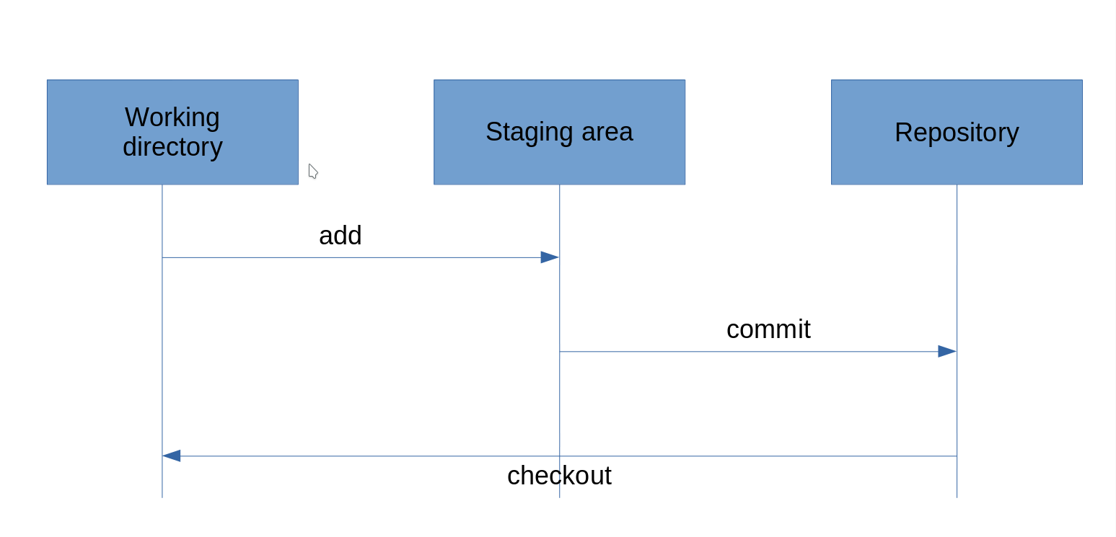
Git repository

Xargs로 여러 이름의 파일 동시에 cp, mv 하기

xargs는 공백(“”,’’,\로 보호받을수 있음), 개행을 기준으로 토큰을 구분하며 standard input으로부터 읽어들여서 명령어를 수행한다.(참고: https://codingdog.tistory.com/entry/%EB%A6%AC%EB%88%85%EC%8A%A4-xargs-%EB%AA%85%EB%A0%B9%EC%96%B4%EC%97%90-%EB%8C%80%ED%95%B4-%EC%95%8C%EC%95%84%EB%B4%85%EC%8B%9C%EB%8B%A4 )

ex) X나 x로 시작하는 파일들을 한번에 ./txt디렉토리로 cp하기

1) find . -type f -iname 'x*' | xargs -i cp {} ./txt
find . -type f -iname 'x*' | xargs -I{} cp {} ./txt (i와 같은 결과)

2) find ./xargstest -type f -name '*.txt' | xargs -t -I % cp -a % ~/backups (%는 파일이름으로 치환될 표식으로서, 따로 지정하지 않으면 기본값은 {}이다. 표식을 지정하지 않으려면 -I가 아닌, -i 옵션을 써야한다.
Cp -a 는 원본 파일의 속성, 링크 정보까지 모두 복사한다는 의미.)

3) -I를 이용하여 여러 명령의 실행할수도 있다.
echo "file1 file2 file3" | xargs -t -I % sh -c '{ touch %; ls -l %; }' (-I 옵션 뒤에 replacs-str를 정의하고 relace-str이 모두 xargs에 인수로 전달된다. 예제에서는 먼저 touch를 사용하여 파일을 만들고, 그다음 ls명령을 사용하여 파일을 나열한다.)

4) find Downloads -name "DomTerm" -type d -print0 | xargs -0 /bin/rm -v -rf "{}"
find . -type f -iname 'x*' | xargs rm (간단한 파일명의 경우 별다른 옵션 붙이지 않아도 되지만, 파일명에 공백이 있을 수 도 있으므로 -print0와 -O 옵션을 함께 써주는게 좋다. -print0 enables printing of the full file path on the standard output, followed by a null character(말 그대로 변수에 저장된 값이 아스키값으로 0) and -0 xargs flag effectively deals with space in filenames.)

5) 하나의 파일을 여러 디렉토리에 카피하기
echo ./Templates/ ./Documents/ | xargs -n 1 cp -v ./Downloads/SIC_Template.xlsx (여기서는 오히려 {}를 붙이지 않는다. | 이전 명령의 standard output을 인자로 건네받기 때문. Cp -v 는 복사 진행상태를 출력한다는 옵션이다.)
6) cut -d: -f1 < /etc/passwd | sort | xargs (standard output을 계속 넘기고 standard input으로 계속 받는 예시. 출처 : https://www.tecmint.com/xargs-command-examples/)
7) 원하는 파일들 검색해서 압축하기 find /home/tariq -name "*.jpg*" -type f -print0 | xargs -0 tar -cvzf photos.tar.gz (tar도 파일명에서 공백등을 Null처리하려면 –null 옵션을 붙여야하지만, xargs에서 -0을 사용해서 넘겼기때문에 생략할수 있다. -print0 -0은 관용구처럼 사용된다.)
xargs [옵션] 명령어
- 옵션 출처 : https://lascrea.tistory.com/62 )

- a : 표준 입력 대신 파일에서 항목을 읽음, 이 옵션을 사용하여 명령을 실행하면 stdin(표준 스트림)은 변경되지 않는다. 그렇지 않으면 stdin이 /dev/null에서 리다이렉션 됨

- - O : 공백이나 특수문자를 찾을때 사용 (문자를 그대로 사용) *delimiter나 metacharacter 무시.
(Ex. find /opt -name “*.[ch]” | xargs touch -> 여기서 파일 이름에 공백이 있을 경우 각각 분리된 파일로 넘겨지는데 find /opt -name “*.[ch]” -print0 | xargs -O touch 형식으로 사용하면
-print0 은 파일 사이의 공백을 \0으로 분리자로 출력하고 xargs에서는 \0으로 표시된 분리자를 인식하여 하나의 파일이름으로 인식하고 다음 인자로 넘어간다)

- - d : xargs의 기본 delimiter는 공백(blank space)이다. 이 기본 delimiter를 다른 단일 문자나 escape character(ex: new line)로 바꾸기 위해 -d를 사용한다.
입력된 문자를 그대로 사용한다 (따음표, 백슬래쉬 같은 특수문자), 단순히 문자가 스페이스 같은걸로 분리되어 있을때 사용가능 하지만 다른 인수와 같이 처리되는 데는 사용 불가능
ex) echo "Jan*Feb*March" | xargs -d* | xargs mkdir

- - n : 지정된 숫자만큼 행을 출력 (앞에서 들어오는 인자의 수를 제한할 수 있다. 앞에서 5개의 표준 입력이 만들어져도 -n 으로 지정한 숫자만큼의 매개변수가 넘어온다.)

- - p : 사용자에게 각 명령 행을 실행할지 여부와 터미널에서 행을 읽는거에 대한 여부를 묻는다 ( yes , no 지정)

- - P : 하나의 명령에 프로세스 지정, -n 옵션과 같이 사용 ( -n으로 10개의 출력을 한다면 -p를 사용시 -n만큼의 프로세스가 실행, -p를 0으로 지정하면 한번에 사용할수 있는 프로세스를 모두 사용)

- - t : xargs를 통해 구성된 명령어를 표준 에러로 출력 (실행된 커먼드가 무엇인지 표시하므로 디버깅과정에 유용)

- - s : 한 라인에 들어갈 수 있는 문자열 수를 지정, 기본적으로 128k 안으로 문자열을 만들어 하나의 명령을 실행하나 해당 옵션은 최대 1024k까지 사용가능하게 한다.

- - x : -s 로 지정한 크기가 초과되면 종료시킨다
—show-limits : xargs의 버퍼 크기 선택 및 -s 옵션에 대한 길이 제한을 출력

- - E : 문자열 끝을 eof-str로 설정한다.

- - I(i) : xargs에 전달된 라인 전체를 뒤에 나오는 명령어의 인자로 사용 (디폴트로 라인 전체를 의미하는 기호는 {} 이다)
(Ex. find . -name “*.c”” | xargs -i {} sh -c ‘echo -n {} >> c_file.txt; stat -c %Y {} >> c_file.txt’ -> 하위 폴더에서 모든 C로 끝나는 파일들을 찾아 파일이름과 날짜롤 c.file.txt에 저장)

- - l(L) : 해당 명령을 사용하면 명령어 뒤에 공백이 있으면 다음 행으로 인식하는게 아닌 다음줄에 입력 라인에 있어도 논리적으로 이어지게 한다.
(-l 옵션을 사용하면 읽어들이는 각 행은 내부적으로 버퍼링이 된다. -l 옵션만 사용하는 경우 허용하는 버퍼의 상한이 있어 제한이 걸리는데 (대량의 파일이나 행을 읽어들이는 경우) -s 옵션을 함께 사용하면

- -s 옵션에 지정된 만큼 버퍼 크기를 늘릴 수 있으며 매우 긴 행이 발생되지 않도록 할 수 있다)

- 예제
# find /tmp -name core -type f -print | xargs /bin/rm -f
(/tmp 디랙토리 아래 core라는 파일을 찾아 삭제)
# fine /tmp -name core -type -f -print0 | xargs -O /bin/rm -f
(공백이나 개행 문자가 들어가 있는 파일이나 디렉토리 이름을 올바르게 처리되도록 파일 이름을 처리하여 core 파일을 삭제)
# find /tmp -depth -name core -type f -delete
(위의 두 예제와 같은 내용이나 이번 예제가 더 효율적이다. rm 을 시작하기위해 fork와 exec를 사용하여 프로세스를 생성하지 않기 때문)

# ls *.txt | xargs cat >> abc.txt
(ls를 이용하여 text파일을 모두 읽어와 하나의 파일로 병합한다)

# ls | grep “*.bak” | xargs cp /home/bak_file -> X
위와 같이 명령을 실행하면 오류가 발생한다. 출력값이 cp 명령에서 맨끝이 아니라 중간에 인자로 들어가기 때문이다. 이럴 경우 -i(-I) 옵션을사용하여 출력값을 어느위치에서 인자로 사용할 것인지 지정해주면 된다.
# ls | grep “*.bak” | xargs -I{} cp {} /home/bak_file -> O 또는 # ls | grep “*.bak” | xargs -i cp {} /home/bak_file -> O
(소문자 i를 사용하는 방식이 옛날 방식이므로 대문자 I를 사용한것을 권장한다, -i에는 기본값을 지정하는 것이 없다)

# find ~/ -type f | grep -H “*.txt$” | xargs grep -H “abcd”
(디렉토리에서 txt파일을 우선 찾은 다음 이름에 abcd를 포함하는 파일을 또 찾음)

# cat url-list.txt | xargs wget -c
(파일안에 url이 있을 경우 해당 인자들을 모두 wget으로 넘겨 다운받는다)

# find / -name “*.jpg” -type -f -print | xargs tar -cvzf images.tar.gz
(모든 jpg파일을 찾아 images.tar.gz로 압축)

# ls *.jpg | xargs -n1 -I{} cp {} /external-hard-drive/tmp
(ls 로 출력된 모든 이미지를 하나씩 인자로 받아 외장하드로 복사)

출처: https://www.gnu.org/software/findutils/manual/html_node/find_html/xargs-options.html
--arg-file=inputfile (예시 출처 : https://www.tecmint.com/xargs-command-examples/ )
-a inputfile (예시 : xargs -a rss_links.txt : 표준입력대신 파일에서 항목을 읽는다.)
Read names from the file inputfile instead of standard input. If you use this option, the standard input stream remains unchanged when commands are run. Otherwise, stdin is redirected from/dev/null.
--null (예시 출처 : https://www.tecmint.com/xargs-command-examples/ )
-0 (예시 : find Pictures/tecmint/ -name "*.png" -type f -print0 | xargs -0 tar -cvzf images.tar.gz)
Input file names are terminated by a null character instead of by whitespace, and any quotes and backslash characters are not considered special (every character is taken literally). Disables the end of file string, which is treated like any other argument. 즉, 파일명뒤에 NULL을 붙혀서 공백, “”,’’,\ 모두 무시해버린다.
--delimiter delim
-d delim (delimiter : 구분기호 ) -d를 사용하여 단일문자 또는 메타케릭터를 delimiter로 사용할수 있게해준다. 예시 : echo "file1;file2;file3" | xargs -d \; -t touch )
Input file names are terminated by the specified character delim instead of by whitespace, and any quotes and backslash characters are not considered special (every character is taken literally). Disables the logical end-of-file marker string, which is treated like any other argument.
The specified delimiter may be a single character, a C-style character escape such as ‘\n’, or an octal or hexadecimal escape code. Octal and hexadecimal escape codes are understood as for the printf command. Multibyte characters are not supported.
-E eof-str
--eof[=eof-str]
-e[eof-str]
Set the logical end-of-file marker string to eof-str. If the logical end-of-file marker string occurs as a line of input, the rest of the input is ignored. If eof-str is omitted (‘-e’) or blank (either ‘-e’ or ‘-E’), there is no logical end-of-file marker string. The ‘-e’ form of this option is deprecated in favour of the POSIX-compliant ‘-E’ option, which you should use instead. As of GNU xargs version 4.2.9, the default behaviour of xargs is not to have a logical end-of-file marker string. The POSIX standard (IEEE Std 1003.1, 2004 Edition) allows this.
The logical end-of-file marker string is not treated specially if the ‘-d’ or the ‘-0’ options are in effect. That is, when either of these options are in effect, the whole input file will be read even if ‘-E’ was used.
--help
Print a summary of the options to xargs and exit.
-I replace-str
--replace[=replace-str]
-i[replace-str]
Replace occurrences of replace-str in the initial arguments with names read from standard input. Also, unquoted blanks do not terminate arguments; instead, the input is split at newlines only. If replace-str is omitted (omitting it is allowed only for ‘-i’), it defaults to ‘{}’ (like for ‘find -exec’). Implies ‘-x’ and ‘-l 1’. The ‘-i’ option is deprecated in favour of the ‘-I’ option.
-L max-lines
--max-lines[=max-lines]
-l[max-lines]
Use at most max-lines non-blank input lines per command line. For ‘-l’, max-lines defaults to 1 if omitted. For ‘-L’, the argument is mandatory. Trailing blanks cause an input line to be logically continued on the next input line, for the purpose of counting the lines. Implies ‘-x’. The ‘-l’ form of this option is deprecated in favour of the POSIX-compliant ‘-L’ option.
--max-args=max-args (예시출처:https://www.linode.com/docs/guides/using-xargs-with-examples/)
-n max-args (예시 : find ./xargstest/archive -type f -name '*.txt*' -print0 | xargs -0 -t -n 2 diff : 인수 개수를 제한한다.)
Use at most max-args arguments per command line. Fewer than max-args arguments will be used if the size (see the ‘-s’ option) is exceeded, unless the ‘-x’ option is given, in which case xargs will exit. 한번에 실행되는 명령어의 인수 개수를 제한한다..
--open-tty
-o
Reopen stdin as /dev/tty in the child process before executing the command, thus allowing that command to be associated to the terminal while xargs reads from a different stream, e.g. from a pipe. This is useful if you want xargs to run an interactive application.
grep -lZ PATTERN * | xargs -0o -n1 vi
--interactive
-p
Prompt the user about whether to run each command line and read a line from the terminal. Only run the command line if the response starts with ‘y’ or ‘Y’. Implies ‘-t’.
--no-run-if-empty
-r
If the standard input is completely empty, do not run the command. By default, the command is run once even if there is no input.
--max-chars=max-chars
-s max-chars
Use at most max-chars characters per command line, including the command, initial arguments and any terminating nulls at the ends of the argument strings.
--show-limits
Display the limits on the command-line length which are imposed by the operating system, xargs’ choice of buffer size and the ‘-s’ option. Pipe the input from /dev/null (and perhaps specify ‘--no-run-if-empty’) if you don’t want xargs to do anything.
--verbose ( 실행되는 명령어를 표시한다.)
-t (예시: ls | xargs -t wc ) ( wc :사용자가 지정한 파일의 행, 단어, 문자수를 세는 프로그램, 파일 이름을 지정하지 않으면 표준 입력으로 부터 정보를 받아들여 계산한다. -l : 행, -w :단어, -c : 문자)
Print the command line on the standard error output before executing it.
--version
Print the version number of xargs and exit.
--exit
-x
Exit if the size (see the ‘-s’ option) is exceeded.
--max-procs=max-procs
-P max-procs (예시 : find ./xargstest -name '*.zip' | xargs -t -P 2 -L 1 -I % unzip -u %)
Run simultaneously up to max-procs processes at once; the default is 1. If max-procs is 0, xargs will run as many processes as possible simultaneously. See Controlling Parallelism, for information on dynamically controlling parallelism.
--process-slot-var=environment-variable-name
Set the environment variable environment-variable-name to a unique value in each running child process. Each value is a decimal integer. Values are reused once child processes exit. This can be used in a rudimentary load distribution scheme, for example.
8.4.2 Conflicting options
The options ‘--max-lines’ (‘-L’, ‘-l’), ‘--replace’ (‘-I’, ‘-i’) and ‘--max-args’ (‘-n’) are mutually exclusive.
seIf some of them are specified at the same time, then xargs will generally use the option specified last on the command line, i.e., it will reset the value of the offending option (given before) to its default value. Additionally, xargs will issue a warning diagnostic on stderr.
$ seq 4 | xargs -l2 -n3
xargs: warning: options --max-lines and --max-args/-n are \
mutually exclusive, ignoring previous --max-lines value
1 2 3
4
The exception to this rule is that the special max-args value 1 is ignored after the ‘--replace’ option and its short-option aliases ‘-I’ and ‘-i’, because it would not actually conflict.
$ seq 2 | xargs --replace -n1 echo a-{}-b
a-1-b
a-2-b

6.3.1 NUL-Terminated File Names
(출처 : tar 명령어 설명중에서 https://www.gnu.org/software/tar/manual/html_node/nul.html )

The “--null” option causes “files-from=file-of-names” ( -T file-of-names : 다른 파일명들 리스트를 내용으로가지고 있는 어떤 파일로부터 압축하거나 해제할 인수들(파일명들)을 받는 옵션 ) to read file names terminated by a NUL instead of a newline, so files whose names contain newlines can be archived using ‘”--files-from”.
--null’
Only consider NUL-terminated file names, instead of files that terminate in a newline.
--no-null’
Undo the effect of any previous “--null” option.
The ‘--null’ option is just like the one in GNU xargs and cpio, and is useful with the ‘-print0’ predicate of GNU find. In tar, --null also disables special handling for file names that begin with dash (similar to --verbatim-files-from option).
This example shows how to use find to generate a list of files larger than 800 blocks in length and put that list into a file called ‘long-files’. The ‘-print0’ option to find is just like ‘-print’, except that it separates files with a NUL rather than with a newline. You can then run tar with both the ‘--null’ and ‘-T’ options to specify that tar gets the files from that file, ‘long-files’, to create the archive ‘big.tgz’. The ‘--null’ option to tar will cause tar to recognize the NUL separator between files.
$ find . -size +800 -print0 > long-files
$ tar -c -v --null --files-from=long-files --file=big.tar
The ‘--no-null’ option can be used if you need to read both NUL-terminated and newline-terminated files on the same command line. For example, if ‘flist’ is a newline-terminated file, then the following command can be used to combine it with the above command:
$ find . -size +800 -print0 |
tar -c -f big.tar --null -T - --no-null -T flist
This example uses short options for typographic reasons, to avoid very long lines.
GNU tar is tries to automatically detect NUL-terminated file lists, so in many cases it is safe to use them even without the ‘--null’ option. In this case tar will print a warning and continue reading such a file as if ‘--null’ were actually given:
$ find . -size +800 -print0 | tar -c -f big.tar -T -
tar: -: file name read contains nul character
The null terminator, however, remains in effect only for this particular file, any following ‘-T’ options will assume newline termination. Of course, the null autodetection applies to these eventual surplus ‘-T’ options as well.

Null Terminated Lists of Things in Bash
You know the drill. You have to do something with a bunch of files, so you find them and use xargs to do what you will.
find -iname '*.tmp' | xargs rm
xargs assumes whitespace separated input by default, which means that if there’s a this file.tmp in there, xargs tries to do the following:
rm 'this'
rm 'file.tmp'
That fails if you’re lucky. If you aren’t, some of those files really do exist and get unintentionally deleted.
A favorable way of doing this is to remove ambiguity from the list of files you’re passing around by making sure each filename is terminated by a null byte. Because filenames on Linux can never contain NUL, programs can safely assume that any characters encountered before it are part of the filename and not a possible delimiter. The following works correctly for filenames that contain whitespace or newlines:
find -iname '*.tmp' -print0 | xargs -0 rm
This is a standard idiom in any command line user’s repertoire.
find and xargs aren’t the only two tools you’re used to that support this, though, and that lets you do some cool things with confidence.
Note: There are arguably better ways of doing this, such as using find -exec or GNU Parallel in place of xargs.

Example: Passing around filenames without their extension
You usually want to do this when you’re planning on converting one type of file to another. The basename utility that lets us strip a trailing suffix from a string supports NUL terminated output with the -z or --zero flags. I commonly convert images and video as follows:
# Repackage all '.mp4' files in the current directory as '.mkv'
basename -azs .mp4 *.mp4 | xargs -0 -I{} ffmpeg -i {}.mp4 \
-acodec copy \
-vcodec copy \
{}.mkv
# Convert all '.png' files in the current directory to '.jpg' with the same
# name.
basename -azs .jpg *.jpg | xargs -0 -I{} convert {}.png {}.jpg

Example: Passing around files containing a search pattern
Because every single program must come up with its own name for the same thing, grep will output a null terminated list of files if you give it the -Z or --null flags on the command line. Use that to delete all files in the current working directory containing the word ‘consistency’ as follows:
grep -s -lZ 'consistency' ./* | xargs -0 rm

Keeping track of it all
Because there’s so many different flags for this, I find it helpful to mentally group programs that use the same one. Eg. the sort, uniq, sed, and basename utilities all use -z.
Be warned, these can still have different multi character flags for the same thing:
- basename --zero
- sort --zero-terminated
- uniq --zero-terminated
- sed –null-data

- This is why I drink.

Grep command option

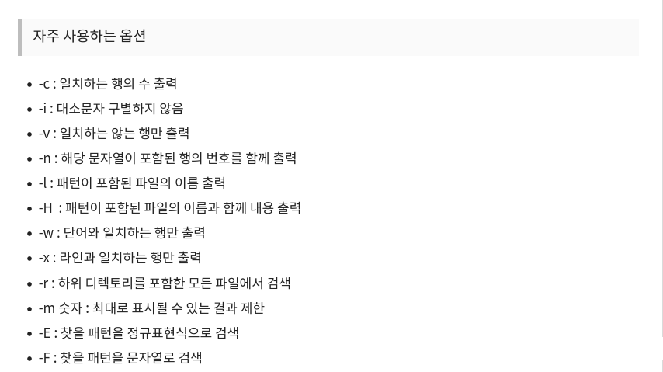

-s , --no-message :Suppress error messages about nonexistent or unreadable files

-o : Print only the matched (non-empty) parts of a matching line, with each such part
on a separate output line.
ex) grep -Ewo

-Z , --null : output a null terminated list of files
ex) grep -s -lZ 'consistency' ./* | xargs -0 rm

ex) grep -Pno ‘^\d’ rigsample.txt
grep -Eno ‘^[0-9]’ rigsample.txt

word boundary
https://www.regular-expressions.info/wordboundaries.html
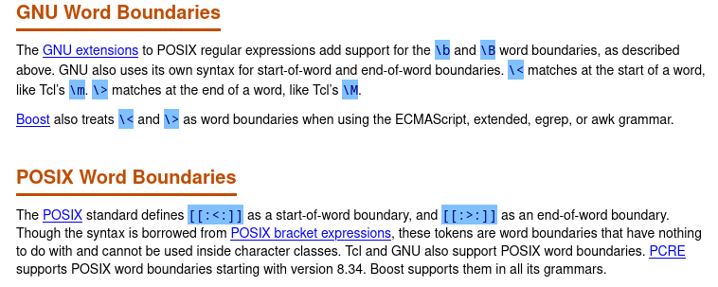
https://ko.javascript.info/regexp-boundary

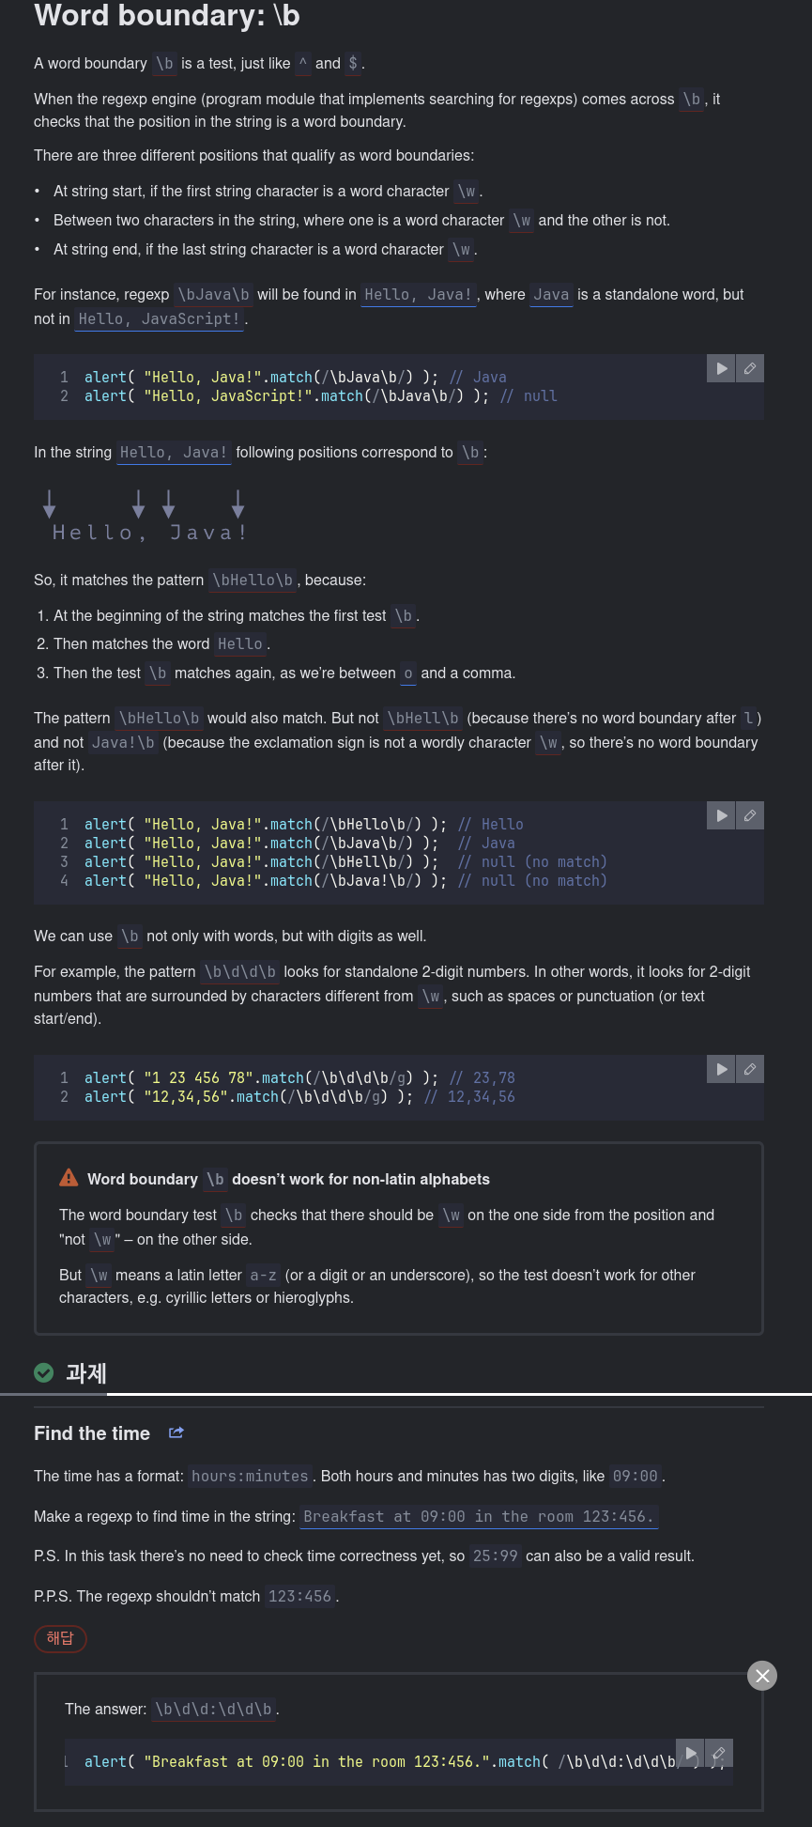

\b \> \< 의 차이점
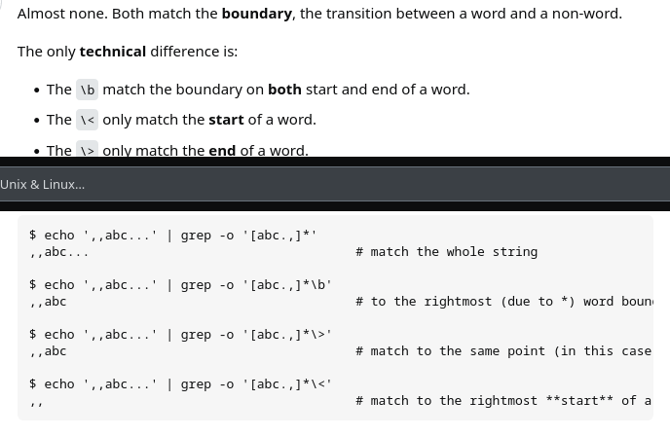
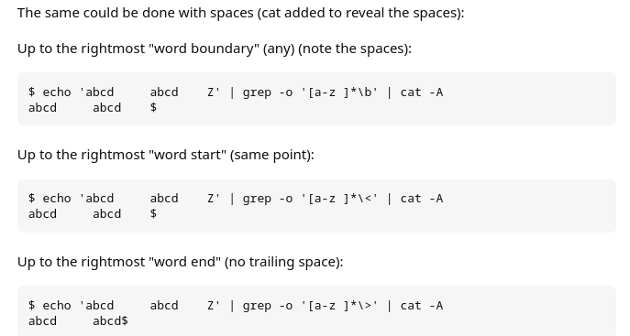

~
➜ grep -E '[ae]' test.txt # 각 character에서 e나 a를 검색 (둘 중에 하나 검색)
gray grey greay graey

~
➜ grep -E 'gr[ae]y' test.txt # gr로 시작하고 y로 끝나는 4글자 단어 중에서 e나 a가 들어간 단어검색
gray grey greay graey

~
➜ grep -E 'gr[ae][ae]*y' test.txt #gr로 시작하고 y로 끝나는 4글자 이상의 단어중에서 검색
gray grey greay graey

~
➜ grep -E 'gr[ae][ae]y' test.txt #gr로 시작하고 y로 끝나는 4글자 단어중에서 검색
gray grey greay graey

~
➜ grep -E 'gr[ae][ae]?y' test.txt #gr로 시작하고 y로 끝나는 3글자 혹은 4글자 단어중에서 검색
gray grey greay graey

< 단어 경계는 \w와 \W의 그 사이를 찾는 작업 >
-->> https://choonse.com/2022/06/01/1033/
정규표현식(regular expression)을 사용해 일치(match)하는 단어나 기호를 찾는 것은 매우 간단합니다.
My name is ABC.
ABC는 정규표현식 /ABC/를 사용하면 간단하게 찾을 수 있습니다.
그러나 다음 문자열에서 to를 찾기 위해 /to/를 사용하면 의도한 결과를 벗어납니다.
She told me not to go.
to가 포함된 모든 단어를 검색하는데요.
이 때 /b를 사용해 경계를 지정하면 원하는 부분만 찾을 수 있습니다.
그렇다면 /b의 정확한 기능은 무엇일까요?

1. /b의 기능
/b는 문자(\w에 해당하는 문자, a-z,A-Z,0-9,_)와 비(非)문자(\W에 해당하는 경우) 부분의 경계를 의미합니다.
이 부분의 이해가 어려울 수도 있는데요.
예를 들어 보겠습니다.
문자(\w로 표현): abcdefzhijklmnopqrstuvwxyzABCDEFGHIJKLMNOPQRSTUVWXYZ0123456789_
비문자(W로 표현) : 위 문자를 제외한 모든 기호
위와 같은 정의를 갖는 문자와 비문자 사이의 경계를 나타냅니다.
참고로 문자의 \w는 w가 소문자, 비문자의 \W는 대문자입니다.
띄워쓰기는 비문자에 해당하므로 /b를 사용해 단어의 경계를 정하고 원하는 결과를 만들 수 있는 것입니다.
그럼 다음 상황을 확인해보죠.
/\ba/g
위 표현식을 사용했을 때 다음 문자열에서 찾을 수 있는 결과는 무엇일까요?
-a
‘ a’
_a
aa
star
결과는 다음과 같으며 한 줄로 표현하겠습니다.
–a ‘ a‘ _a aa star
-a에서 a가 선택되는 이유는 -가 비문자이며 a가 문자이므로 \b는 두 사이를 가리키기 때문입니다.
‘ a’에서도 a 앞의 띄워쓰기는 비문자, a는 문자이므로 \b는 두 사이를 가리킵니다.
_a에서 a가 선택되지 않는 이유는 _ 기호는 문자로 취급하며 a도 문자이기 때문입니다.(\w의 정의)
aa에서 a가 선택된 이유는 문자열 제일 앞 또는 제일 뒤가 문자면 \b의 조건에 해당한다고 정의하기 때문입니다.
따라서 위의 문장에서 to만 찾으려면 다음과 같은 표현식을 사용하면 됩니다.
/\bto\b/g
She told me not to go.
참고로 \b, \B는 경계만을 가리킬 뿐 실제 문자와 일치하는 것은 아니므로 결과에는 포함되지 않습니다.

2. /B의 기능
그렇다면 대문자로 표현되는 \b의 반대 기능 \B의 정의는 무엇일까요?
바로 비문자와 비문자 사이의 경계, 또는 문자와 문자 사이의 경계를 의미합니다.
!-! abc와 같은 비문자 사이에서 비문자(-)를 찾거나 문자 사이에서 문자(b)를 찾을 수 있습니다.
/\B-\B/g
!-! ‘-‘

3. 활용
\b, \B는 주로 단어 검색에 유용합니다.
이 기능의 명칭이 단어 경계(word boundary)이므로 용도는 명확합니다.
문자열 내 의도하지 않은 기호의 탐색이나 카멜케이스(CamelCase)등과 관련된 작업에도 사용할 수 있습니다.

git push 실행시 username/passwd 안물어보게하기

=> git config credential.helper store --global

vim 녹화 기능
qq : 녹화시작
q : 녹화중지
100@q : 녹화내용 100번실행

Navigating the Bash shell with pushd and popd
출처: https://opensource.com/article/19/8/navigating-bash-shell-pushd-popd
Pushd and popd are the fastest navigational commands you've never heard of.

Opensource.com
The pushd and popd commands are built-in features of the Bash shell to help you "bookmark" directories for quick navigation between locations on your hard drive. You might already feel that the terminal is an impossibly fast way to navigate your computer; in just a few key presses, you can go anywhere on your hard drive, attached storage, or network share. But that speed can break down when you find yourself going back and forth between directories, or when you get "lost" within your filesystem. Those are precisely the problems pushd and popd can help you solve.

pushd
At its most basic, pushd is a lot like cd. It takes you from one directory to another. Assume you have a directory called one, which contains a subdirectory called two, which contains a subdirectory called three, and so on. If your current working directory is one, then you can move to two or three or anywhere with the cd command:
$ pwd
one
$ cd two/three
$ pwd
three
You can do the same with pushd:
$ pwd
one
$ pushd two/three
~/one/two/three ~/one
$ pwd
three
The end result of pushd is the same as cd, but there's an additional intermediate result: pushd echos your destination directory and your point of origin. This is your directory stack, and it is what makes pushd unique.

Stacks
A stack, in computer terminology, refers to a collection of elements. In the context of this command, the elements are directories you have recently visited by using the pushd command. You can think of it as a history or a breadcrumb trail.
You can move all over your filesystem with pushd; each time, your previous and new locations are added to the stack:
$ pushd four
~/one/two/three/four ~/one/two/three ~/one
$ pushd five
~/one/two/three/four/five ~/one/two/three/four ~/one/two/three ~/one

Navigating the stack
Once you've built up a stack, you can use it as a collection of bookmarks or fast-travel waypoints. For instance, assume that during a session you're doing a lot of work within the ~/one/two/three/four/five directory structure of this example. You know you've been to one recently, but you can't remember where it's located in your pushd stack. You can view your stack with the +0 (that's a plus sign followed by a zero) argument, which tells pushd not to change to any directory in your stack, but also prompts pushd to echo your current stack:
$ pushd +0
~/one/two/three/four ~/one/two/three ~/one ~/one/two/three/four/five
Alternatively, you can view the stack with the dirs command, and you can see the index number for each directory by using the -v option:
$ dirs -v
0 ~/one/two/three/four
1 ~/one/two/three
2 ~/one
3 ~/one/two/three/four/five
The first entry in your stack is your current location. You can confirm that with pwd as usual:
$ pwd
~/one/two/three/four
Starting at 0 (your current location and the first entry of your stack), the second element in your stack is ~/one, which is your desired destination. You can move forward in your stack using the +2 option:
$ pushd +2
~/one ~/one/two/three/four/five ~/one/two/three/four ~/one/two/three
$ pwd
~/one
This changes your working directory to ~/one and also has shifted the stack so that your new location is at the front.
You can also move backward in your stack. For instance, to quickly get to ~/one/two/three given the example output, you can move back by one, keeping in mind that pushd starts with 0:
$ pushd -0
~/one/two/three ~/one ~/one/two/three/four/five ~/one/two/three/four

Adding to the stack
You can continue to navigate your stack in this way, and it will remain a static listing of your recently visited directories. If you want to add a directory, just provide the directory's path. If a directory is new to the stack, it's added to the list just as you'd expect:
$ pushd /tmp
/tmp ~/one/two/three ~/one ~/one/two/three/four/five ~/one/two/three/four
But if it already exists in the stack, it's added a second time:
$ pushd ~/one
~/one /tmp ~/one/two/three ~/one ~/one/two/three/four/five ~/one/two/three/four
While the stack is often used as a list of directories you want quick access to, it is really a true history of where you've been. If you don't want a directory added redundantly to the stack, you must use the +N and -N notation.

Removing directories from the stack
Your stack is, obviously, not immutable. You can add to it with pushd or remove items from it with popd.
For instance, assume you have just used pushd to add ~/one to your stack, making ~/one your current working directory. To remove the first (or "zeroeth," if you prefer) element:
$ pwd
~/one
$ popd +0
/tmp ~/one/two/three ~/one ~/one/two/three/four/five ~/one/two/three/four
$ pwd
~/one
Of course, you can remove any element, starting your count at 0:
$ pwd ~/one
$ popd +2
/tmp ~/one/two/three ~/one/two/three/four/five ~/one/two/three/four
$ pwd ~/one
You can also use popd from the back of your stack, again starting with 0. For example, to remove the final directory from your stack:
$ popd -0
/tmp ~/one/two/three ~/one/two/three/four/five
When used like this, popd does not change your working directory. It only manipulates your stack.

Navigating with popd
The default behavior of popd, given no arguments, is to remove the first (zeroeth) item from your stack and make the next item your current working directory.
This is most useful as a quick-change command, when you are, for instance, working in two different directories and just need to duck away for a moment to some other location. You don't have to think about your directory stack if you don't need an elaborate history:
$ pwd
~/one
$ pushd ~/one/two/three/four/five
$ popd
$ pwd
~/one
You're also not required to use pushd and popd in rapid succession. If you use pushd to visit a different location, then get distracted for three hours chasing down a bug or doing research, you'll find your directory stack patiently waiting (unless you've ended your terminal session):
$ pwd ~/one
$ pushd /tmp
$ cd {/etc,/var,/usr}; sleep 2001
[...]
$ popd
$ pwd
~/one

Pushd and popd in the real world
The pushd and popd commands are surprisingly useful. Once you learn them, you'll find excuses to put them to good use, and you'll get familiar with the concept of the directory stack. Getting comfortable with pushd was what helped me understand git stash, which is entirely unrelated to pushd but similar in conceptual intangibility.
Using pushd and popd in shell scripts can be tempting, but generally, it's probably best to avoid them. They aren't portable outside of Bash and Zsh, and they can be obtuse when you're re-reading a script (pushd +3 is less clear than cd $HOME/$DIR/$TMP or similar).
Aside from these warnings, if you're a regular Bash or Zsh user, then you can and should try pushd and popd.

Vim fold 사용법

그럼 fold를 사용하고 싶은 이유는 무엇일까?
- 긴 코드를 한눈에 보고 싶어서
- 코드간의 이동을 편리하게 하고 싶어서
- vim에서 강력하게 제공해 주는 기능을 잘 사용해보고 싶어서
정도인듯 하다.
그럼 천리길도 한 걸음부터라고, 기본적인 fold 명령어부터 정리해보겠다.
fold를 사용하는 기본 명령어는 z이다. (상상력을 총 동원하면) z가 텍스트가 접힌 모양으로 보이지 않는가? 그렇게 보이지 않는다면 그렇게 보일때까지 잘 살펴보자. (| -> z) 그렇게 보인다면 이제 fold 명령어를 까먹을 일은 거의 없을것이다.
기본적으로 z 명령어는 operator로 동작한다. 그 이후에 text object 등과 함께 사용할 수 있다는 말이다.
zfap "zf + ap (pharagrap selection)
zf10j "zf + 10j (아래까지 10줄 fold)
zf 명령어는 무엇일까? 기본적으로 z 명령어는 세가지가 있다. 만들기, 열기, 닫기
일단 fold를 한 번 만들어 놓으면 zo, zc로 여닫을 수 있다.
zf "F-old 만들기 (만들면서 자동으로 닫는다)
zo "O-pen fold (열기)
zc "C-lose fold (닫기)
visual mode로 선택한 부분만 :fold로 접을 수 있다. zf와 동일한 역할을 한다.
또한 fold는 중첩(nested)으로 만들 수 있다.
여러 개의 fold를 만들면 각각의 fold를 찾아다니면서 zo를 눌러주는 게 불편할 수 있다.
이를 방지하기 위해서 다음 명령어들이 제공된다.
zr "R-duce folding - 다음 폴드를 찾아서 열어준다.
zm "fold M-ore - 다음 폴드를 찾아서 닫아준다.
이를 하나하나 하지 않고 모든 fold를 한 번에 여닫을 수 있다. (이 명령어는 꽤 유용하게 쓰인다)
zR "R-duces folding - 모든 폴드를 열어준다.
zM "fold M-ore and M-ore - 모든 폴드를 닫아준다.
현재 존재하는 모든 folding을 disable 할 수도 있다.
zn "모든 folding을 disable (open)
zN "zn을 사용하기 이전 단계로 변경
zi "둘 사이를 toggle
위 명령어는 파일에 fold를 만들어 놓고, 해당 fold간에 돌아다니면서 작업을 할 때 유용하게 쓰인다. zi로 열어서 작업 후에 zi로 다시 닫으면 원래대로 돌아가기 때문. 실제로 파일을 열고 zi를 사용해보면 fold를 사용하려는 목적인 파일 훑어보기에 큰 도움이 된다.
이 정도의 명령어만 알아도 기본적으로 fold를 만들고 여닫는 것 뿐 아니라 부분/전체적인 fold를 컨트롤 할 수 있다. 다음 포스트에서는 이 fold를 더 본격적으로 활용할 수 있는 방법에 대해서 정리할 예정.

POSIX Bracket Expressions
출처 : https://www.regular-expressions.info/posixbrackets.html
POSIX bracket expressions are a special kind of character classes. POSIX bracket expressions match one character out of a set of characters, just like regular character classes. They use the same syntax with square brackets. A hyphen creates a range, and a caret at the start negates the bracket expression.
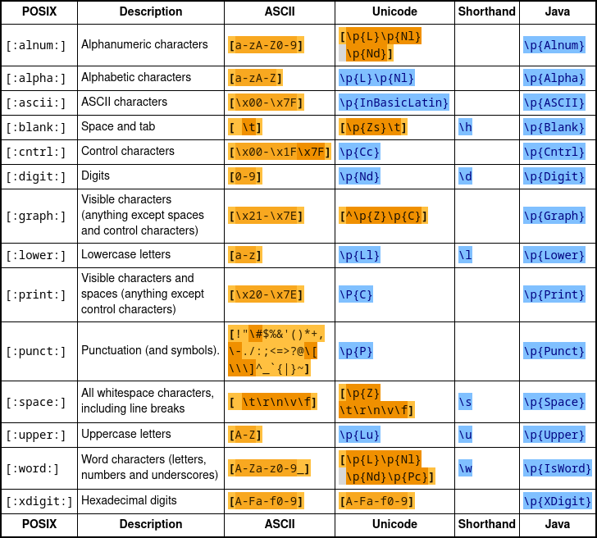
One key syntactic difference is that the backslash is NOT a metacharacter in a POSIX bracket expression. So in POSIX, the regular expression [\d] matches a \ or a d. To match a ], put it as the first character after the opening [ or the negating ^. To match a -, put it right before the closing ]. To match a ^, put it before the final literal - or the closing ]. Put together, []\d^-] matches ], \, d, ^ or -.

grep에서 두가지 패턴을 동시에 검색하는 법
( Concatenation 참고 : https://www.javatpoint.com/concatenate )
grep -e '[Yy].*[Yy].[Ee][Ee]'\|'[Ee][Ee].*[Yy].*[Yy]'

How do you concatenate in regex?
The Concatenation Operator
This operator concatenates two regular expressions a and b . No character represents this operator; you simply put b after a . The result is a regular expression that will match a string if a matches its first part and b matches the rest.

Concatenating strings and using += in bash
출처 : https://www.networkworld.com/article/971110/concatenating-strings-and-

There are many ways to concatenate strings when you're using bash and += might just surprise you!

Credit: Maxiphoto / Getty Images
It’s quite easy to get bash to concatenate strings and do simple math on Linux, but there are a number of options for you to use. This post focusses on concatenating strings, but also shows how one of the operators (+=) also plays a primary role in incrementing numbers.

Concatenating strings
In general, the only time that you’d want to concatenate strings on Linux is when one string is already defined and you want to add more to it. For example, if you have a script that greets the person running it, you might set up a string in the script to prepare the greeting and then add the person’s username or name before displaying it.
In this first example, we create a welcome string in a script and then pull the user’s first name from the /etc/passwd file and include it in the displayed text.

#!/bin/bash
greeting="Welcome! Let's get started with your annual interview"
name=`grep ^$USER /etc/passwd | awk -F: '{print $5}' | awk '{print $1}'`
greet="$greeting, $name"

echo $greet
When the script is run, it will start like this:

$ ./greet
Welcome! Let's get started with your annual interview, Sandra

The greeting was composed by simply including both the predefined greeting and the user’s first name in a variable named “greet”. Whether you create one string from two or simply use both in an echo command makes little difference. We could have easily displayed the greeting like this instead of creating separate $greeting and $greet variables:

echo "Welcome! Let's get started with your annual interview, $name"

You can also add to an existing greeting without creating an additional variable as in these three command sequences. Notice how, in the first one, the $greet variable is included in the command that redefines it.

$ greet="Welcome! Let's get started with your annual interview"
$ greet="${greet}, $USER"
$ echo $greet
Welcome! Let's get started with your annual interview, shs

The following command, using printf, has the same effect.

$ greet="Welcome! Let's get started with your annual interview, "
$ greet=$(printf "%s $USER" "$greet")
$ echo $greet
Welcome! Let's get started with your annual interview, shs

This last approach combines three variables to create the greeting and uses the full username from the /etc/passwd file.

$ greet="Welcome! Let's get started with your annual interview"
$ punct=", "
$ target=`grep ^$USER /etc/passwd | awk -F: '{print $5}'`
$ echo "$greet$punct$target"
Welcome! Let's get started with your annual interview, Sandra Henry-Stocker

The += sequence shown in the next example appends a name to the event variable:

$ event="Happy Birthday"
$ event+=", Amanda"
$ echo $event
Happy Birthday, Amanda

Incrementing numbers
This += sequence can be used to increment numbers. In the examples below, we set up a variable, add 1 to its value and then add 14. Notice how the ++ (add 1) and += (add specified number) sequences differ.

$ x=10
$ ((++x))
$ echo $x
11
$ ((x+=14))
$ echo $x
25

NOTE: Using += without the double parentheses does something altogether different. It treats the digits as strings and concatenates them.

$ y=12; echo $y
12
$ y+=34; echo $y
1234

To use the += sequence to add to an array, you can do something like what you see below. First, we define $x as shown below, creating the array in the process.

$ x=25
$ echo ${x[@]}
25

Then we can add a second element using the += sequence like this:

$ x+=(34)
When we display the array again, we see it now has two elements:
$ echo ${x[@]}
25 34

You can display the size of an array with a command like this:
$ echo ${#x[@]}
2

Wrap-Up
Manipulating strings by defining separate portions and then using them together can make using the strings in scripts more convenient when only small portion of the text is likely to vary. The += sequence provides useful options both in manipulating both strings and numbers, but the latter can involve math as well as string concatenation. It’s good to know which one to expect.

Alternation in REGEX
참고 : https://blog.robertelder.org/regular-expression-alternation/

Lookaround Regular Expression in Neovim/Vim
출처: https://jdhao.github.io/2018/10/18/regular_expression_nvim/#fn:2

Today I want to use some regular expressions for searching and replacing in my files. But I found that Nvim/Vim regular expression engine has its own flavor, which is different from the regex engine used by Sublime Text. I ended up learning some of the basics of Nvim-style regex. In this post, I want to share about how to use lookaround in Nvim.

Lookaround in Nvim
First, in Nvim, the syntax for look around is:
- \@=: positive lookahead
- \@!: negative lookahead
- \@<=: positive lookbehind
- \@<!: negative lookbehind
But how to use look around in Nvim? Let is take an example to explain this. Suppose we have text as follows:
foobar foo barfoo
To match foo which is followed by bar (bar not part of the match), use the following regex:
/foo\(bar\)\@=
In Nvim, ( and ) matches literally, which is different from PCRE. In order to use lookaround in Nvim, we have to include the lookaround pattern in a group, hence the escaped parentheses \(\) around bar.
So the first foo in the above text matches:
foobar foo barfoo
^
one match here
Similarly, we have the following 4 patterns:
- Match foo which is not followed by bar: /foo\(bar\)\@!
# now we have two matches
foobar foo barfoo
^ ^
two matches here
- Match foo which is preceded by bar: /\(bar\)\@<=foo
foobar foo barfoo
^
one match here
- Match foo which is not preceded by bar: /\(bar\)\@<!foo
foobar foo barfoo
^ ^
two matches here
- Match foo which is neither followed nor preceded by bar: /\(bar\)\@<!foo\(bar\)\@!
foobar foo barfoo
^
one match here

Combine magic mode and look around
Several months after I first wrote this article, I learned that Nvim also has a very magic mode (see :h /magic for more info) which behaves more like PCRE. The very magic mode is activate by preceding the search pattern with \v. In the very magic mode, you have to remove the \ character from the look around pattern. So in the very magic mode, the following regex should be used instead:
- positive look ahead: @=
- negative look ahead: @!
- positive look behind: @<=
- negative look behind: @<!
For example, to match foo which is followed by bar, you should use:
\vfoo(bar)@=

\ze and \zs for positive lookaround
We may also use \zs and ze for positive lookbehind and lookahead. \zs means that the actual match starts from here and \ze means that the actual match ends here. Take the above foobar text as an example:
- Match foo preceded by bar: \bar\zsfoo
- Match foo followed by bar: foo\zebar
In the above two match, bar is not part of the match. You can see that\ze and \zs simplify the pattern for positive lookaround.

A last example
Let’s take another example (adapted from this post):
rs11223-A -A
rs23300-G -TTA
rs9733-T -G
rs11900000-GT -TTG
Suppose we want to find - in the first part of each line, how do we write the regex pattern?

Using positive lookbehind
With positive lookbehind, the pattern can be (definitely not the only one):
/\(\d\+\)\@<=-
In the above regex pattern, \+ means to match previous pattern 1 or more time, which is a bit different from what we are accustomed to in Sublime Text.

Using \zs
With \zs, we can simplify the match pattern:
/\d\+\zs-
Ok, that is all. Hope you can finally understand how to correctly use lookaround regex in Nvim.

References
- https://vi.stackexchange.com/questions/3036/is-lookaround-possible-in-vims-regex-system
- Vim regex cheatsheet
- A good post about vim lookaround regex.

1. Use :h perl-patterns to find the difference of Nvim regex and Perl’s regex.
2. If you are not familiar with what lookaround in regex means, you can find a intro here and here
Vim regex

1) / --> general search / forward ..bonus,stay in search more C-g and C-t

2) . --> any chanracter

3) ? ---> search backwards

4) \<word boundary\>

5) \(pattern grouping\)

6) [] --> character class i.e [a-zA-Z]

7) [^] ---> negating a class

8) \d \x \o ---> instead of number int/hex/octal /D,/O,/X --> non-version

9) \l \L \u \U ---> uppercase and lowercase

10) \s --> whitespace chanracter

11) \S --> non-whitespace chanracter

12) /[0-9]\{3} --> quantifier ..any digit repeat 3 times

13) /[0-9]\{2,4} ---> range repeater min,max

14) * ---> zero or more /word*

15) + ---> one or more /word\+

16) ? --> zero or one /word\?

17) greedy is absolute like "bad" and it will match only bad and lazy start with a - {-n,m} ex: /fo\{-2,5} then it will show foo to fooooo

18) Anchors ^ for beginning and $ for ending

19) \n ---> backreference i.e \1 \2 \3

20) \0 --> whole match example: %s/[0-9]\+/"\0"

21) zero width :h /zero-width example : ^ $ \< \>

22) \ze ---> lookahead example: foo\zebar /foo\(bar\)\@=

23) \zs ---> lookbehind example : bar\zsfoo \@<= /\(foo\)\@<=bar

24) Lookahead and lookbehind together : /\(foo\)\@<=bar\(baz\)\@=

25) \%[] ---> optional match ,example : /bull%[shit] will match either bull, bullshit

26) \s_ ----> whitespace with newline

27) \v --> very magic , example /\v(foo)+

28) & --> the whole match , example \0 could be replace by this

29) g --> global command , example g/^$/ d

30) \w --> match a word /W --> not match a word

Vim Regular Expressions
출처: https://learnbyexample.gitbooks.io/vim-reference/content/Regular_Expressions.html
- Flags for Search and Replace
- Pattern atom
- Pattern Qualifiers
- Character Classes
- Multiple and Saving Patterns
- Word Boundary
- Search Pattern modifiers
- Changing Case using Search and Replace
- Delimiters in Search and Replace
- Further Reading

Flags for Search and Replace (보통의 regex에서는 g,i,m,s등)
- g replace all occurrences within line
- c ask for confirmation before each replacement
- i ignore case for searchpattern
- I don't ignore case for searchpattern
Flags can be combined
- s/cat/Dog/gi replace every occurrence of cat (ignoring case, so it matches Cat, cAt, etc) with Dog (note that i doesn't affect the replacement string Dog)
For more info, :h :s_flags

Pattern atom
- ^ start matching from beginning of a line
  - /^This match This only at beginning of line
- $ match pattern should terminate at end of a line
  - /)$ match ) only at end of line
  - /^$ match empty line
- . match any single character, excluding new line
  - /c.t match 'cat' or 'cot' or 'c2t' or 'c^t' but not 'cant'
For more info, :h pattern-atoms

Pattern Qualifiers
- *greedy match preceding character 0 or more times
  - /abc* match 'ab' or 'abc' or 'abccc' or 'abcccccc' etc
- \+ greedy match preceding character 1 or more times
  - /abc\+ match 'abc' or 'abccc' but not 'ab'
- \? match preceding character 0 or 1 times (\= can also be used)
  - /abc\? match 'ab' or 'abc' but not 'abcc'
- \{-} non-greedy match preceding character 0 or more times
  - Consider this line of text 'This is a sample text'
  - /h.\{-}s will match: 'his'
  - /h.*s will match: 'his is a s'
  - Read more on non-greedy matching
- \{min,max} greedy match preceding character min to max times (including min and max)
  - min or max can be left unspecified as they default to 0 and infinity respectively
  - greedy match, tries to match as much as possible
- \{-min,max} non-greedy match, tries to match as less as possible
- \{number} match exactly with specified number
  - /c\{5} match exactly 'ccccc'
For more info, :h pattern-overview

Character Classes
- [abcde] match any of 'a' or 'b' or 'c' or 'd' or 'e' ONE time
  - use [a-e] as shortform
- [^abcde] match any character other than 'a' or 'b' or 'c' or 'd' or 'e'
  - use [^a-e] as shortform
- [aeiou] match vowel character
- [^aeiou] match consonant character
- \a matches alphabet character, short-cut for [a-zA-Z]
- \A matches other than alphabet [^a-zA-Z]
- \l matches lowercase alphabets [a-z]
- \L matches other than lowercase alphabets [^a-z]
- \u matches uppercase alphabets [A-Z]
- \U matches other than uppercase alphabets [^A-Z]
- \d matches digit character [0-9]
- \D matches other than digit [^0-9]
- \x matches hexademical character [0-9a-fA-F]
- \X matches other than hexademical [^0-9a-fA-F]
- \w matches any alphanumeric character or underscore [a-zA-Z0-9_]
- \W match other than alphanumeric character or underscore [^a-zA-Z0-9_]
- \s matches white-space characters space and tab
- \S matches other than white-space characters
- \t used in replacestring to insert a Tab character
- \r used in replacestring to insert a newline character
For more info, :h /character-classes

Multiple and Saving Patterns
- \| allows to specify two or more patterns to be matched
  - /min\|max match 'min' or 'max'
- \(pattern\) allows to group matched patterns and use special variables \1, \2, etc to represent them in same searchpattern and/or replacestring when using substitute command
  - /hand\(y\|ful\) match 'handy' or 'handful'
  - /\(\a\)\1 match repeated alphabets

Word Boundary
- \<pattern Bind the searchpattern to necessarily be starting characters of a word
  - /\<his matches 'his' and 'history' but not 'this'
- pattern\> Bind the searchpattern to necessarily be ending characters of a word
  - /his\> matches 'his' and 'this' but not 'history'
- \<pattern\> Bind the searchpattern to exactly match whole word
  - /\<his\> matches 'his' and not 'this' or 'history'

Search Pattern modifiers
- \v helps to avoid \ for pattern qualifiers, grouping pattern, etc
  - /\vc{5} match exactly 'ccccc'
  - /\vabc+ match 'abc' or 'abccc' but not 'ab'
  - /\vabc? match 'ab' or 'abc' but not 'abcc'
  - /\v<his> match whole word 'his', not 'this' or 'history'
  - /\vmin|max match 'min' or 'max'
  - /\vhand(y|ful) match 'handy' or 'handful'
  - /\v(\a)\1 match repeated alphabets
  - s/\v(\d+) (\d+)/\2 \1/ swap two numbers separated by space
- \V no need to use \ when trying to match special characters
  - /V^.*$ match the exact sequence ^.*$
- \c case insensitive search
  - /\cthis matches 'this', 'This', 'thiS', etc
- \C case sensitive search
  - /\Cthis match exactly 'this', not 'This', 'thiS', etc
- \%V only inside visually selected area
  - s/\%Vcat/dog/g replace 'cat' with 'dog' only in visually selected region
For more info
- :h /magic
- Magicness in Vim regex
- Excellent examples and other Vim settings on case sensitivity

Changing Case using Search and Replace
These are used in the replacestring section
- \u uppercases the next character
- \U UPPERCASES the following characters
- \l and \L are equivalent for lowercase
- use \e and \E to end further case changes
Example:
- :% s/\v(\a+)/\u\1/g will Capitalize all the words in current file (i.e only first character of word is capitalized)
- :% s/\v(\a+)/\U\1/g will change to all letters to UPPERCASE in current file
- :% s/\v(\w)_(\a+)/\1\u\2/g change variable_name to camelCase
  - for ex: 'min_max' will change to 'minMax', 'array_sum' will change to 'arraySum' and so on
- Changing case with regular expressions

Delimiters in Search and Replace
One can also use other characters like #^$ instead of /
- :% s#/project/adder/#/verilog/project/high_speed_adder/#g this avoids mess of having to use \/ for every / character

Further Reading
- :h regular-expression
- vimregex
- What does this regex mean?

% : Find the next item in this line after or under the
cursor and jump to its match. inclusive motion.
Items can be:
([{}]) parenthesis or (curly/square) brackets
(this can be changed with the'matchpairs' option)

/* */ start or end of C-style comment

Vim 심화- 찾아 바꾸기 (substitute)
출처 : https://coldmater.tistory.com/228
- 2021. 12. 20.
이번 시간에는 Vim 에서 어떻게 '찾아 바꾸기'를 하는지 알아보도록 하자. 'Vim 에서 찾기' 기능은 앞선 '기본조작'편에서 이미 알아보았다. '찾기'는 [The Vim Way] 09 Vim 기본조작 - Vim 문자열 찾기 편에서 알아볼 수 있다.

Vim 찾아 바꾸기
요즘 IDE 또는 텍스트에디터에서는 '찾아 바꾸기'는 매우 기본적으로 탑재되어있는 기능 중에 하나이다. 특히 jetbrains 계열의 IDE 에서는 정규표현식, 대소문자 구분 여부, 단일 단어 여부에 따라 찾기 및 찾아바꾸기 기능을 지원한다. 즉, vim 에서 제공하는 찾아바꾸기를 굳이 이용할 이유가 없는 것도 사실이지만, original vim 을 이용해야하는 상황이거나, 범위를 지정하여 찾아바꾸기를 진행해야 하는 경우 등의 상황이라면 이번 포스팅에서 다룬 내용이 유용할 수 있을 것이다. 이 포스팅은 '과도하게(?) 자세히' 본 기능에 대해서 소개한다. 바쁜 당신을 위해 바로 아래 '빠르게 살펴보기'를 준비했다.

Vim 찾아바꾸기 Quick View
Normal 모드에서 다음을 입력하면 문서 전체에 대하여 나타나는 모든 'something' 을 'sth' 로 변경한다.
(대소문자 관계 없이 - case insenstive - 하게 변경하고자 한다면, g 뒤에 i 를 덧붙여준다.)
:%s/something/sth/g
아래는 이 명령의 동작 원리를 상세하게 풀어 설명한다.

Vim 찾아 바꾸기 기본 (현재 라인)
vim 에서 찾아 바꾸기는 '커맨드모드'에서 이루어진다. 커맨드모드에서 다음 명령어를 입력하여 현재 커서가 위치하는 라인에 대하여 '찾아 바꾸기'를 수행할 수 있다.
- : 로 커맨드모드 진입
- s/{찾을 대상 regex}/{바꿀 문자열} 입력
:s 는 커맨드모드에서 '찾아바꾸기'를 의미하는 명령이다. (substitute 의 첫 글자)
첫 번째 슬래시(/) 이후에는 '찾을 문자열(정규표현식)'을 입력한다. (보통 pattern 이라고 표기한다.)
두 번째 슬래시(/) 이후에는 '바꿀 문자열'을 입력한다.
가령 다음과 같이 입력하면 'show' 라는 문자열을 'give' 라는 문자열로 변경하는 명령어를 의미하게 된다. 단, 커서가 위치한 라인만 해당 사항이 적용된다는 것과, '찾을 대상'으로 지정한 첫 번째 대상만 (정규식의 특징) 변경된다는 점에 유의한다.
:s/show/give
'찾을 대상'은 사실 정규표현식을 지정하는 곳이다. 다음처럼 입력하면 w 로 시작하는 단어(regex: [w]\w+)'를 모두 'path' 로 변경해준다.
:s/[w]\w+/path

Vim 매칭되는 모든 대상 변경하기
위에서 살펴보았듯이 정규표현식(찾을 문자열)과 매칭되는 첫 번째 대상만이 변경되는 것을 확인할 수 있다. 문장 'show us the way to wake' 에서 정규표현식 [w]\w+ 에 매칭되는 문자열은 'way' 와 'wake' 인데, 이 둘을 모두 변경하고 싶다면 어떻게 해야할까?
(비추천)Vim 이전 커맨드모드 명령어 재실행
첫 번째 방법은 이전에 수행한 커맨드모드 명령을 다시 반복하면 된다. Vim 이전 커맨드모드 명령 반복은 @: 이다. 이전 시간([The Vim Way] 13 Vim 기본조작 - 기본조작편 요약 (ft. viEmu Cheat Sheet), Vim 학습 커리큘럼)에 살펴보았듯 @{register} 명령어는 register 에 저장된 매크로 실행인데, : 레지스터는 이전 커맨드모드 명령이 저장되는 곳이다. 따라서, @:는 이전 커맨드모드 명령어를 재실행한다. 다음 스크린샷에서처럼 '이전 커맨드모드 명령어 실행 - @:' 기능을 이용하여 순차적으로 way 를 path 로 변경해보자.
💥 안타깝게도 VSCode Vim 에서는 escaping 문자가 들어간 커맨드모드 명령을 다시 반복하는 데 문제가 있어보인다. (2021년 12월 기준) 사실 커맨드모드 명령을 반복하는 것을 소개하기 위해 이번 장을 '굳이' 추가했다.

사실 '찾아 바꾸기'를 이렇게 사용하는 사용자는 아마 지구상에 존재하지 않을지도 모른다.

정규표현식에 global 지정자 추가

다음과 같이 정규식의 마지막에 'global' 을 의미하는 g 를 추가하여 '찾을 문자열'과 매칭되는 모든 대상에 대해 바꾸기를 수행할 수 있다. 사실, 라인마다 매칭되는 첫번째 대상만을 변경하는 경우는 거의 없다. 따라서 /g 는 거의 필수로 들어가게 된다.
:s/way/path/g
Vim 대소문자 관계없이 매칭되는 모든 대상 변경하기
g 뒤에 i 를 추가해준다. 이는 case-insensitive 를 의미한다. 다음 명령의 의미는 '대소문자 관계없이 모든 way 를 path 로 변경하라' 라는 의미가 된다.
:s/way/path/gi

Vim 범위 지정하여 찾아 바꾸기
- Visual Mode 로 범위를 지정
- : 로 커맨드모드 진입 -> 자동으로 지정한 범위(:'<,'> 표시)에 대해 커맨드모드 진입
- s/{찾을 대상 regex}/{바꿀 문자열} 입력
커맨드모드 명령어는 지정한 범위에 대해서만 적용되도록 할 수 있다. Visual Mode 로 범위를 지정한 뒤 :을 입력하면 상태표시줄에 이전과는 조금 다른 표시가 보인다. '<,'> 표시는 지정된 블록의 시작('<)과 끝('>)을 의미한다. 따라서 해당 명령이 지정된 범위에 대해서만 작동할 것을 암시한다.

Vim 문서 전체를 대상으로 찾아 바꾸기
- ggVG
- :s/{찾을 대상 정규표현식}/{바꿀 문자열}/g
ggVG 는 3가지 명령의 조합이다. gg 는 문서의 맨 처음으로, V(= shift + v) 는 Visual Line Mode 진입, G(= shift + g) 는 문서의 맨 끝으로 이동하는 명령이다. 즉, 문서 전체를 선택하여 Visual Mode 로 진입한다. 이후 : 를 입력하면, 지정된 범위를 표현하는 '<,'> 표시와 함께 커맨드모드가 시작된다. 이 때 s/{찾을 대상 정규표현식}/{바꿀 문자열}/g 를 입력하여 바꾸기 명령을 수행할 수 있다. 마찬가지로 명령어의 오른족 끝에 /g 를 붙여 매칭되는 모든 토큰을 변경하겠다는 것을 명시해주었다.

하지만 더 나은 방법이 있다.

Vim 특정 라인을 지정하여 찾아 바꾸기
vim command 모드 명령어는 : 이후에 범위를 지정할 수 있다. 앞선 예제에서 '<,'>의 의미가 각각 블록 범위의 첫 행과 끝 행을 의미했던것과 동일한 원리로 라인 번호를 지정할 수 있다. 아래와 같이 입력하면 3번부터 5번 라인에 대해 나타나는 모든(/g) 'something' 을 'sth' 로 변경할 수 있다.
:3,5s/something/sth/g
또한, 특수한 라인 번호를 지정할 수도 있다. 다음은 vim 커맨드모드 명령을 수행할 대상 라인 번호를 지정할 수 있는 다양한 방법이다.
- 0 - 첫 라인(1번 라인) 위의 가상의 라인, 사실상 1과 동일하다
- $ - 마지막 라인, 마지막 라인 넘버는 보통 가변적이므로 이렇게 지정한다.
- '< - 블록 지정범위의 시작 라인
- '> - 블록 지정범위의 끝 라인
- . - 현재 커서가 위치한 라인
- '{mark} - 해당 mark 가 포함되어있는 라인
💡 이번 연재를 통틀어 mark 를 다루지 않았습니다. mark 는 커서의 위치를 특정 문자에 매핑하여 기억할 수 있는 기능입니다. Vim Normal mode 에서 m 명령 이후 기억할 문자(A~Z, a~z, 0~9)를 입력하면 해당 문자에 현재 위치가 기억됩니다. (:marks 로 기억된 마크들을 모두 확인할 수 있습니다.)
마크된 위치로 `{mark문자}(= 백틱 + 마크기호)로 이동할 수 있으며 해당 라인으로는 `{mark문자}로 이동할 수 있습니다. 가령 Vim Normal Mode 에서 mk 를 입력하면 현재 커서의 위치에 k 라는 마크를 지정하는 것입니다. 이후 'k(= 따옴표 + 마크기호) 로 마크된 위치의 라인으로 이동할 수 있으며, `k
(= 백틱 + 마크기호) 로 마크된 정확한 위치로 이동할 수 있습니다.
'k 가 의미하는 것은 k 마크가 위치한 라인'이 되므로, 굳이 마크를 활용해 라인을 지정하는 것은 커맨드모드에서 범위를 'k를 활용하여 지정하기 위해서입니다.
기회가 된다면, 추후 Vim Marking 에 관하여 포스팅을 하도록 하겠습니다.

가령 다음과 같이 써주면 문서의 전체(0 라인부터 $ 라인까지)에 대해서 'something' 을 'sth' 로 변경하는 커맨드모드 명령이 된다.
:0,$s/something/sth/g
% - 커맨드모드 문서 전체 지정자
문서 전체에 대해서라면 범위(시작과 끝)를 지정하는 대신 문서 전체를 지정하는 방법도 있다. 바로 %이다. 다음처럼 사용하면 문서 전체에 대해서 'something'을 'sth' 로 변경한다. 즉, 1,$ 범위의 축약형이 % 이다.
:%s/something/sth/g

Vim Substitution Structure
사실 vim substitute 명령은 다음과 같은 구조로 이루어져있다.
:[range]s/[pattern]/[substitution]/[flags]
[range]
range 는 범위를 의미하며 위에서 살펴보았던 것처럼 , 를 활용하여 특정 라인부터 특정 라인까지를 범위로 지정하거나, 문서 전체(%)를 지정할 수 있었다.

[pattern]
pattern 은 정규표현식을 의미한다. 문자열을 그대로 입력할 수도 있지만, 정규표현식이므로 몇몇 문자는 정규표현식의 operator 임에 유의한다.

[substitution]
대체할 문자열이다. patten 에 정규식의 그룹을 활용했다면, 여기서 $1, $2 등을 활용해 그룹을 명시할 수 있다.
가령, <code>Hello! World!</code> 를 <c>Hello! World!</c> 와 같이 바꾸고 싶다면 다음과 같은 명령어로 가능하다.
:s/<code>(.*)<\/code>/<c>$1<\/c>/g
[flags]
정규표현식의 flags 와 거의 동일하다. 다양한 flags 들이 있지만, g 는 global(모든 대상에 대하여)을 의미하고, i 는 case-insensitive 를 의미한다.

Vim 찾아바꾸기 - 찾기&변경 응용
커맨드모드 명령 substitute 를 활용하여 '찾아 바꾸기'를 수행할 수도 있지만, 모든 변경을 수행하지 않고, 변경할 내용을 순차적으로 확인하면서 변경하는 방법도 존재한다.
- /{pattern} 으로 찾을 문자열을 찾는다.
- ciw 명령어를 입력한 뒤 해당 단어를 수정한다.
- n 으로 다음 찾을 문자열로 이동한다.
- (변경할지 여부를 결정한 뒤) 변경하려면 .으로 해당 문자를 변경(이전 명령 - 3.에서 수행한 - 반복)한다.
- 원하는만큼 3. ~ 4. 를 반복한다.
다음 문장에서 특정 will 만 William 으로 변경하는 예제를 스크린샷으로 보도록 하자.

이상으로 Vim 에서 찾아 바꾸기(substitute) 기능을 어떻게 활용할 수 있는지 다양한 방법들과 함께, 그 구조를 살펴보았다. 사실 요즘 IDE 들의 찾아바꾸기 기능은 거의 기초적인 기능이기에 큰 효용이 없을지도 모르는 기능이지만, 만약을 대비해 익혀두는 것 또한 나쁘지 않을 것 같다.
다음 포스팅에서는 프로그래머에게 특별히 유용한 surround 기능을 소개한다. 이 기능으로 괄호와 관련된 다양한 동작들을 수행할 수 있다.
출처 : https://coldmater.tistory.com/228

Join lines after to text pattern in Vim
출처 : https://superuser.com/questions/1201674/join-lines-after-to-text-pattern-in-vim
I'm trying without success to join lines using a vim
let say I've a text file which looks like this:
HI
Hello
A, b, c, d,
HI
Hello
A, b, c, d,
HI
Hello
A, b, c, d,
HI
Hello
A, b, c, d,
I want to join all lines that start with HI. to after of Hello. so that it looks like:
Hello HI
A, b, c, d,
Hello HI
A, b, c, d,
Hello HI
A, b, c,
Hello HI
A, b, c, d,
:g/^Hello/m-2|j
This is the command you want.
- g is for the global command
- ^Hello is the regex
- m-2 moves the current line to 2 lines above its current position; means swap current line with the above one
- j joins the current line and the line above, inserting a space between the two. Use j! for no space.
- | separates the 2 ex-commands

Exclusive and Inclusive Motion in Neovim/Vim
2019-05-18

출처 : https://jdhao.github.io/2019/05/18/nvim_exclusive_inclusive_motion/

Contents
- Introduction
- Exclusive and inclusive motion explained
- Change the exclusivity of a motion
- References

Introduction
Suppose that we have the following text in normal mode (cursor is indicated by ^):
hello world
^
If we use dw, we delete hello<Space>¹ and only world is left; if we use de, hello is deleted and <Space>world is left. Have you ever wondered about why dw do not delete w while de will delete the o in hello? It seems that motion e and w are somewhat inconsistent in their behaviours. It turns out that it has something to do with the exclusivity of motions in Vim.

Exclusive and inclusive motion explained
Most Vim motions are either exclusive or inclusive. This nature of a motion is best revealed when you perform an operation (these operations include, but are not limited to c, d, y) followed by these motions. Inclusive means that the texts between the start and end position of the cursor is used for that operation, while exclusive means that the last character near the end of current buffer² is not included in the operation.
If you had known the above difference between the exclusive and inclusive motion, you would not be surprised about the so called inconsistency between dw and de. The reason is that w is an exclusive motion and e is an inclusive motion. Someone has asked on the Stack Exchange site on why backward delete such db can not delete the character in the cursor position. That is also because b is an exclusive motion so that the last character toward the end of the buffer is not included.

Change the exclusivity of a motion
To force an exclusive motion to be inclusive or vice versa, you can prepend the motion by v (from Vim doc):
v When used after an operator, before the motion command: Force
the operator to work characterwise, also when the motion is
linewise. If the motion was linewise, it will become
|exclusive|.
If the motion already was characterwise, toggle
inclusive/exclusive. This can be used to make an exclusive
motion inclusive and an inclusive motion exclusive.
Take the case in the first paragraph for an example, dvw will delete hello<Space>w (w becomes inclusive) and dve will delete only hell (e becomes exclusive). To find more detailed doc on this behaviour, read :h exclusive carefully.

References
- https://stackoverflow.com/questions/21686886/making-backwards-motions-always-inclusive
- https://stackoverflow.com/questions/16815627/in-vim-why-is-the-behavior-of-w-word-selector-inconsistent-when-preceded-by-d
- https://stackoverflow.com/questions/23041326/why-dmotion-command-is-not-consistent-with-motion-command-in-vim/56179473#56179473

1.<Space> indicates a space character.↩︎
2. You need to interpret this carefully. When you do forward motions, the last character is where the motion lands. If you do backward motions, the last character in this context means the character your motion starts at.↩︎

Vim REGEX
참고 :

https://learnbyexample.github.io/vim_reference/Regular-Expressions.html

Modifiers (perl 5.38.2)

참조 : https://perldoc.perl.org/perlre#Modifiers

Overview
The default behavior for matching can be changed, using various modifiers. Modifiers that relate to the interpretation of the pattern are listed just below. Modifiers that alter the way a pattern is used by Perl are detailed in "Regexp Quote-Like Operators" in perlop and "Gory details of parsing quoted constructs" in perlop. Modifiers can be added dynamically; see "Extended Patterns" below.
m
Treat the string being matched against as multiple lines. That is, change "^" and "$" from matching the start of the string's first line and the end of its last line to matching the start and end of each line within the string.
s
Treat the string as single line. That is, change "." to match any character whatsoever, even a newline, which normally it would not match.
Used together, as /ms, they let the "." match any character whatsoever, while still allowing "^" and "$" to match, respectively, just after and just before newlines within the string.
i
Do case-insensitive pattern matching. For example, "A" will match "a" under /i.
If locale matching rules are in effect, the case map is taken from the current locale for code points less than 255, and from Unicode rules for larger code points. However, matches that would cross the Unicode rules/non-Unicode rules boundary (ords 255/256) will not succeed, unless the locale is a UTF-8 one. See perllocale.
There are a number of Unicode characters that match a sequence of multiple characters under /i. For example, LATIN SMALL LIGATURE FI should match the sequence fi. Perl is not currently able to do this when the multiple characters are in the pattern and are split between groupings, or when one or more are quantified. Thus
"\N{LATIN SMALL LIGATURE FI}" =~ /fi/i; # Matches
"\N{LATIN SMALL LIGATURE FI}" =~ /[fi][fi]/i; # Doesn't match!
"\N{LATIN SMALL LIGATURE FI}" =~ /fi*/i; # Doesn't match!

# The below doesn't match, and it isn't clear what $1 and $2 would
# be even if it did!!
"\N{LATIN SMALL LIGATURE FI}" =~ /(f)(i)/i; # Doesn't match!
Perl doesn't match multiple characters in a bracketed character class unless the character that maps to them is explicitly mentioned, and it doesn't match them at all if the character class is inverted, which otherwise could be highly confusing. See "Bracketed Character Classes" in perlrecharclass, and "Negation" in perlrecharclass.
x and xx
Extend your pattern's legibility by permitting whitespace and comments. Details in "/x and /xx"
p
Preserve the string matched such that ${^PREMATCH}, ${^MATCH}, and ${^POSTMATCH} are available for use after matching.
In Perl 5.20 and higher this is ignored. Due to a new copy-on-write mechanism, ${^PREMATCH}, ${^MATCH}, and ${^POSTMATCH} will be available after the match regardless of the modifier.
a, d, l, and u
These modifiers, all new in 5.14, affect which character-set rules (Unicode, etc.) are used, as described below in "Character set modifiers".
n
Prevent the grouping metacharacters () from capturing. This modifier, new in 5.22, will stop $1, $2, etc... from being filled in.
"hello" =~ /(hi|hello)/; # $1 is "hello"
"hello" =~ /(hi|hello)/n; # $1 is undef
This is equivalent to putting ?: at the beginning of every capturing group:
"hello" =~ /(?:hi|hello)/; # $1 is undef
/n can be negated on a per-group basis. Alternatively, named captures may still be used.
"hello" =~ /(?-n:(hi|hello))/n; # $1 is "hello"
"hello" =~ /(?<greet>hi|hello)/n; # $1 is "hello", $+{greet} is
# "hello"
Other Modifiers
There are a number of flags that can be found at the end of regular expression constructs that are not generic regular expression flags, but apply to the operation being performed, like matching or substitution (m// or s/// respectively).
Flags described further in "Using regular expressions in Perl" in perlretut are:
c - keep the current position during repeated matching
g - globally match the pattern repeatedly in the string
Substitution-specific modifiers described in "s/PATTERN/REPLACEMENT/msixpodualngcer" in perlop are:
e - evaluate the right-hand side as an expression
ee - evaluate the right side as a string then eval the result
o - pretend to optimize your code, but actually introduce bugs
r - perform non-destructive substitution and return the new value
Regular expression modifiers are usually written in documentation as e.g., "the /x modifier", even though the delimiter in question might not really be a slash. The modifiers /imnsxadlup may also be embedded within the regular expression itself using the (?...) construct, see "Extended Patterns" below.

Details on some modifiers
Some of the modifiers require more explanation than given in the "Overview" above.

/x and /xx (parsing:구문 분석, parser:인터프리터의 구성요소 가운데 하나로 입력 token에 내재된 자료 구조를 빌드하고 문법을 검사한다.)
A single /x tells the regular expression parser to ignore most whitespace that is neither backslashed nor within a bracketed character class, nor within the characters of a multi-character metapattern like (?i: ... ). You can use this to break up your regular expression into more readable parts. Also, the "#" character is treated as a metacharacter introducing a comment that runs up to the pattern's closing delimiter, or to the end of the current line if the pattern extends onto the next line.(x modifier를 사용하는 정규표현식내에 사용된 “#”은 정규표현식의 끝을 나타내기도 하고 , 정규표현식에 다음 라인이 있는 경우 현재 라인이 끝남을 의미한다. x를 사용하지 않고 #을 사용하면 그냥 #문자로 인식한다.) Hence, this is very much like an ordinary Perl code comment. (You can include the closing delimiter within the comment only if you precede it with a backslash, so be careful!)
Use of /x means that if you want real whitespace or "#" characters in the pattern (outside a bracketed character class, which is unaffected by /x), then you'll either have to escape them (using backslashes or \Q...\E) or encode them using octal, hex, or \N{} or \p{name=...} escapes. It is ineffective to try to continue a comment onto the next line by escaping the \n with a backslash or \Q.
You can use "(?#text)" to create a comment that ends earlier than the end of the current line, but text also can't contain the closing delimiter unless escaped with a backslash.
A common pitfall is to forget that "#" characters (outside a bracketed character class) begin a comment under /x and are not matched literally. Just keep that in mind when trying to puzzle out why a particular /x pattern isn't working as expected. Inside a bracketed character class, "#" retains its non-special, literal meaning.
-----------------------------------------------------------------
출처: https://stackoverflow.com/questions/28621118/why-does-adding-the-perl-x-switch-stop-my-regex-from-matching
The /x modifier tells Perl to ignore most whitespace that isn't escaped in the regex.
For example, let's just focus on apples to get. You could match it with:
$line =~ /apples to get/
But if you try:
$line =~ /apples to get/x
then Perl will ignore the spaces. So it would be like trying to match applestoget.
You can read more about it in perlre. They have this nice example of how you can use the modifier to make the code more readable.
# Delete (most) C comments.
$program =~ s {
/\* # Match the opening delimiter.
.*? # Match a minimal number of characters.
\*/ # Match the closing delimiter.
} []gsx;
They also mention how to match whitespace or # again while using the /x modifier.
Use of /x means that if you want real whitespace or # characters in the pattern (outside a bracketed character class, which is unaffected by /x), then you'll either have to escape them (using backslashes or \Q...\E ) or encode them using octal, hex, or \N{} escapes.
Part of allowing comments is also ignoring literal white space. Use for spaces you wish to match.
For example
$line =~ /^ #beginning of string
JOB:[ ]fruit[ ] #some literal text
(\d+) #capture digits to $1
[ ]apples[ ]to[ ]get #more literal text
/x
Notice all those spaces before the beginning of the comments. It would stink if they counted.…
------------------------------------------------------------------
Starting in Perl v5.26, if the modifier has a second "x" within it, the effect of a single /x is increased. The only difference is that inside bracketed character classes, non-escaped (by a backslash) SPACE and TAB characters are not added to the class, and hence can be inserted to make the classes more readable:
/ [d-e g-i 3-7]/xx
/[ ! @ " # $ % ^ & * () = ? <> ' ]/xx
may be easier to grasp than the squashed equivalents
/[d-eg-i3-7]/
/[!@"#$%^&*()=?<>']/
Note that this unfortunately doesn't mean that your bracketed classes can contain comments or extend over multiple lines. A # inside a character class is still just a literal #, and doesn't introduce a comment. And, unless the closing bracket is on the same line as the opening one, the newline character (and everything on the next line(s) until terminated by a ] will be part of the class, just as if you'd written \n.
Taken together, these features go a long way towards making Perl's regular expressions more readable. Here's an example:
# Delete (most) C comments.
$program =~ s {
/\* # Match the opening delimiter.
.*? # Match a minimal number of characters.
\*/ # Match the closing delimiter.
} []gsx;
Note that anything inside a \Q...\E stays unaffected by /x. And note that /x doesn't affect space interpretation within a single multi-character construct. For example (?:...) can't have a space between the "(", "?", and ":". Within any delimiters for such a construct, allowed spaces are not affected by /x, and depend on the construct. For example, all constructs using curly braces as delimiters, such as \x{...} can have blanks within but adjacent to the braces, but not elsewhere, and no non-blank space characters. An exception are Unicode properties which follow Unicode rules, for which see "Properties accessible through \p{} and \P{}" in perluniprops.
The set of characters that are deemed whitespace are those that Unicode calls "Pattern White Space", namely:
U+0009 CHARACTER TABULATION
U+000A LINE FEED
U+000B LINE TABULATION
U+000C FORM FEED
U+000D CARRIAGE RETURN
U+0020 SPACE
U+0085 NEXT LINE
U+200E LEFT-TO-RIGHT MARK
U+200F RIGHT-TO-LEFT MARK
U+2028 LINE SEPARATOR
U+2029 PARAGRAPH SEPARATOR

Character set modifiers
/d, /u, /a, and /l, available starting in 5.14, are called the character set modifiers; they affect the character set rules used for the regular expression.
The /d, /u, and /l modifiers are not likely to be of much use to you, and so you need not worry about them very much. They exist for Perl's internal use, so that complex regular expression data structures can be automatically serialized and later exactly reconstituted, including all their nuances. But, since Perl can't keep a secret, and there may be rare instances where they are useful, they are documented here.
The /a modifier, on the other hand, may be useful. Its purpose is to allow code that is to work mostly on ASCII data to not have to concern itself with Unicode.
Briefly, /l sets the character set to that of whatever Locale is in effect at the time of the execution of the pattern match.
/u sets the character set to Unicode.
/a also sets the character set to Unicode, BUT adds several restrictions for ASCII-safe matching.
/d is the old, problematic, pre-5.14 Default character set behavior. Its only use is to force that old behavior.
At any given time, exactly one of these modifiers is in effect. Their existence allows Perl to keep the originally compiled behavior of a regular expression, regardless of what rules are in effect when it is actually executed. And if it is interpolated into a larger regex, the original's rules continue to apply to it, and don't affect the other parts.
The /l and /u modifiers are automatically selected for regular expressions compiled within the scope of various pragmas, and we recommend that in general, you use those pragmas instead of specifying these modifiers explicitly. For one thing, the modifiers affect only pattern matching, and do not extend to even any replacement done, whereas using the pragmas gives consistent results for all appropriate operations within their scopes. For example,
s/foo/\Ubar/il
will match "foo" using the locale's rules for case-insensitive matching, but the /l does not affect how the \U operates. Most likely you want both of them to use locale rules. To do this, instead compile the regular expression within the scope of use locale. This both implicitly adds the /l, and applies locale rules to the \U. The lesson is to use locale, and not /l explicitly.
Similarly, it would be better to use use feature 'unicode_strings' instead of,
s/foo/\Lbar/iu
to get Unicode rules, as the \L in the former (but not necessarily the latter) would also use Unicode rules.
More detail on each of the modifiers follows. Most likely you don't need to know this detail for /l, /u, and /d, and can skip ahead to /a.

/l
means to use the current locale's rules (see perllocale) when pattern matching. For example, \w will match the "word" characters of that locale, and "/i" case-insensitive matching will match according to the locale's case folding rules. The locale used will be the one in effect at the time of execution of the pattern match. This may not be the same as the compilation-time locale, and can differ from one match to another if there is an intervening call of the setlocale() function.
Prior to v5.20, Perl did not support multi-byte locales. Starting then, UTF-8 locales are supported. No other multi byte locales are ever likely to be supported. However, in all locales, one can have code points above 255 and these will always be treated as Unicode no matter what locale is in effect.
Under Unicode rules, there are a few case-insensitive matches that cross the 255/256 boundary. Except for UTF-8 locales in Perls v5.20 and later, these are disallowed under /l. For example, 0xFF (on ASCII platforms) does not caselessly match the character at 0x178, LATIN CAPITAL LETTER Y WITH DIAERESIS, because 0xFF may not be LATIN SMALL LETTER Y WITH DIAERESIS in the current locale, and Perl has no way of knowing if that character even exists in the locale, much less what code point it is.
In a UTF-8 locale in v5.20 and later, the only visible difference between locale and non-locale in regular expressions should be tainting, if your perl supports taint checking (see perlsec).
This modifier may be specified to be the default by use locale, but see "Which character set modifier is in effect?".

/u
means to use Unicode rules when pattern matching. On ASCII platforms, this means that the code points between 128 and 255 take on their Latin-1 (ISO-8859-1) meanings (which are the same as Unicode's). (Otherwise Perl considers their meanings to be undefined.) Thus, under this modifier, the ASCII platform effectively becomes a Unicode platform; and hence, for example, \w will match any of the more than 100_000 word characters in Unicode.
Unlike most locales, which are specific to a language and country pair, Unicode classifies all the characters that are letters somewhere in the world as \w. For example, your locale might not think that LATIN SMALL LETTER ETH is a letter (unless you happen to speak Icelandic), but Unicode does. Similarly, all the characters that are decimal digits somewhere in the world will match \d; this is hundreds, not 10, possible matches. And some of those digits look like some of the 10 ASCII digits, but mean a different number, so a human could easily think a number is a different quantity than it really is. For example, BENGALI DIGIT FOUR (U+09EA) looks very much like an ASCII DIGIT EIGHT (U+0038), and LEPCHA DIGIT SIX (U+1C46) looks very much like an ASCII DIGIT FIVE (U+0035). And, \d+, may match strings of digits that are a mixture from different writing systems, creating a security issue. A fraudulent website, for example, could display the price of something using U+1C46, and it would appear to the user that something cost 500 units, but it really costs 600. A browser that enforced script runs ("Script Runs") would prevent that fraudulent display. "num()" in Unicode::UCD can also be used to sort this out. Or the /a modifier can be used to force \d to match just the ASCII 0 through 9.
Also, under this modifier, case-insensitive matching works on the full set of Unicode characters. The KELVIN SIGN, for example matches the letters "k" and "K"; and LATIN SMALL LIGATURE FF matches the sequence "ff", which, if you're not prepared, might make it look like a hexadecimal constant, presenting another potential security issue. See https://unicode.org/reports/tr36 for a detailed discussion of Unicode security issues.
This modifier may be specified to be the default by use feature 'unicode_strings, use locale ':not_characters', or use v5.12 (or higher), but see "Which character set modifier is in effect?".

/d
IMPORTANT: Because of the unpredictable behaviors this modifier causes, only use it to maintain weird backward compatibilities. Use the unicode_strings feature in new code to avoid inadvertently enabling this modifier by default.
What does this modifier do? It "Depends"!
This modifier means to use platform-native matching rules except when there is cause to use Unicode rules instead, as follows:
- the target string's UTF8 flag (see below) is set; or
- the pattern's UTF8 flag (see below) is set; or
- the pattern explicitly mentions a code point that is above 255 (say by \x{100}); or
- the pattern uses a Unicode name (\N{...}); or
- the pattern uses a Unicode property (\p{...} or \P{...}); or
- the pattern uses a Unicode break (\b{...} or \B{...}); or
- the pattern uses "(?[ ])"
- the pattern uses (*script_run: ...)
Regarding the "UTF8 flag" references above: normally Perl applications shouldn't think about that flag. It's part of Perl's internals, so it can change whenever Perl wants. /d may thus cause unpredictable results. See "The "Unicode Bug"" in perlunicode. This bug has become rather infamous, leading to yet other (without swearing) names for this modifier like "Dicey" and "Dodgy".
Here are some examples of how that works on an ASCII platform:
$str = "\xDF"; #
utf8::downgrade($str); # $str is not UTF8-flagged.
$str =~ /^\w/; # No match, since no UTF8 flag.

$str .= "\x{0e0b}"; # Now $str is UTF8-flagged.
$str =~ /^\w/; # Match! $str is now UTF8-flagged.
chop $str;
$str =~ /^\w/; # Still a match! $str retains its UTF8 flag.
Under Perl's default configuration this modifier is automatically selected by default when none of the others are, so yet another name for it (unfortunately) is "Default".
Whenever you can, use the unicode_strings to cause to be the default instead.

/a (and /aa)
This modifier stands for ASCII-restrict (or ASCII-safe). This modifier may be doubled-up to increase its effect.
When it appears singly, it causes the sequences \d, \s, \w, and the Posix character classes to match only in the ASCII range. They thus revert to their pre-5.6, pre-Unicode meanings. Under /a, \d always means precisely the digits "0" to "9"; \s means the five characters [ \f\n\r\t], and starting in Perl v5.18, the vertical tab; \w means the 63 characters [A-Za-z0-9_]; and likewise, all the Posix classes such as [[:print:]] match only the appropriate ASCII-range characters.
This modifier is useful for people who only incidentally use Unicode, and who do not wish to be burdened with its complexities and security concerns.
With /a, one can write \d with confidence that it will only match ASCII characters, and should the need arise to match beyond ASCII, you can instead use \p{Digit} (or \p{Word} for \w). There are similar \p{...} constructs that can match beyond ASCII both white space (see "Whitespace" in perlrecharclass), and Posix classes (see "POSIX Character Classes" in perlrecharclass). Thus, this modifier doesn't mean you can't use Unicode, it means that to get Unicode matching you must explicitly use a construct (\p{}, \P{}) that signals Unicode.
As you would expect, this modifier causes, for example, \D to mean the same thing as [^0-9]; in fact, all non-ASCII characters match \D, \S, and \W. \b still means to match at the boundary between \w and \W, using the /a definitions of them (similarly for \B).
Otherwise, /a behaves like the /u modifier, in that case-insensitive matching uses Unicode rules; for example, "k" will match the Unicode \N{KELVIN SIGN} under /i matching, and code points in the Latin1 range, above ASCII will have Unicode rules when it comes to case-insensitive matching.
To forbid ASCII/non-ASCII matches (like "k" with \N{KELVIN SIGN}), specify the "a" twice, for example /aai or /aia. (The first occurrence of "a" restricts the \d, etc., and the second occurrence adds the /i restrictions.) But, note that code points outside the ASCII range will use Unicode rules for /i matching, so the modifier doesn't really restrict things to just ASCII; it just forbids the intermixing of ASCII and non-ASCII.
To summarize, this modifier provides protection for applications that don't wish to be exposed to all of Unicode. Specifying it twice gives added protection.
This modifier may be specified to be the default by use re '/a' or use re '/aa'. If you do so, you may actually have occasion to use the /u modifier explicitly if there are a few regular expressions where you do want full Unicode rules (but even here, it's best if everything were under feature "unicode_strings", along with the use re '/aa'). Also see "Which character set modifier is in effect?".

Which character set modifier is in effect?
Which of these modifiers is in effect at any given point in a regular expression depends on a fairly complex set of interactions. These have been designed so that in general you don't have to worry about it, but this section gives the gory details. As explained below in "Extended Patterns" it is possible to explicitly specify modifiers that apply only to portions of a regular expression. The innermost always has priority over any outer ones, and one applying to the whole expression has priority over any of the default settings that are described in the remainder of this section.
The use re '/foo' pragma can be used to set default modifiers (including these) for regular expressions compiled within its scope. This pragma has precedence over the other pragmas listed below that also change the defaults.
Otherwise, use locale sets the default modifier to /l; and use feature 'unicode_strings, or use v5.12 (or higher) set the default to /u when not in the same scope as either use locale or use bytes. (use locale ':not_characters' also sets the default to /u, overriding any plain use locale.) Unlike the mechanisms mentioned above, these affect operations besides regular expressions pattern matching, and so give more consistent results with other operators, including using \U, \l, etc. in substitution replacements.
If none of the above apply, for backwards compatibility reasons, the /d modifier is the one in effect by default. As this can lead to unexpected results, it is best to specify which other rule set should be used.

Character set modifier behavior prior to Perl 5.14
Prior to 5.14, there were no explicit modifiers, but /l was implied for regexes compiled within the scope of use locale, and /d was implied otherwise. However, interpolating a regex into a larger regex would ignore the original compilation in favor of whatever was in effect at the time of the second compilation. There were a number of inconsistencies (bugs) with the /d modifier, where Unicode rules would be used when inappropriate, and vice versa. \p{} did not imply Unicode rules, and neither did all occurrences of \N{}, until 5.12.

플래그
참고 : https://ko.javascript.info/regexp-introduction
정규 표현식엔 검색에 영향을 주는 플래그를 선택적으로 붙일 수 있습니다.
자바스크립트는 6개의 플래그를 지원합니다.
i
i 플래그가 붙으면 대·소문자 구분 없이 검색합니다. 따라서 A와 a에 차이가 없습니다(아래 예시 참조).
g
g 플래그가 붙으면 패턴과 일치하는 모든 것들을 찾습니다. g 플래그가 없으면 패턴과 일치하는 첫 번째 결과만 반환됩니다.
m multi line
다중 행 모드(multiline mode)를 활성화합니다. 자세한 내용은 앵커 ^와 $의 여러 행 모드, 'm' 플래그에서 다룰 예정입니다.
s single line
.이 개행 문자 \n도 포함하도록 ‘dotall’ 모드를 활성화합니다. 자세한 내용은 문자 클래스에서 다룰 예정입니다.
u
유니코드 전체를 지원합니다. 이 플래그를 사용하면 서로게이트 쌍(surrogate pair)을 올바르게 처리할 수 있습니다. 자세한 내용은 유니코드: 'u' 플래그와 \p{...} 클래스에서 다룰 예정입니다.
y
문자 내 특정 위치에서 검색을 진행하는 ‘sticky’ 모드를 활성화 시킵니다. 자세한 내용은 Sticky flag "y", searching at position에서 다룰 예정입니다.

앵커 ^와 $의 여러 행 모드, 'm' 플래그
m 플래그를 사용하면 여러 행 모드(multiline mode)를 활성화할 수 있습니다.
여러 행 모드는 ^와 $의 작동 방식에만 영향을 줍니다. ^,$를 쓰지않는 검색의 경우 m이 있던 없던 영향이 없이 처음 검색된 값 하나만 출력한다. 매칭되는 전부를 보려면 g옵션을 주면 된다.
여러 행 모드에서는 두 앵커가 전체 문자열의 처음과 끝뿐 아니라 각 행의 시작과 끝에도 대응합니다.

^로 행 시작 검색하기
아래 예시에 여러 행으로 된 텍스트가 있습니다. \d/gm 패턴으로 각 행이 시작하는 위치에 있는 숫자를 찾을 수 있습니다.

let str = `1st place: Winnie
2nd place: Piglet
3rd place: Eeyore`;

alert( str.match(/^\d/gm) ); // 1, 2, 3
m 플래그 없이 검색하면 맨 앞 숫자만 검색되죠.

let str = `1st place: Winnie
2nd place: Piglet
3rd place: Eeyore`;

alert( str.match(/^\d/g) ); // 1 (g가 없으면 매칭된 첫번째 결과만 보여준다)
이렇게 결과가 다른 것은 캐럿 기호 ^가 기본적으로는 텍스트의 시작 위치에만 대응하기 때문입니다. 여러 행 모드를 사용해야 모든 행의 시작 위치와 대응하죠.
주의:
'행 시작’이라는 것은 엄밀히 말해서 '줄 바꿈 직후’를 의미합니다. 여러 행 모드에서 ^을 사용한 검사는 줄 바꿈 문자 \n 바로 뒤 모든 위치와 일치합니다.
텍스트의 시작 위치를 포함해서요.

$로 행 끝 검색하기
달러 기호 $는 캐럿 기호와 비슷하게 동작합니다.
정규 표현식 \d$를 사용하면 행 끝에 있는 숫자를 전부 찾을 수 있습니다.

let str = `Winnie: 1
Piglet: 2
Eeyore: 3`;

alert( str.match(/\d$/gm) ); // 1,2,3
m 플래그가 없으면 달러 기호 $는 전체 텍스트의 끝에만 일치하므로 가장 뒤에 있는 마지막 숫자만 찾게 됩니다. (위의 예에서는 3만 검색됨)
주의:
'행 끝’이라는 것은 엄밀히 말해서 '줄 바꿈 직전’을 의미합니다. 여러 행 모드에서 $을 사용한 검사는 줄 바꿈 문자 \n 바로 앞의 모든 위치와 일치합니다.
텍스트의 끝 위치를 포함해서요.

^ $ 대신 \n 검색하기
줄 바꿈을 찾을 때는 앵커 ^ $뿐 아니라 줄 바꿈 문자 \n을 사용할 수도 있습니다.
두 방법은 어떤 게 다를까요? 예시를 보죠.
이번에는 \d$ 대신 \d\n을 사용해 검색해봅시다.

let str = `Winnie: 1
Piglet: 2
Eeyore: 3`;

alert( str.match(/\d\n/gm) ); // 1\n,2\n
일치하는 결과가 3개가 아니라 2개인 것을 확인할 수 있습니다.
3 다음에 줄 바꿈이 없기 때문이죠. 텍스트의 끝이기 때문에 $에는 일치하지만요.
차이점이 하나 더 있습니다. 일치 결과에 줄 바꿈 문자 \n이 포함되어있습니다. 앵커 ^ $는 행의 시작·끝이라는 조건만 검사하지만 \n은 문자이기 때문에 결과에 포함됩니다.
따라서 결과에 줄 바꿈 문자가 필요하다면 정규식 패턴에 \n을 사용합니다. 줄 바꿈 문자 없이 행의 시작·끝에 있는 문자만 찾고 싶을 때는 앵커를 사용합니다.

문자 클래스
실제 업무 상황을 생각해봅시다. "+7(903)-123-45-67"같은 전화번호에서 79035419441처럼 숫자만 남겨야 합니다.
이렇게 하려면 숫자가 아닌 문자를 모두 찾아서 지우면 되겠죠. 여기서 문자 클래스를 사용할 수 있습니다.
문자 클래스(character class) 는 특정 집합에 포함된 모든 기호에 일치하는 특별한 표현입니다.
가장 먼저 숫자 클래스부터 알아봅시다. 숫자(digit) 클래스는 \d라고 쓰고 '아무 숫자 하나’에 대응합니다.
앞에서 나온 전화번호 예시에서 첫 번째 숫자를 찾아봅시다.

let str = "+7(903)-123-45-67";

let regexp = /\d/;

alert( str.match(regexp) ); // 7
g 플래그가 없으면 정규 표현식은 패턴과 일치하는 첫 문자만 찾습니다. 여기서는 \d에 일치하는 첫 번째 숫자이죠.
이제 g 플래그를 추가해 모든 숫자를 찾아봅시다.

let str = "+7(903)-123-45-67";

let regexp = /\d/g;

alert( str.match(regexp) ); // 일치하는 문자의 배열: 7,9,0,3,1,2,3,4,5,6,7

// 이 배열로 숫자만 있는 전화번호를 만듭시다.
alert( str.match(regexp).join('') ); // 79035419441
여기까지 숫자를 찾는 문자 클래스였습니다. 물론 다른 문자 클래스도 있습니다.
자주 사용하는 문자 클래스에는 다음 클래스가 있습니다.
\d ('digit(숫자)'의 ‘d’)
숫자: 0에서 9 사이의 문자
\s ('space(공백)'의 ‘s’)
스페이스, 탭(\t), 줄 바꿈(\n)을 비롯하여 아주 드물게 쓰이는 \v, \f, \r 을 포함하는 공백 기호
\w ('word(단어)'의 ‘w’)
‘단어에 들어가는’ 문자로 라틴 문자나 숫자, 밑줄 _을 포함합니다. 키릴 문자나 힌디 문자같은 비 라틴 문자는 \w에 포함되지 않습니다.
예를 들어 \d\s\w는 1 a처럼 ‘숫자’ 뒤에 ‘공백 문자’ 뒤에 '단어에 들어가는 문자’를 의미합니다.
정규 표현식에 일반 기호와 문자 클래스를 같이 사용할 수 있습니다.
예시로, CSS\d는 CSS 뒤에 숫자 하나가 있는 문자열과 일치합니다.

let str = "Is there CSS4?";
let regexp = /CSS\d/;

alert( str.match(regexp) ); // CSS4
또한 문자 클래스를 여러 개 사용할 수도 있습니다.

alert( "I love HTML5!".match(/\s\w\w\w\w\d/) ); // ' HTML5'
일치 결과(각각의 문자 클래스에 글자 하나씩 일치):

반대 클래스
모든 문자 클래스에는 '반대 클래스’가 있습니다. 같은 글자로 표기하지만 대문자로 사용합니다.
'반대’란 다음 예시들처럼 해당 문자를 제외한 모든 문자에 일치한다는 뜻입니다.
\D
숫자가 아닌 문자: \d와 일치하지 않는 일반 글자 등의 모든 문자
\S
공백이 아닌 문자: \s와 일치하지 않는 일반 글자 등의 모든 문자
\W
단어에 들어가지 않는 문자: \w와 일치하지 않는 비 라틴 문자나 공백 등의 모든 문자
이번 챕터의 첫 부분에서 +7(903)-123-45-67같은 문자열에서 숫자를 모두 찾아 합쳐서 숫자만 남은 전화번호를 만드는 방법을 알아봤습니다.

let str = "+7(903)-123-45-67";

alert( str.match(/\d/g).join('') ); // 79031234567
더 짧게 할 수 있는 다른 방법은 \D로 숫자가 아닌 문자를 찾아 문자열에서 없애버리는 것입니다.

let str = "+7(903)-123-45-67";

alert( str.replace(/\D/g, "") ); // 79031234567

점은 '아무 문자’에나 일치
점.은 줄 바꿈 문자를 제외한 모든 문자와 일치하는 특별한 문자 클래스입니다.
예시:

alert( "Z".match(/./) ); // Z
정규 표현식 안에서도 사용 가능합니다.

let regexp = /CS.4/;

alert( "CSS4".match(regexp) ); // CSS4
alert( "CS-4".match(regexp) ); // CS-4
alert( "CS 4".match(regexp) ); // CS 4 (공백도 문자예요.)
점은 아무 문자에나 일치하지만 '문자의 부재’와 일치하지는 않습니다. 반드시 일치하는 문자가 있어야 합니다.

alert( "CS4".match(/CS.4/) ); // null, 점과 일치하는 문자가 없기 때문에 일치 결과가 없습니다.

‘s’ 플래그와 점을 사용해 정말로 모든 문자 찾기
기본적으로는 점은 줄 바꿈 문자 \n와는 일치하지 않습니다.
즉, 정규 표현식 A.B는 A와 B 사이에 \n을 제외한 어떤 문자든 들어간 문자열과 일치합니다.

alert( "A\nB".match(/A.B/) ); // null (일치하지 않음)
실제로는 점이 줄 바꿈 문자를 포함한 정말로 모든 문자와 일치해야 하는 상황이 자주 있습니다.
이럴 때 사용하는 것이 s입니다. 정규 표현식에 s를 사용했을 때 점.은 모든 문자와 일치합니다.

alert( "A\nB".match(/A.B/s) ); // A\nB (일치!)
Firefox, IE, Edge에서 지원하지 않음
https://caniuse.com/#search=dotall에서 지원 여부의 최신 상황을 확인해보세요. 이 글을 작성하는 시점에 s 플래그는 Firefox, IE, Edge에서 아직 지원하지 않습니다.
다행히도 어느 브라우저에서나 쓸 수 있는 대안이 있습니다. [\s\S]같은 정규 표현식을 사용해 '모든 문자’와 일치시킬 수 있습니다.

alert( "A\nB".match(/A[\s\S]B/) ); // A\nB (일치!)
[\s\S] 패턴의 문자 그대로의 뜻은 '공백 문자 또는 공백 문자가 아닌 문자’입니다. 결국은 모든 문자라는 뜻이죠. 이런 식으로 반대되는 클래스를 같이 사용하는 다른 패턴, 예를 들면 [\d\D]을 사용할 수도 있습니다. 또는 아무 문자도 없는 경우를 제외하는 [^]을 사용할 수도 있습니다.
그리고 이 기술을 이용해 같은 정규 표현식 안에서 점의 두 가지 패턴을 모두 사용할 수 있습니다. 줄 바꿈 문자를 포함하지 않는 원래의 점 .과 모든 문자와 일치하는 [\s\S]같은 패턴을 동시에 사용 가능합니다.
공백을 주의하세요.
사람은 보통 공백을 크게 의식하지 않습니다. 사람에게는 문자열 1-5나 1 - 5나 거의 같으니까요.
하지만 정규 표현식에서 공백을 염두하지 않으면 원하는 결과를 얻지 못할 수 있습니다.
하이픈으로 구분된 숫자를 찾아봅시다.

alert( "1 - 5".match(/\d-\d/) ); // null, 일치 결과 없음!
정규 표현식에 공백을 넣어서 \d - \d로 바꿔봅시다.

alert( "1 - 5".match(/\d - \d/) ); // 1 - 5, 이제 제대로 되네요.
// \s 클래스를 사용해도 됩니다.
alert( "1 - 5".match(/\d\s-\s\d/) ); // 1 - 5, 이것도 됩니다.
공백 역시 문자입니다. 다른 문자만큼이나 중요합니다.
정규 표현식에 공백을 추가하거나 지우면 다르게 작동합니다.
즉, 정규 표현식에서는 모든 문자가 중요합니다. 공백도 마찬가지로요.

요약
문자 클래스에는 다음 클래스들이 있습니다.
- \d – 숫자
- \D – 숫자가 아닌 문자
- \s – 스페이스, 탭, 줄 바꿈 문자
- \S – \s를 제외한 모든 문자
- \w – 라틴 문자, 숫자, 밑줄 '_'
- \W – \w를 제외한 모든 문자
- . – 정규 표현식 's' 플래그가 있으면 모든 문자, 없으면 줄 바꿈 \n을 제외한 모든 문자
하지만 이게 전부가 아닙니다!
자바스크립트에서 문자열에 사용하는 유니코드 인코딩은 문자에 여러 프로퍼티를 제공합니다. 어떤 언어에 속하는 글자인지 또는 글자가 아닌 구두점인지 알려주는 프로퍼티처럼요.
이런 프로퍼티를 기준으로 문자를 찾을 수도 있습니다. u 플래그를 사용하면 되는데요. 다음 글에서 알아보도록 하죠.

sed란?
출처 : https://velog.io/@inhwa1025/Linux-SED-%EB%AA%85%EB%A0%B9%EC%96%B4-%EC%82%AC%EC%9A%A9%EB%B2%95
- streamlined editor의 약자
- sed는 vi 편집기와 같은 편집을 위한 명령어.
- vi 편집기는 편집기를 열어 화면과 상호작용하는 대화형 방식이지만 sed 편집기는 명령행에서 파일을 인자로 받아 명령어를 통해 작업한 후 결과를 화면으로 확인하는 방식
- sed 편집기는 쉘 리다이렉션을 이용해 편집 결과를 저장하기 전까지는 파일에 아무런 변경도 가하지 않음
- 명령 수행 후 출력 결과가 원본과 다르더라도 원본에 손해가 없음

sed의 워크스페이스 (REPR)
- sed 편집기는 동작 시 내부적으로 두 개의 워크스페이스를 사용함

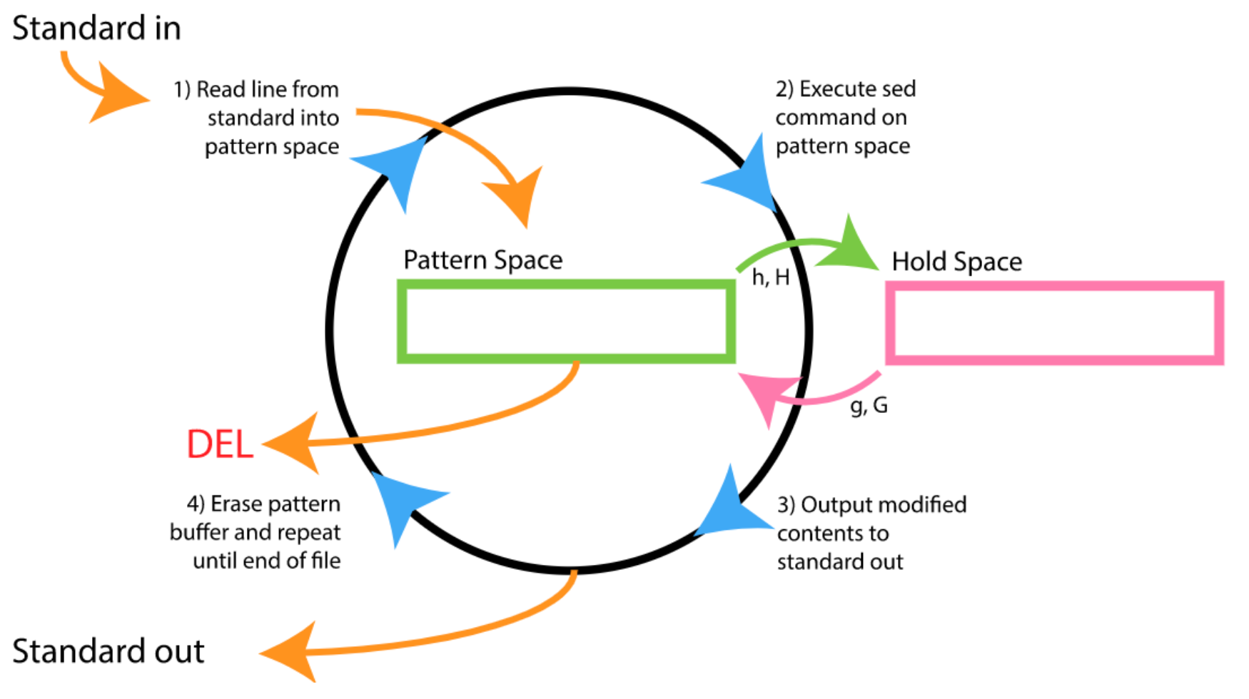

2. Sed Scripting Flow‌
출처 : https://vds-admin.ru/sed-and-awk-101-hacks/chapter-1-sed-syntax-and-basic-commands
Sed scripting follows the easily remembered sequence Read, Execute, Print, Repeat. Use the simple REPR acronym to remember sed execution flow. We look at the steps in this sequence. Sed will:
- Read a line into the pattern space (an internal temporary sed buffer, where it places the line it reads from the input file).
- Execute the sed command on the line in the sed pattern space. If there are more than one sed commands available, either via a sed script, -e options, or { }, it executes all the sed commands one by one in sequence on the line that is currently in the pattern space.
- Print the line from the pattern space. After printing this line, the sed pattern space will be empty.
- Repeat this again until the end of the input file is reached.
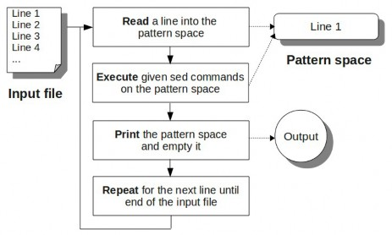

패턴 스페이스 (= 패턴 버퍼)
- sed가 파일을 라인단위로 읽을 때 읽은 라인이 저장되는 임시 공간
- sed 명령어를 통해 내용 조작이나 출력을 수행하면 패턴 버퍼의 내용이 사용됨

홀드 스페이스 (= 홀드 버퍼)
- 패턴 버퍼보다 좀 더 길게 가지고 있는 저장소
- 이전에 작업하던 라인 기억 가능
- 어떤 내용을 홀드 버퍼에 저장하면, sed가 다음 행을 읽더라도 원할 때 다시 불러와 재사용 가능

sed option
- sed -help 또는 man sed 를 입력하여 sed 도움말을 확인할 수 있음
option | 설명
-e | 조건식 스크립트를 직접 지정
-f | 조건식 스크립트가 기재된 파일을 지정
-n | 패턴이 일치하는 라인만 출력
-r/-E | 확장 정규표현을 사용한 스크립트를 사용 (Extended regex)
-i | 수정한 내용으로 파일 덮어쓰기
- 덮어쓰기 전의 파일을 따로 저장 가능
sed -i.bak -e '/^#/d' my.conf

sed subcommand (‘/…./{}’괄호안에 쓰임)
subcommand | 설명
a\ | 현재 행에 하나 이상의 새로운 행 추가
c\ | 현재 행의 내용을 새로운 내용으로 교체
d | 행 삭제
i\ | 현재 행의 위에 텍스트 삽입
h | 패턴 스페이스의 내용을 홀드 스페이스에 복사
H | 패턴 스페이스의 내용을 홀드 스페이스에 추가
g | 홀드 스페이스의 내용을 패턴 스페이스에 덮어쓰기
G | 홀드 스페이스의 내용을 패턴 스페이스에 추가
l | 출력되지 않는 특수문자를 명확하게 출력
p | 행 출력
n | 다음 입력 행을 첫 번째 명령어가 아닌 다음 명령어에서 처리
q | sed 종료
r | 파일로부터 행 읽어오기
! | 선택된 행을 제외한 나머지 전체 행에 명령어 적용
S | 문자열 치환

s와 함께 사용하는 치환 플래그 (‘s/…./’에서 쓰는 flag)
flag | 설명
g | 치환이 행 전체에 대해 이뤄짐
p | 행 출력
w | 파일에 쓰기
x | 홀드 스페이스와 패턴 스페이스의 내용을 서로 맞바꾸기
y | 한 문자를 다른 문자로 변환 (정규표현식 메타문자 사용 불가능)

메타 문자
문자 | 설명
^ | 맨 앞
$ | 맨 뒤
. | 임의의 한 문자
* | 직전의 문자를 0회 이상 반복
+ | 직전의 문자를 1회 이상 반복
\? | 직전의 문자가 0회 혹은 1회만 출현
[ ] | 문자 클래스. [abc0-9]이면 숫자와 a,b,c 중 어떠한 한 문자
| | OR. [ab|ap]이면 ab 혹은 ap
{3} | 직전의 문자가 3번만 출현
{3,5} | 직전의 문자가 3~5번 출현
\b | 단어 구분 (word boundary)

출처 : https://reakwon.tistory.com/164

name phone birth sex score
reakwon 010-1234-1234 1981-01-01 M 100
sim 010-4321-4321 1999-09-09 F 88
nara 010-1010-2020 1993-12-12 M 20
yut 010-2323-2323 1988-10-10 F 59
kim 010-1234-4321 1977-07-17 M 69
nam 010-4321-7890 1996-06-20 M 75
sol 010-5911-1111 1976-10-12 F 60
lee 010-4949-4949 1988-09-30 F 80
feng 010-1111-9999 1979-03-20 M 90

기본적으로 sed는 아래와 같은 형태로 사용합니다.
sed -n -e 'command' [input file]
-n : sed는 pattern buffer의 내용을 자동적으로 출력해주는데, 이 옵션을 사용하게 되면 자동 출력을 하지 않습니다.( don’t print any line by default unless an explicit request to print is found.) -n옵션을 하지 않고 sed명령을 해보시면 눈에 띄게 많은 데이터가 출력되는것을 확인할 수 있습니다. 매우 지저분하지요. 그래서 -n옵션을 붙여 패턴 버퍼의 자동출력을 하지 않습니다. 여러분은 그래서 sed 명령의 기본 형태는 sed -n으로 생각하시면 됩니다.
-e : 이 옵션 다음으로는 우리가 사용할 command를 가지고 텍스트 파일을 가공해줍니다. -e의 command에는 어떤 종류가 있는지 확인해보도록 합시다.
그리고 맨 마지막에는 우리가 가공할 원본 파일을 지정해주면 됩니다.

1. 특정 행을 출력 - p (print)
1-1. 천재 내용을 출력 : 기본적으로 전체의 줄을 출력하려면 command에 /$/p 또는 1,$p로 출력해볼 수 있습니다.
sed -n -e '1,$p' sed_test_file.txt
sed -n -e '/$/p' sed_test_file.txt (/…./ 는 regex의 여기서부터 여기까지가 표현식이다를 알리는 경계선, vim에서는 ‘패턴이 발견된 라인의 다음 다음라인부터’라는 의미가 있다. )
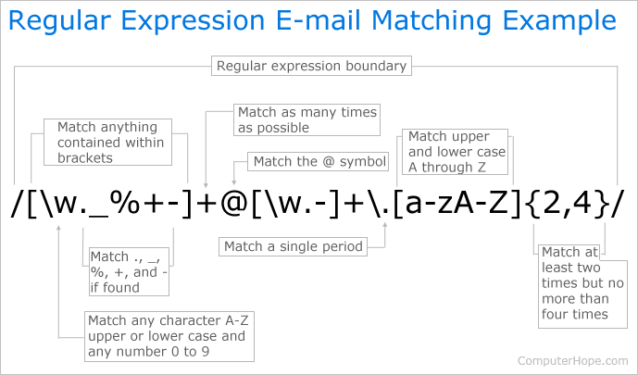
1-2. 첫번째 줄 출력 : 여러분이 첫번째 줄만 출력해주기를 아래의 command를 사용할 수 있습니다.
sed -n -e '1p' ./sed_test_file.txt
name phone birth sex score

끝 p는 print의 p를 의미합니다.
1-3. start ~ end 줄까지 출력 : 그렇다면 첫째줄부터 4번째줄을 출력하기를 원한다면 쉼표로 구분된 출력하길 원하는 줄, 마지막 줄 p 의 형태를 사용하면 됩니다.
sed -n -e '1,4p' sed_test_file.txt
name phone birth sex score
reakwon 010-1234-1234 1981-01-01 M 100
sim 010-4321-4321 1999-09-09 F 88
nara 010-1010-2020 1993-12-12 M 20

1-4. 특정줄에서 마지막 줄까지 출력 : 어떤 줄에서 마지막 줄까지 출력하려면 $문자를 사용하면 됩니다. $는 마지막줄을 의미합니다. 그래서 5번째 줄에서 마지막줄까지 출력하려면 아래와 같은 command를 사용할 수 있습니다.
sed -n -e '7,$p' sed_test_file.txt
nam 010-4321-7890 1996-06-20 M 75
sol 010-5911-1111 1976-10-12 F 60
lee 010-4949-4949 1988-09-30 F 80
feng 010-1111-9999 1979-03-20 M 90
1-5. 다중 command 사용 : 만약 command를 여러개 사용하고 싶다면 -e 옵션을 이용해서 여러개 사용하여 command를 줄 수 있습니다. 만약 1번째 줄을 출력해주고, 8번째 줄부터 끝까지 출력하기를 원한다면 아래의 명령을 사용하면 됩니다.
sed -n -e '1p' -e '8,$p' sed_test_file.txt
name phone birth sex score
sol 010-5911-1111 1976-10-12 F 60
lee 010-4949-4949 1988-09-30 F 80
feng 010-1111-9999 1979-03-20 M 90
1-6. 특정 문자열이 있는 줄 출력
만약 위의 파일에서 여자(F, Female)만 출력한다고 하다면 어떻게 command를 어떻게 사용할까요? 아래와 같은 형식대로 사용하면 됩니다.
/포함된 문자열/p

텍스트 파일에서 우리가 찾을 문자열이 포함된 줄을 출력(p, print)한다고 생각하시면 됩니다. 아래의 명령이 여성만 뽑아내는 command입니다.
sed -n -e '/F/p' sed_test_file.txt

2. 특정 행 삭제 - d (delete)
행삭제에 관한 명령어는 d를 사용하면 됩니다. d를 사용하는 것외에는 위의 줄 출력을 해주는 명령어 형태로 사용하면 됩니다.
2-1. 2~6번째 줄을 삭제하고 나머지 모든 내용을 출력
sed -n -e '2,6d' -e '1,$p' sed_test_file.txt
name phone birth sex score
nam 010-4321-7890 1996-06-20 M 75
sol 010-5911-1111 1976-10-12 F 60
lee 010-4949-4949 1988-09-30 F 80
feng 010-1111-9999 1979-03-20 M 90

3. 단어 치환(Substitute) - s (substitute)
이제부터는 출력결과는 생략하도록 하겠습니다. 특정 단어를 치환하려면 s명령을 이용하면 됩니다. 형식은 아래와 같습니다. s앞에는 범위를 지정해 줄 수도 있다. ( 3,5 s/// 3,+3 s/// 3,$ s///등)
3.1 기본적인 특정 단어 치환
s/old/new/g
s/old/new/gi

단어 s는 substitute(치환)의 약자, 그리고 /로 구분하여 old는 단어를 치환할 문자열, new는 새롭게 치환한 문자열인데 비어있으면 그 문자열을 삭제한 효과를 가질 수 있습니다. g는 global의 약자로 전체에 적용됨을 의미합니다.
두번째의 i는 ignore case의 약자로 old의 단어를 검색할때 대소문자 구분하지 않겠다는 것을 의미합니다.
아래 명령의 결과를 보고 차이점을 확인해보세요.
sed -n -e 's/reakwon/reak/g' -e '2p' sed_test_file.txt
sed -n -e 's/reakwoN/reak/g' -e '2p' sed_test_file.txt
sed -n -e 's/reakwoN/reak/gi' -e '2p' sed_test_file.txt

3.2 특정 단어로 시작 혹은 끝나는 단어를 포함하는 라인의 문자열 치환
특정단어로 시작하는 단어로 문자열을 치환하는 것도 가능합니다. 특정 단어로 시작하는 줄을 선택하려면 앞에 '^'문자를 사용하면 되죠. 사실 정규표현식을 아신다면 앞에 ^가 붙는다면 ^이후에 나오는 문자열로 시작되는 문자열들을 추출한다는 것을 아실겁니다. 사실 몰라도 외워서 아시면 됩니다. 단 많이 실수하시는 부분이 특정 단어로 시작하거나 끝나는 문자열이 아닌 줄(line)입니다.

아래의 파일(let_it_go.txt)에서 Let으로 시작하는 줄의 첫 Let를 LET으로 바꿔보려면 다음 보이는 명령을 사용하면 됩니다.
Let it go, let it go.
Can't hold it back anymore.
Let it go, let it go.
Turn away and slam the door.
I don't care what they're going to say.
Let the storm rage on.
The cold never bothered me anyway.

sed -n -e 's/^let/LET/gi' -e '1,$p' let_it_go.txt

반대로 끝나는 문자열은 끝에 $를 붙여줘서 검색하면 됩니다. Anyway. 으로 끝나는 줄의 Anyway를 대문자로 바꾸려면 아래와 같은 command를 사용하면 됩니다.
sed -n -e 's/anyway.$/ANYWAY/gi' -e '1,$p' let_it_go.txt

4. 문자열 추가 - a, i (append, insert)
문자열을 추가하는 방법에는 두 가지 정도가 존재합니다. 해당 문자열 아래에 추가하느냐(Append) 아니면 이 전 줄에 삽입하느냐(Insert)가 있는데요. 기본적인 형식은 아래의 command처럼 사용합니다.
/찾을 문자열/a\다음 출에 추가할 문자열
/찾을 문자열/i\위에 삽입할 문자열

찾을 문자열 뒤에 추가할 문자열을 위의 형식대로 사용하면 됩니다. 위의 let_it_go.txt파일에서 bye로 끝나는 줄 다음에 end라는 줄을 넣고 싶다면 이렇게 사용하면 됩니다. 반대로 위에 추가하려면 a를 i로 바꾸면 되겠죠.

sed -n -e '/bye/a\end' -e '1,$p' let_it_go.txt

5. 특정 행의 내용을 전부 교체 - c (change)
c command를 이용해서 행의 내용을 바꿀 수 있습니다. command 형태는 이렇습니다.
/바꿀 행이 포함한 문자열/c\바꿀 행의 내용

예를 들어 Let으로 시작하는 줄의 내용을 바꾸고 싶다면 어떻게 할까요? 우선 ^를 사용하여 Let으로 시작하는 줄들을 찾고 c 커맨드로 바꿔질 줄 내용을 입력해주시면 됩니다.
sed -n -e '/^Let/c\Let it go X2' -e '1,$p' let_it_go.txt

6. 특정 행에 파일의 내용을 추가 - r (read)
혹은 파일의 내용을 줄에다가 추가할 수도 있습니다. 여기 우리가 내용을 추가할 파일이 존재합니다.

perfect.txt
PERFECT! EXCELLENT!

100으로 끝나는 줄에 저 텍스트 파일의 내용을 아랫줄에 첨가하려면 아래와 같은 명령을 사용하면 됩니다.
sed -n -e '/100$/r perfect.txt' -e '1,$p' sed_test_file.txt
name phone birth sex score
reakwon 010-1234-1234 1981-01-01 M 100
PERFECT! EXCELLENT!
sim 010-4321-4321 1999-09-09 F 88
nara 010-1010-2020 1993-12-12 M 20
yut 010-2323-2323 1988-10-10 F 59
kim 010-1234-4321 1977-07-17 M 69
nam 010-4321-7890 1996-06-20 M 75
sol 010-5911-1111 1976-10-12 F 60
lee 010-4949-4949 1988-09-30 F 80
feng 010-1111-9999 1979-03-20 M 90

이상으로 sed에 대한 기본 개념과 사용방법, 그리고 예제를 살펴보았습니다. 여러분이 정규표현식을 사용하여 깊게 사용할 수도 있지만, 저는 정규표현식을 거의 사용할 일이 없으니 여기까지 하도록 하겠습니다. 이정도만 알아도 sed 명령을 사용하는 것에는 불편함이 없을 겁니다.

Sed Hold and Pattern Space Commands
출처: https://vds-admin.ru/sed-and-awk-101-hacks/chapter-6-sed-hold-and-pattern-space-commands
Sed has two types of internal storage space:
- Pattern space: You already know about pattern space, which is used as part of the typical sed execution flow. Pattern space is the internal sed buffer where sed places, and modifies, the line it reads from the input file.
- Hold space: This is an additional buffer available where sed can hold temporary data. Sed allows you to move data back and forth between pattern space and hold space, but you cannot execute the typical sed commands on the hold space. As we already discussed, pattern space gets deleted at the end of every cycle in a typical sed execution flow. However, the content of the hold space will is retained from one cycle to the next; it is not deleted between cycles.
Please create a new text file to be used for the sed hold space examples:
$ vi empnametitle.txt
John Doe
CEO
Jason Smith
IT Manager
Raj Reddy
Sysadmin
Anand Ram
Developer
Jane Miller
Sales Manager
As you can see, for each employee this file contains name and title on two consecutive lines.

41. Swap Pattern Space with Hold Space (x command)
The sed Exchange (x) command swaps pattern space with hold space. This command in itself is not that helpful, unless it is combined with other sed commands; however, in conjunction with other commands, it is quite powerful. Suppose that pattern space contains "line 1" and hold space contains "line 2". After the x command is executed, pattern space will have "line 2", and hold space will have "line 1". The following example prints the names of the managers. It looks for the keyword 'Manager' and prints the previous line. Print manager names from empnametitle.txt:
$ sed -n -e 'x;n' -e '/Manager/{x;p}' empnametitle.txt
Jason Smith ( x : 각 space의 물리적 위치가 아니라 저장되는 값이 바뀐다는 의미. )
Jane Miller
In the above example:
- {x;n} - x swaps pattern space to the hold space; n reads the next line into the pattern space. So, this command saves the current line in hold space and reads the next line into pattern space. For the example file, it is saving employee name to hold space and fetching employee title into pattern space.
- Manager/{x;p} - If the content of the pattern space contains the keyword 'Manager', this command swaps pattern space with hold space and then prints pattern space. This means that if the employee title contains 'Manager' the employee name will be printed.
You can also save this in a sed script file and execute it as shown below.
$ vi x.sed
#!/bin/sed -nf
x;n
/Manager/{x;p}

$ chmod u+x x.sed

$ ./x.sed empnametitle.txt
Jason Smith
Jane Miller

42. Copy Pattern Space to Hold Space (h command)
The hold command (h) copies pattern space to hold space. Unlike the x command, the h command does not change the content of pattern space. The previous content of the hold space is overwritten with the content from the pattern space. Suppose pattern space contains "line 1" and hold space contains "line 2"; after the h command is executed, pattern space is not changed and will still have "line 1", but hold space will also have "line 1". Print the names of the managers:
$ sed -n -e '/Manager/!h' -e '/Manager/{x;p}'
empnametitle.txt
Jason Smith
Jane Miller
The above command should be executed in a single line as shown below.
sed -n -e '/Manager/!h' -e '/Manager/{x;p}' empnametitle.txt
In the above example: /Manager/!h - If the content of the pattern space doesn't contain Manager (the ! after the pattern means "not equal to" the pattern), copy the content of the pattern space to the hold space. (In this case, this might be employee name (or) a title that is not "Manager".) Note that, unlike the previous example, this one does not use the 'n' command to get the next line; instead, the next line is fetched via normal execution flow. /Manager/{x;p} - If the content of the pattern space contains the keyword 'Manager', this command swaps pattern space with hold space and prints. This is identical to the command we used for printing in the example for the x command. You can also save this in a sed script file and execute it as shown below.
$ vi h.sed
#!/bin/sed -nf
/Manager/!h
/Manager/{x;p}
$ chmod u+x empnametitle.txt
$ ./h.sed empnametitle.txt
Jason Smith
Jane Miller

43. Append Pattern Space to Hold Space (H command)
Capital H is the command to append pattern space to hold space with a new line. The previous content of hold space is not overwritten; instead the content of pattern space is appended to the existing content of hold space by adding a new line at the end. Suppose pattern space contains "line 1" and hold space contains "line 2"; after the H command is executed, pattern space is not changed and will still have "line 1", but hold space will have "line 2\nline 1". Print the name and title (in separate lines) of the managers:
$ sed -n -e '/Manager/!h' -e '/Manager/{H;x;p}'
empnametitle.txt
Jason Smith
IT Manager
Jane Miller
Sales Manager
The above command should be executed in a single line as shown below.
sed -n -e '/Manager/!h' -e '/Manager/{H;x;p}' empnametitle.txt
In the above example:
- /Manager/!h - If the content of the pattern space doesn't contain Manager (the ! after the pattern means "not equal to" the pattern), copy the content of the pattern space to the hold space. (In this case, this might employee name (or) a title that is not "Manager".) This is the same command we used in the h command example.
- /Manager/{H;x;p} - If the content of the pattern space contains the keyword 'Manager', the H command appends pattern space (which is Manager) to hold space with a new line. So, the hold space at this stage will have "Employee Name\nTitle" (which contains the keyword manager). The x command swaps hold space back into pattern space, and p prints the pattern space.
You can also save this in a sed script file and execute it as shown below.
$ vi H-upper.sed
#!/bin/sed -nf
/Manager/!h
/Manager/{H;x;p}
$ chmod u+x H-upper.sed
$ ./H-upper.sed empnametitle.txt
Jason Smith
IT Manager
Jane Miller
Sales Manager
The above example can be slightly modified, if you want the employee name and title to be printed on the same line with colon : as a delimiter:
$ sed -n -e '/Manager/!h' -e '/Manager/{H;x;s/\n/:/;p}' empnametitle.txt
Jason Smith:IT Manager
Jane Miller:Sales Manager
The above command should be executed in a single line as shown below.
sed -n -e '/Manager/!h' -e '/Manager/{H;x;s/\n/:/;p}' empnametitle.txt
In the second example everything is same as the previous example except for the substitute command added to the 2nd -e option. The H, x, and p commands do the same thing as before; the s command replaces \n with : after swapping but before printing. Therefore the name and title are printed on one line, separated by a colon. You can also save this in a sed script file and execute it as shown below.
$ vi H1-upper.sed
#!/bin/sed -nf
/Manager/!h
/Manager/{H;x;s/\n/:/;p}
$ chmod u+x H1-upper.sed
$ ./H1-upper.sed empnametitle.txt
Jason Smith:IT Manager
Jane Miller:Sales Manager

44. Copy Hold Space to Pattern Space (g command)
The sed get (g) command copies the content of hold space to pattern space. Think of it this way: h command "holds" it in the hold space, g command "gets" it from the hold space. Suppose pattern space contains "line 1" and hold space contains "line 2"; after the g command is executed, pattern space is changed and now contains "line 2", while hold space is not changed and still contains "line 2". Print the names of the managers:
$ sed -n -e '/Manager/!h' -e '/Manager/{g;p}'
empnametitle.txt
Jason Smith
Jane Miller
The above command should be executed in a single line as shown below.
sed -n -e '/Manager/!h' -e '/Manager/{g;p}' empnametitle.txt
In the above example: /Manager/!h – we've been using this one for the last few examples. If the content of the pattern space doesn't contain Manager, copy the content of pattern space to hold space. /Manager/{g;p} – g gets the line from hold space and puts it in pattern space, then prints it. You can also save this in a sed script file and execute it as shown below.
$ vi g.sed
#!/bin/sed -nf
/Manager/!h
/Manager/{g;p}

$ chmod u+x g.sed

$ ./g.sed empnametitle.txt
Jason Smith
Jane Miller

45. Append Hold Space to Pattern Space (G command)
Upper case G appends the content of hold space to pattern space with a new line. The previous content in the pattern space is not overwritten; instead the content from hold space is appended to the existing content in pattern space by adding a new line at the end. G and g are related in the same way as H and h; the lower case version replaces the content while the upper case one appends to it. Suppose pattern space contains "line 1" and hold space contains "line 2"; after the G command is executed, pattern space is changed to contain "line 1\nline 2" while hold space is not changed and still contains "line 2". Prints the employee name and title of the managers separated by colon.
$ sed -n -e '/Manager/!h' -e '/Manager/{x;G;s/\n/:/;p}' H의 경우 {H;x;s/\n/:/;p}.순서가 다름.
empnametitle.txt {G;x;s/\n/:/;p}를 하면 이름만 출력됨. x때문에‘
Jason Smith:IT Manager ‘직급:이름’이 hold space로 가버리고 hold space에 Miller:Sales Manager 있던 이름이 pattern space로 내려온다.

The above command should be executed in a single line as shown below.
sed -n -e '/Manager/!h' -e '/Manager/{x;G;s/\n/:/;p}' empnametitle.txt
In the above example:
- /Manager/!h – As in previous examples, if the content of pattern space doesn't contain Manager, copy pattern space to hold space.
- /Manager/{x;G;s/\n/:/;p} - If the content of the pattern space contains Manager, do the following:
  - x - Swap the content of pattern space with hold space. So, the employee name stored in hold space will now be in pattern space, while the title will be in hold space.
  - G - Appends the content of hold space (title) to pattern space (employee name). So, the pattern space at this stage will have "Employee Name\nTitle"
  - s/\n/:/ This replaces the \n that separates the "Employee Name\nTitle" with a colon :
  - p prints the result (i.e. the content of pattern space).
  - Note that if we left out the x command, i.e. if we used /Manager/{G;s/\n/:/;p}, we would print the title:name instead of name:title for each manager.
You can also save this in a sed script file and execute it as shown below.
$ vi G-upper.sed
#!/bin/sed -nf
/Manager/!h
/Manager/{x;G;s/\n/:/;p}

$ chmod u+x G-upper.sed

$ ./G-upper.sed empnametitle.txt
Jason Smith:IT Manager
Jane Miller:Sales Manager

정규표현식 Lookahead, Lookbehind 기능 이해하기

출처: https://elvanov.com/2388

개요
Lookahead, Lookbehind 기능은 다소 고급 문법에 속합니다. 자 일단 선 요약하면 다음과 같습니다.
패턴 | 타입 | matches
X(?=Y) | Positive lookahead | X if followed by Y
X(?!Y) | Negative lookahead | X if not followed by Y
(?<=Y)X | Positive lookbehind | X if after Y
(?<!Y)X | Negative lookbehind | X if not after Y

이러한 기능을 모아서 Lookaround 라고 합니다. 본 기능이 동작하는 방식은, 이해하기 쉽게 설명을 하자면, 본래 패턴에 맞는 곳을 우선 찾고, 그 다음 추가적으로 해당 Lookaround 의 조건이 맞는지 아닌지를 체크합니다. 그 다음 Positive 이냐, Negative 이냐에 따라서 결과를 포함시키거나 제외시킵니다. Positive 는 조건 Y 가 만족한다면 매칭 결과에 그대로 포함시킨다는 것입니다. 즉 조건 Y가 충족하지 않는다면 매칭 결과에 포함이 되지 않겠죠. Negative 는 조건 Y 가 만족한다면 매칭 결과에서 제외시킵니다. 즉 조건 Y가 충족하지 않는다면 매칭 결과에 포함이 될 것입니다. Positive 와 Negative 는 정 반대로 동작합니다.
Lookahead와 Lookbehind 의 차이점은 간단합니다. Lookahead 는 꼬리말(suffix)을 확인하는 용도이고, Lookbehind는 머리말(prefix)를 확인하는 용도입니다. 말이 약간 거꾸로 되어 있지요? 실제 문법 상으로는 <가 포함되어 있냐 그렇지 않냐로 구분할 수 있습니다. < 방향이 왼쪽이니까 앞쪽이라고 기억하고 있으면 될 것 같습니다.
일반적으로는 간단히 결과를 제외시키고 싶을 때 Negative Lookaround 로 하여 많이 사용합니다. (참고, 스택 오버플로우)
한 가지 특징으로는, Lookaround 기능은 그 결과가 소모되지 않습니다. 즉 조건이 겹칠 필요가 있을 때 유용하게 사용될 수 있다는 것입니다. 이는 예제를 보면서 한번 같이 확인해보도록 합시다.

Lookbehind의 경우 언어마다 지원 범위가 다를 수 있습니다.
(출처 : https://maxkangdev.tistory.com/29 )
다양한 언어 (java, javascript, pcre)가 regex를 지원합니다. 그렇기 때문에, 언어마다 사용법이 조금씩 다를 수 있습니다.
대표적인 예가 바로 Lookbehind 입니다.
Java 의 경우 Lookbehind 의 길이제한을 두지 않지만, PCRE 이 의 경우 Lookbehind 사용시 길이가 고정 되어야 합니다.

결과가 소모되지 않는 예제

아래 두 개의 이미지 결과 차이로 확인할 수 있습니다. 첫번째 예제는 (?<=마마마) 를 A 로 바꾸는 예제입니다. 여기서 놀라운 점은 결과로 아무것도 잡히지 않는다는 것입니다. 결과로는 오로지 해당 위치를 가리키는 정보만 있을 뿐이지 (마마마가 연속해서 등장하는 바로 뒤자리) 실제로 찾는 값은 없습니다. 없는
걸치환하니까, 결국엔 새롭게 A가 생깁니다.
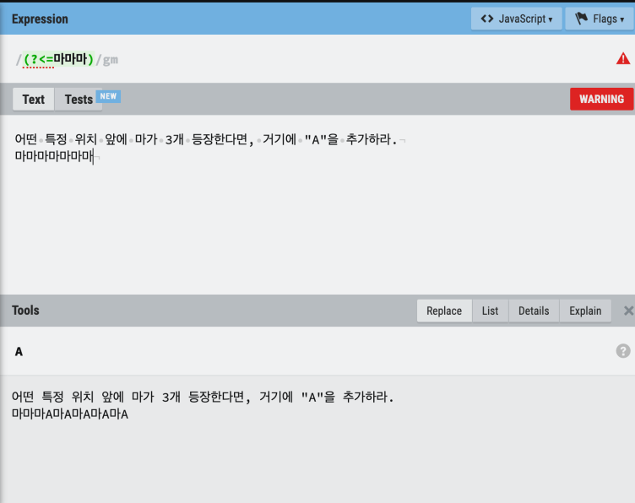

반면 마마마를 통째로 찾고 마마마A로 바꾼다면 우선 마마마가 소모됩니다. 마마마가 사라지고 대신에 마마마A가 등장하니까, 이미 결과에 포함된 마는 찾지 못합니다. 아래 이미지를 참고해주세요.

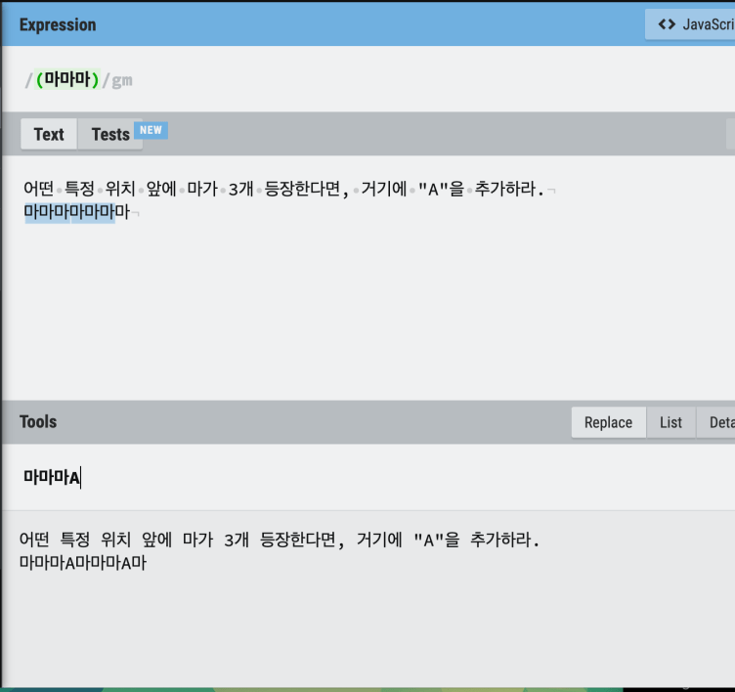

숫자를 comma 로 포맷팅하는 예제

조금 더 복잡한 예제를 확인해봅시다. 만약 큰 숫자를 콤마로 포맷팅하고 싶다고 가정합시다. 예를 들어 1234567을 1,234,567로 만들고 싶습니다. 아이디어를 말로 설명하면 간단합니다. 각각의 숫자에 대해 그 위치가 끝에서 3n+1 에 위치하는 숫자를 뽑아내어 그 숫자 뒤에 ,를 붙이는 것이죠. 즉 1과 4 를 뽑아내면 됩니다! 그럴려면 아래와 같이 하면 됩니다.
(\d)(?=(\d{3})+(?!\d))
무슨 뜻인지 봅시다. \d는 숫자를 의미합니다. [0-9]와 의미가 똑같습니다.
- 우선 (\d) 로 숫자 하나를 잡습니다. 우선 모든 숫자에 대응이 됩니다.
- 이제 조건을 봅시다. 바로 뒤에 따라오는 커다란 (?= 묶음이 보이시죠? 저거는 Positive lookahead 에 의미하고, 추후 결과에서 제외됩니다.
- (\d{3})+ 는 숫자 3개 묶음이 1개 이상 나와야 한다는 의미입니다. 이제 1234 가 결과에 포함이 되었습니다.
- 뒤에서 딱 나누어 떨어지는지를 체크하기 위해 (?!\d) 로 가장 뒤에 숫자가 없는 경우에만 결과에 포함되도록 제한했습니다. 이제 1, 4 가 결과에 포함되었습니다.
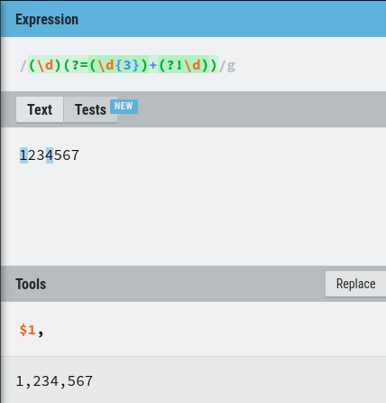
가장 위의 (\d)(?=(\d{3})+(?!\d)) 가 정규식이고, 우리가 테스트하고자 하는 텍스트는 1234567이며, 이 텍스트에 대해서 $1, 로 치환하겠다는 뜻입니다. $1이란 첫 번째 그룹을 의미하므로 위 정규식에서 (/d)에 해당합니다. 그렇게 되면 결과가 1,234,567이 되었다는 것을 확인할 수 있습니다. 어떤가요?!

Bash: grep with LookBehind and LookAhead to isolate desired text
출처: https://fabianlee.org/2021/01/09/bash-grep-with-lookbehind-and-lookahead-to-isolate-desired-text/
grep has support for Perl compatible regular expressions (PCRE) by using the -P flag, and this provides a number of useful features. In this article, I’ll show how LookBehind and LookAhead regular expression support can provide enhanced parsing abilities to your shell scripts.
For example, consider an xml file “test.xml” with the contents:
<root>
<path>/my/data</path>
<paths>/global/data</paths>
</root>
Using the -E extended regular expression flag you could attempt to isolate the <path> value.
# returns the entire line
$ grep -Eo "<path>(.*)</path>" test.xml
<path>/my/data</path>

# a bit smarter, by taking characters until '<' reached
# but still leaves us with prefixed tag
$ grep -Eo "<path>[^ <]*" test.xml
<path>/my/data
From this imperfect parse, you might use some combination of sed/awk/cut to get to your ultimate atomic value. But even easier would be using a LookBehind that does not capture the starting tag at all.
# use non-captured LookBehind to isolate value
$ grep -Po "(?<=path\>)[^<]+" test.xml
/my/data
The “?<=” signals a non-captured LookBehind group. This works perfectly for static length strings, but if your prefix string can have variable length, then continue reading about “\K” below.

Limitation of LookBehind
A drawback of LookBehind is that it requires a static length string, for example if we wanted to accommodate “<path>” as well as “<paths>”, it would be tempting to believe we could add “s?” to the end of the tag name.
# fails because LookBehind requires static string length
$ grep -Po "(?<=paths?\>)[^<]+" test.xml
grep: lookbehind assertion is not fixed length
In these situations, you can use “\K” inside the regex, which resets the capture text.
# use \K to reset capture group for variable length LookBehind
# notice we have now brought back both values from xml
$ grep -Po "<paths?\>\K[^<]+" test.xml
/my/data
/global/data

# another example of using \K
# pulling out just domain name from either http|https site
$ echo "https://www.google.com/?q=foo" | grep -Po 'https?://\K([^ /?\"])*'
www.google.com

LookAhead
LookAhead also allows you to remove part of the matching text from a capture group by specifying a “?=” in front of the capture group. Consider an example where we do need the final child path to end with “/data”, but are only interested in pulling back the base directory.
# the value must end with "/data" to match,
# but we only want the base directory location output
$ grep -Po "<paths?\>\K[^<]+(?=/data)" test.xml
/my
/global
LookAhead can accommodate variable length non-capture groups (unlike LookBehind).

REFERENCES
rexegg.com, LookAhead and LookBehind
regular-expression.mobi, lookbehind and \K
octoparse.com, regex to match html tags
github.com/fabianlee, bash script examples of LookBehind
NOTES
match html tags using capture group.
$ grep -P '<(\S*?)[^>]*>(.*)?</\1>' test.xml
<path>/my/data</path>
grep -P does not support output of any capture group but first, but pcregrep can do it
$ sudo apt-get install pcregrep -y
$ pcregrep -o2 '<(\S*?)[^>]*>(.*)?</\1>' test.xml
/my/data
You can use brute force LookBehind if you need variable length LookBehind, but does not seem worth it when \K does a better job
grep -Po "(?:(?<=http://)|(?<=https://))([^ /?\"])*" greptest.txt


bash에도 lookahead lookbehind가 있나?
Bash는 정규 표현식에 직접적으로 lookahead(전방탐색) 또는 lookbehind(후방탐색)을 지원하지 않습니다. Bash의 내장 정규 표현식은 기본적인 것들을 지원하며, Perl과 같은 다른 언어에서 지원하는 고급 기능은 제공하지 않습니다.
그러나 일부 경우에는 정규 표현식이 아니라 다른 방법을 사용하여 lookahead 또는 lookbehind와 유사한 작업을 수행할 수 있습니다. 예를 들어, 문자열에서 패턴을 찾고 그 패턴 앞이나 뒤의 내용을 추출하려면 다음과 같이 할 수 있습니다.
bash
string="This is a sample string"
pattern="sample"

# Lookahead (앞의 내용 추출)
if [[ $string =~ $pattern(.*) ]]; then
echo "Lookahead: ${BASH_REMATCH[1]}"
fi

# Lookbehind (뒤의 내용 추출)
if [[ $string =~ (.*)$pattern ]]; then
echo "Lookbehind: ${BASH_REMATCH[1]}"
fi
위의 예제에서는 정규 표현식 대신에 변수 확장 및 문자열 조작을 사용하여 lookahead 및 lookbehind와 유사한 결과를 얻습니다. 주의해야 할 점은 이러한 방식이 정규 표현식보다 덜 강력하고 융통성이 떨어질 수 있다는 것입니다. 정교한 패턴 매칭이 필요한 경우 다른 언어 또는 도구를 사용하는 것이 더 좋을 수 있습니다.

산술 연산자
Operator | Description | Example
+ (Addition) | 덧셈 | expr $a + $b
- (Subtraction) | 뺄셈 | expr $a - $b
- (Subtraction) | 곱셈 | expr $a \* $b
/ (Division) | 나누기 | expr $b / $a
% (Modulus) | 나머지 반환 | expr $b % $a
= (Assignment) | 값 할당 | a = $b
== (Equality) | 비교 | [ $a == $b ]
!= (Not Equality) | 비교 | [ $a != $b ]

관계 연산자
bash는 숫자 값과 관련된 관계 연산을 제공하며, 문자열은 제공되지 않는다.
Operator | Description | Example
-eq | 두 피연산자의 값이 동일한 여부를 확인하여 같으면 참을 반환한다. | [ $a -eq $b ]
-ne | 두 피연산자의 값이 동일한지 여부를 확인하여 같지 않으면 참을 반환한다. | [ $a -ne $b ]
-gt | 왼쪽 피연산자의 값이 오른쪽 피연산자의 값보다 큰지 확인하고, 그렇다면 조건이 참이된다. | [ $a -gt $b ]
-lt | 왼쪽 피연산자의 값이 오른쪽 피연산자의 값보다 작은 지 확인하고, 그렇다면 조건이 참이된다. | [ $a -lt $b ]
-ge | 왼쪽 피연산자의 값이 오른쪽 피연산자의 값보다 크거나 같은지 확인하고, 그렇다면 조건이 참이된다. | [ $a -ge $b ]
-le | 왼쪽 피연산자의 값이 오른쪽 피연산자의 값보다 작거나 같은지 확인하고, 그렇다면 조건이 참이된다. | [ $a -le $b ]

Boolean 연산자
a가 10이고 b가 20으로 가정한다.
Operator | Description | Example
! | 논리 부정 | [ ! false ] is true.
-o | OR 연산자 | [ $a -lt 20 -o $b -gt 100 ] is true.
-a | AND 연산자 | [ $a -lt 20 -a $b -gt 100 ] is false.

문자열 연산자
bash에서 문자열 연산을 위해서는 다음과 같은 명령을 수행해야 한다.
변수 a에는 "abc"가 있고 변수 b에는 "efg"가 있다고 가정한다.
Operator | Description | Example
= | 두 피연산자의 값을 확인하고 같다면 참이다. | [ $a = $b ]
!= | 두 피연산자의 값을 확인하고 같지 않으면 참이다. | [ $a != $b ]
-z | 주어진 문자열 피연산자의 길이가 0이면 참이다. | [ -z $a ]
-n | 주어진 문자열 피연사자의 0이 아니면 참이다. | [ -n $a ]
str | 빈 문자열인지를 확인하고 비어있으면 거짓을 반한한다. | [ $a ]

파일 테스트 연산자
파일과 관련된 속성을 테스트 히는데 확인하는 연산자이다. 파일의 이름이 이름은 test이고 크기가 100Byte, R/W/X 권한이 있다고 가정한다.
Operator | Description | Example
-b file | 파일이 블록 파일인지 확인한다. (블록 디바이스 등) | [ -b $file ]
-c file | 파일이 문자 파일인지 확인한다. (키보드, 모뎀, 사운드 카드 등) | [ -c $file ]
-d file | 파일이 디렉터리인지 확인한다. | [ -d $file ]
-f file | 파일이 디렉터리나 일반파일인지 확인한다. (장치 파일이 아님) | [ -f $file ]
-g file | 파일에 SGID (Set Group ID)가 설정되어 있는지 확인한다. | [ -g $file ]
-k file | 파일에 고정 비트가 설정되어 있는지 확인한다. | [ -k $file ]
-p file | 파일이 명명 파이프인지 확인한다. | [ -p $file ]
-t file | 파일 설명자가 있고 터미널과 연결되어 있는지 확인한다. | [ -t $file ]
-u file | 파일에 SUID (Set User ID) 비트가 설정되어 있는지 확인한다. | [ -u $file ]
-r file | 파일을 읽을 수 있는지 확인한다. | [ -r $file ]
-w file | 파일 쓰기가 가능한지 확인한다. | [ -w $file ]
-x file | 파일 실행이 가능한지 확인한다. | [ -x $file ]
-s file | 파일의 크기가 0보다 큰지 확인한다. | [ -s $file ]
-e file | 파일이 존재하는지 확인한다. | [ -e $file ]

출처 : https://www.youtube.com/watch?v=BJ0uHhBkzOQ
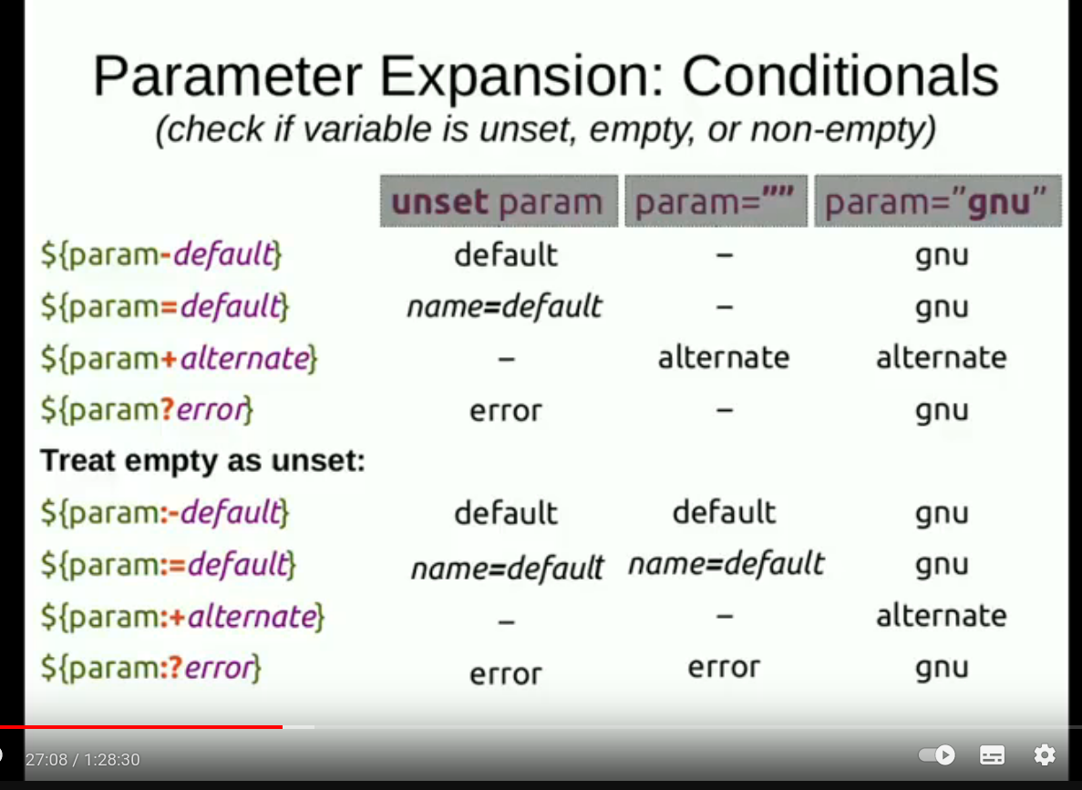

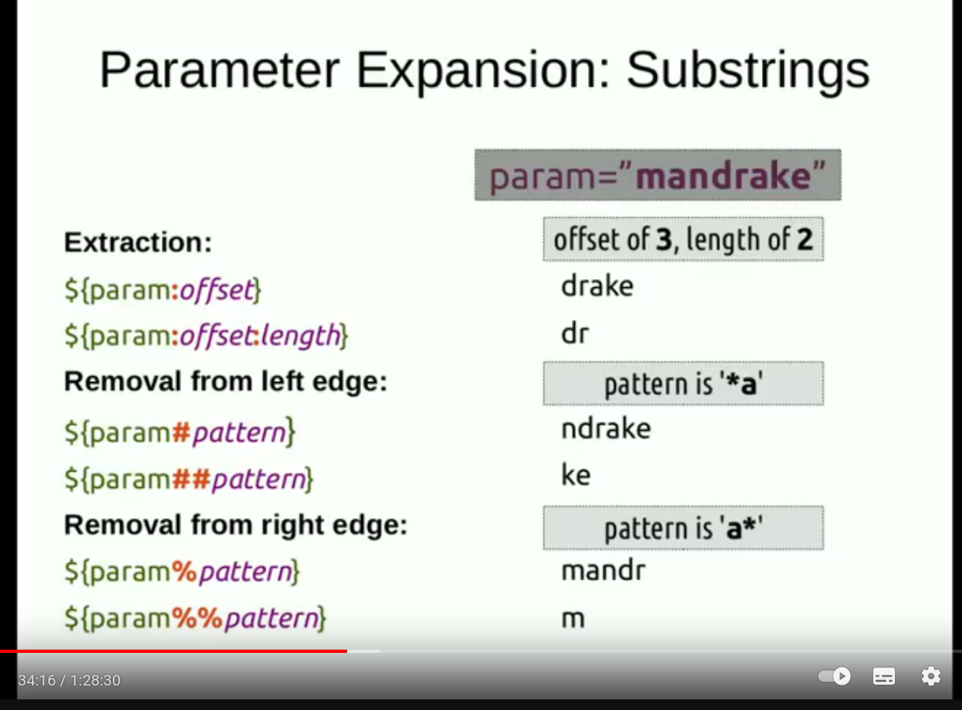

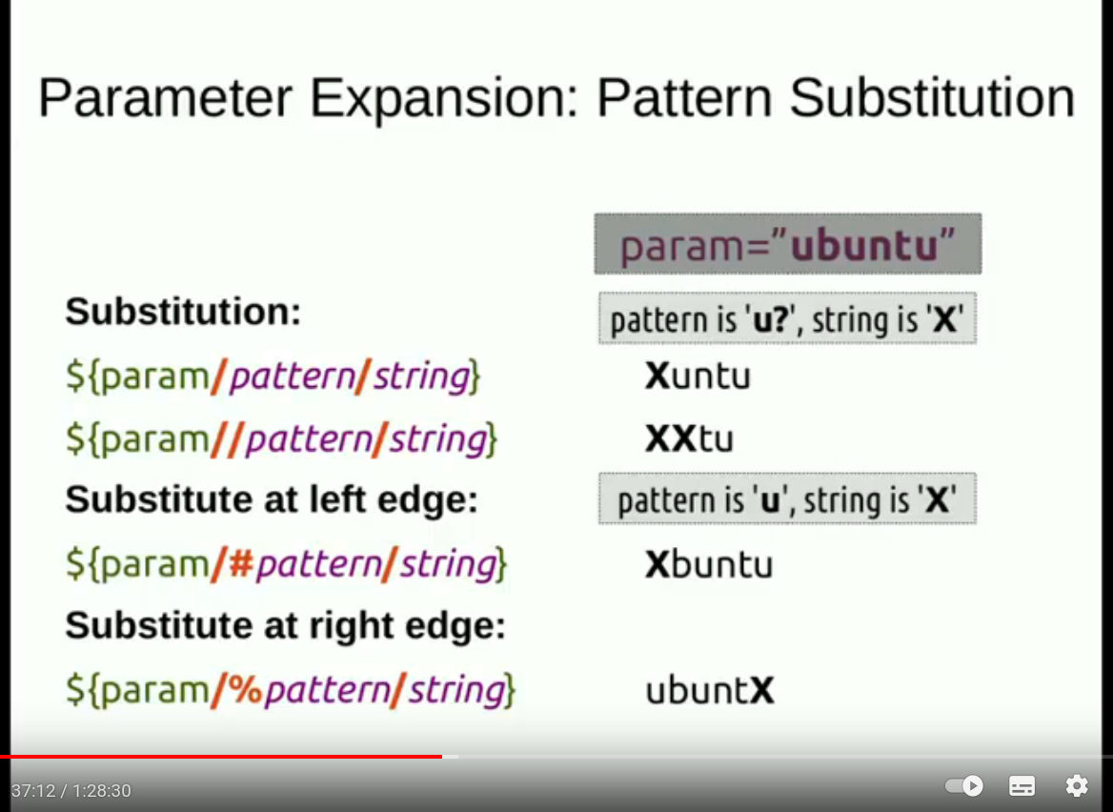

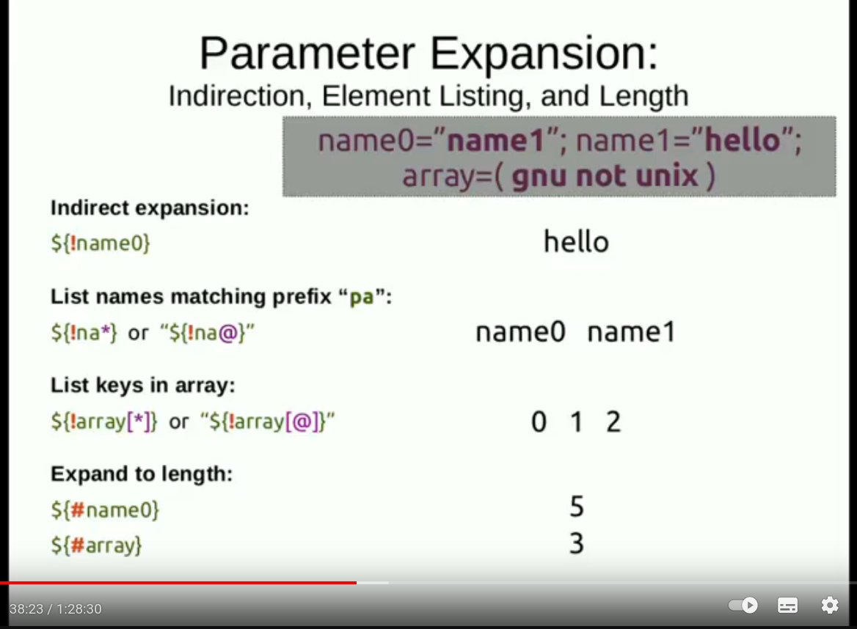

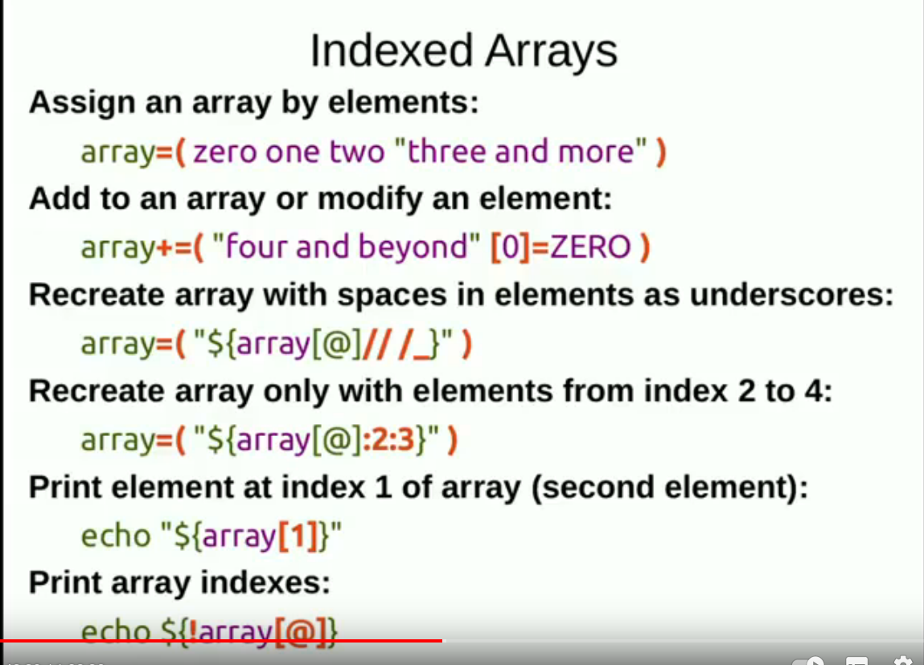

#!/bin/bash #출처: https://www.baeldung.com/linux/moving-files-showing-progress

# Safety check
[ "$#" -eq 0 ] && "No input files" && exit 1

rsync -aP --remove-source-files "$@" && rm -rf "${@:1:$#-1}"
${@:1:$#-1} : slicing array 라고 하는데 위 예제에서는 rm 명령어가 아규먼트를 하나씩 줄이고 있어서 배열들이 알아서 줄어들게된다.
while [[ $# -gt 0 ]] do # $0은 명령어이므로 제외해야한다.
Array=("${@:1:$#}") # 여기서 ${@}는 모든 위치파라미터(명령줄의 아규먼트들).
echo "${array[@]}" # substrings가 아니라 array이며 array slicing이라고한다
#(($#-1)) # 이 예문의 경우 아규먼트를 자동으로 들어낼 명령어가 없기때문에
shift # 배열이 계속 유지가 되버리고, $#-1을 하더라도 $#이 줄어들지 않아서
done # 무한루프를 돌게된다. 강제로 아규먼트를 들어내는 shift를 사용해야함.
Arr=(10 20 hello 30)처럼 일반적으로 배열을 만들면 인덱스에 별 신경 안써도 되지만,
윗 칸의 예처럼 명령줄에서 인자를 받아서 처리하는 경우는 $0은 명령어이고, 마지막 인자의 경우는
대상이 되는 폴더인 경우도 있기때문에 주의해야한다.

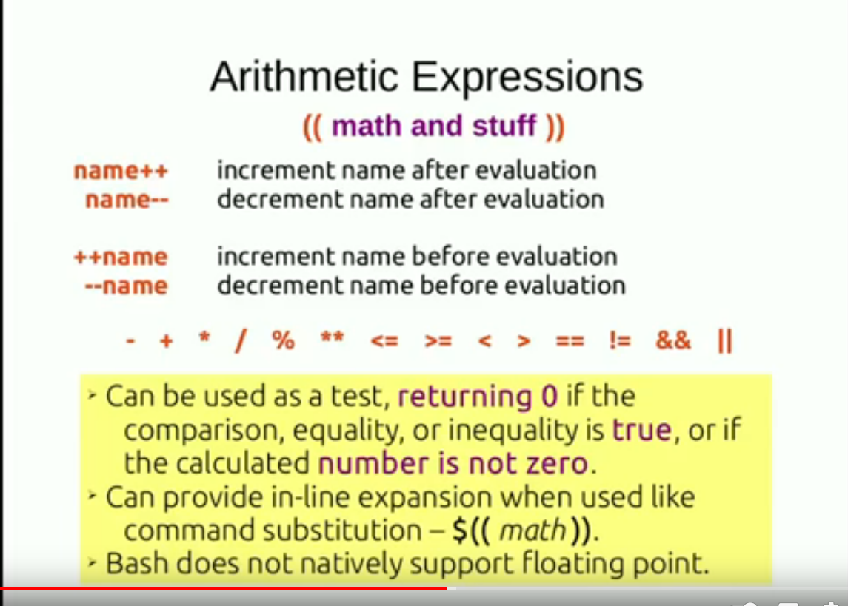

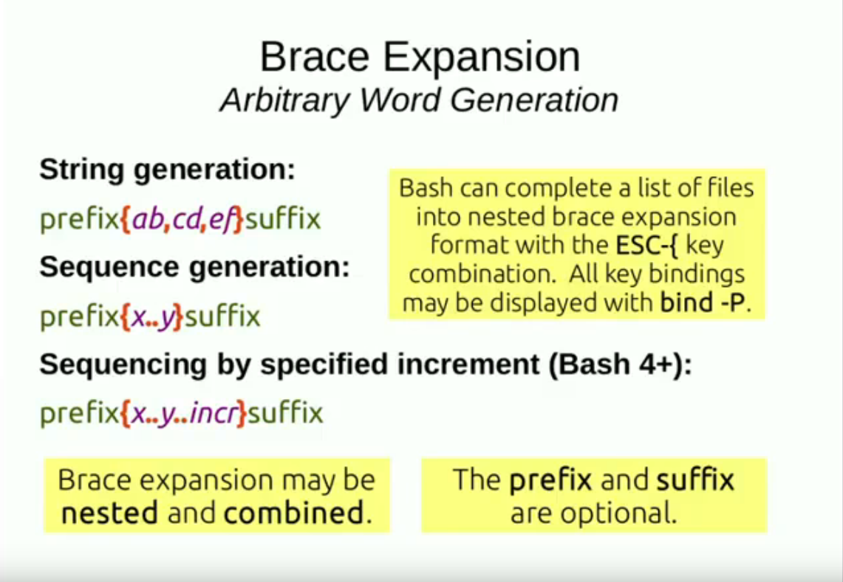

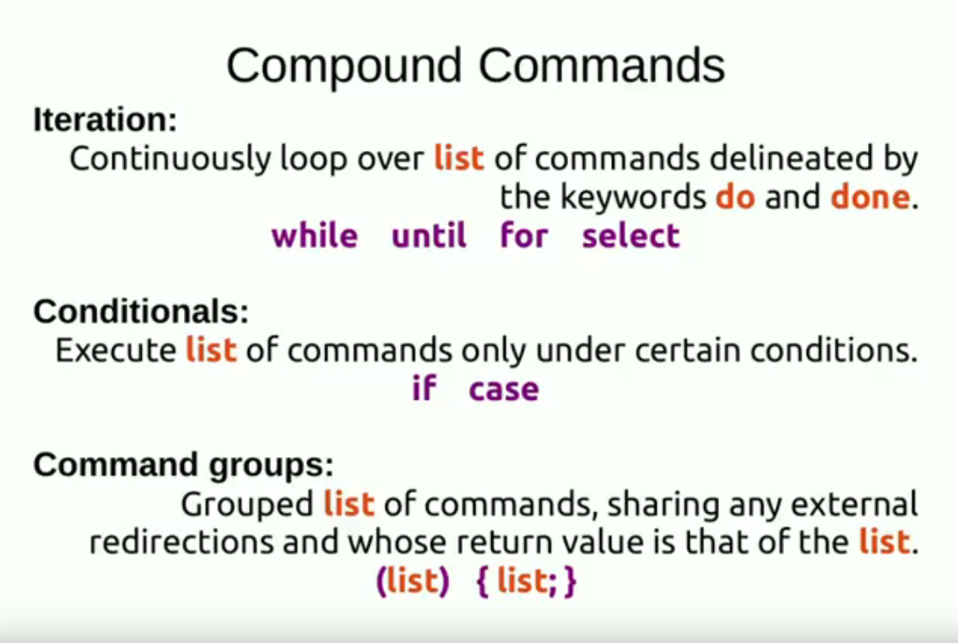

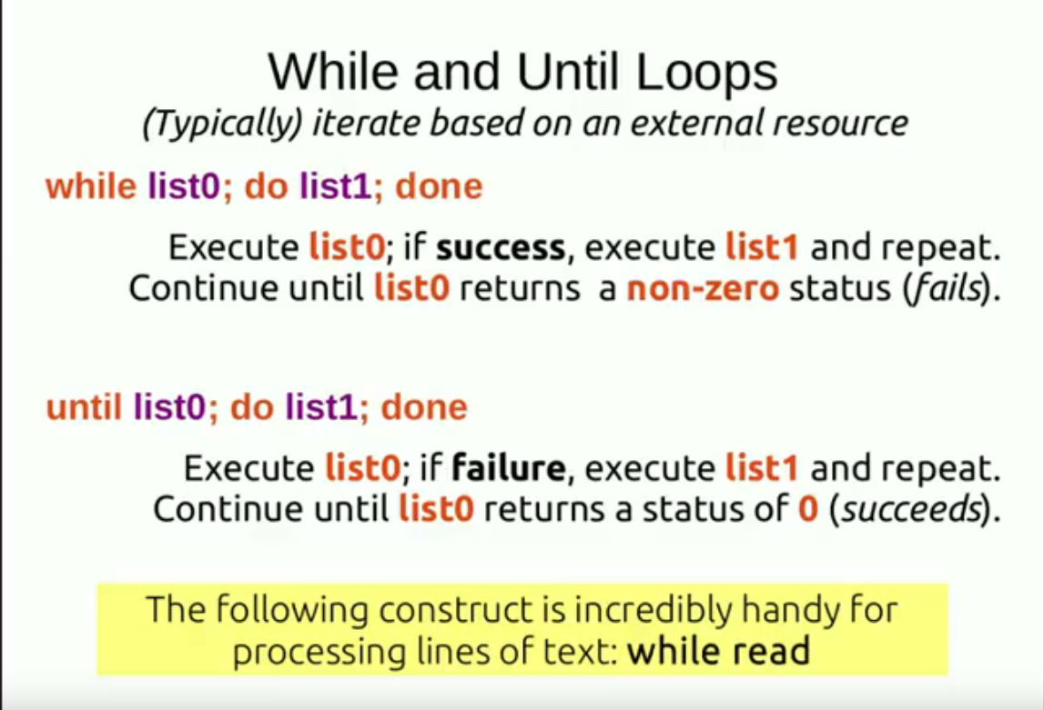

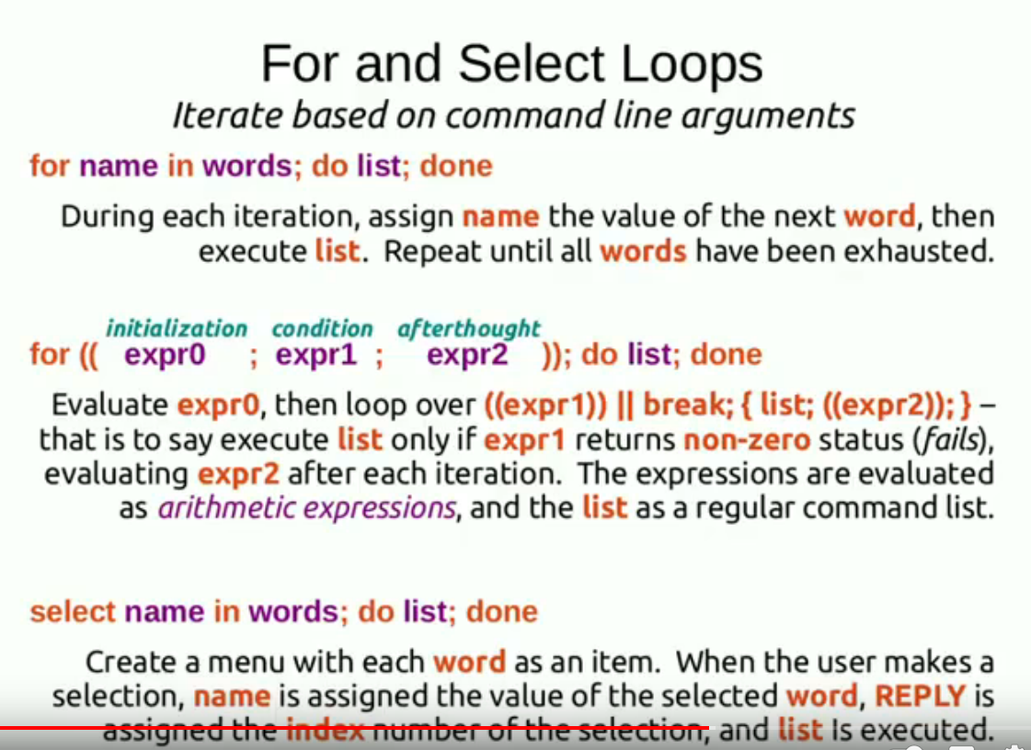

For and select:  for (( i=0 ; i<5 ; i++ ))  do  echo $i  done | For and select:  ((i=0))  while :  do  ((I < 5)) || break  { echo $i; ((i++)) }  done | Select file in *  do  stat “$file”  break  done

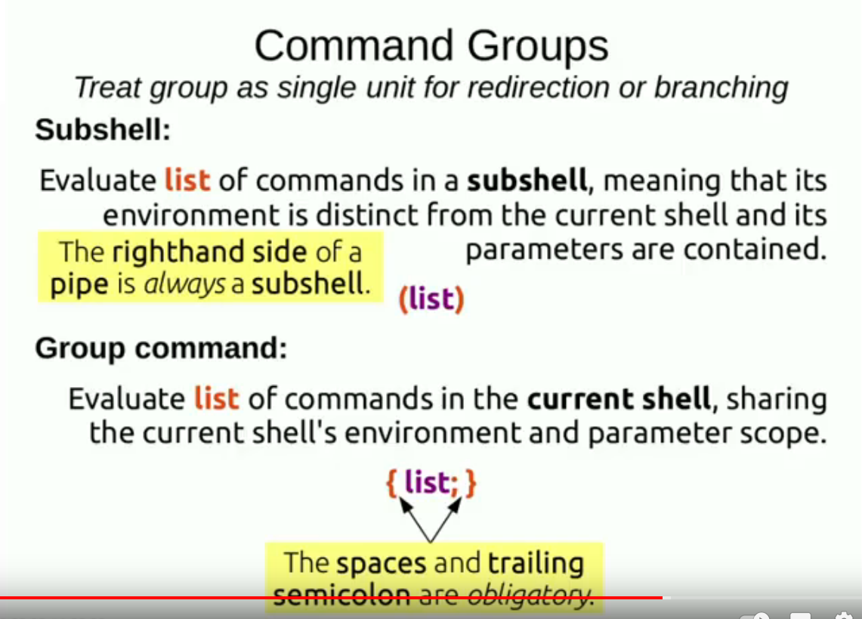

unset x  (x=hello; echo “x: $x”)  echo “x: $x”  x: hello ← inside  x: ← outside | unset x  { x=hello; echo “x: $x” }  echo “x: $x”  x: hello  x: hello

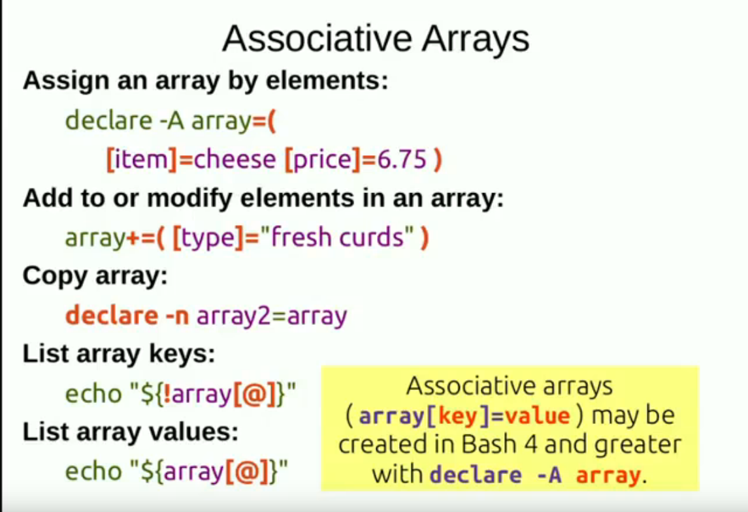
declare -A assoc=( [port]=443 [service]=”secure HTTP” )

for key in “${!assoc[@]}”; do
printf “key: \”%s\”\n value: \”%s\”\n” “$key” “${assoc[$key]}”
done

*배열 초기화는
unset assoc
echo “After unset: ${assoc[@]}
declare -A files_sizes

for file in *; do
[[ -f "$file" ]] && \
files_sizes["$file"]=$(wc -c < "$file")
done

for file in "${!files_sizes[@]}"; do
printf "bytes: %-15s file: \"%s\"\n" "${files_sizes[$file]}" "$file"
done

* declare -p files_sizes : 실제 배열 내용들을 보여준다.

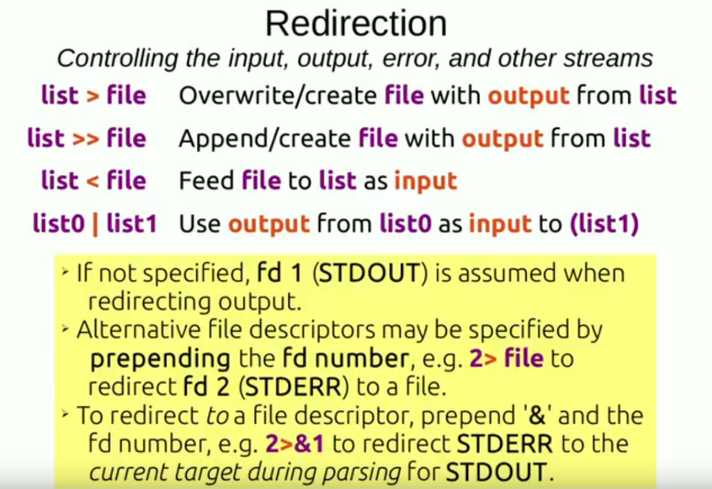

printf “%s\n” ${RANDOM:1:2} ${RANDOM:1:2} ${RANDOM:1:2} | sort -n
echo b; echo a | sort
(echo b: echo a) | sort

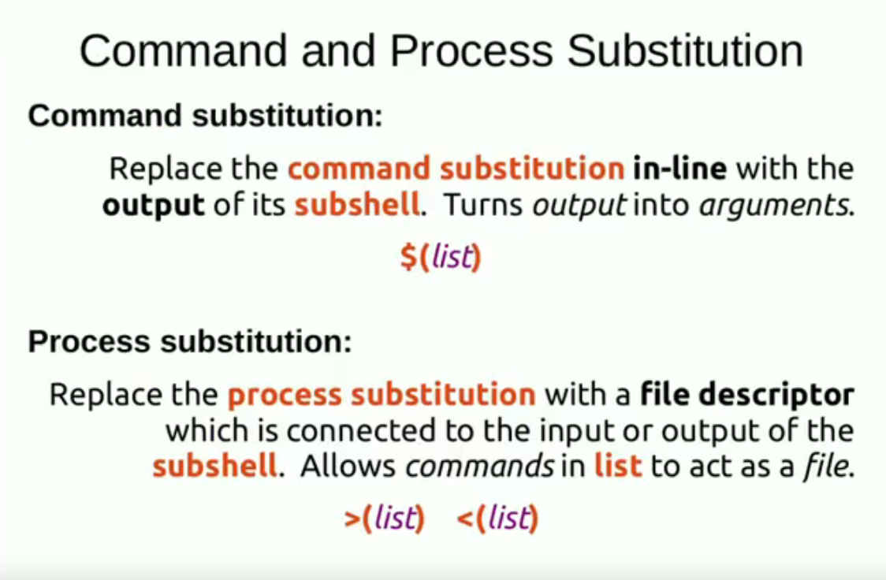

filename="file_$(date +%F)" \
echo "$(date +%s)" > "$filename"
sleep 1s
echo "$(date +%s)" >> "$filename"
printf "%s\n" \
"$filename: $(wc -l "$filename" | cut -d" " -f1) lines" \
"" \ ← 빈 문자열, 빈줄을 나타내기 위해 사용함.
"$(<"$filename")" ← “$(cat “$filename”)”을 쓰는게 줄바꿈되서 잘나옴.
echo "$(echo "$(echo "$(echo "$(ps wwf -s $$)")")")"
wc -c <(echo “$PATH”) or wc -c < <(echo “$PATH”) ** echo <(echo “$PATH”)
Printf “%s\n” one two “three four” | \
tee >(tac) >(sleep 1; cat) >/dev/null | \
cat

프로세스 치환은 다음과 같은 상황에서 특히 유용합니다:
- 입출력 리다이렉션과 함께 사용: 파일이나 파이프 대신 프로세스의 출력 또는 입력을 사용하여 명령어 간에 데이터를 전달할 수 있습니다.
- 프로세스 간 비교나 차이 계산: 예를 들어, diff 명령어에 두 개의 프로세스 출력을 전달하여 비교할 수 있습니다.
- 병렬 프로세싱: 여러 명령어를 병렬로 실행하고 그 결과를 조합하거나 비교할 때 사용할 수 있습니다.
프로세스 치환은 쉘 스크립트에서 특히 유용하며, 명령어 간에 데이터를 효과적으로 전달할 수 있도록 도와줍니다.

물론, 다음은 Bash에서 프로세스 치환을 사용한 몇 가지 예제입니다:
- 파일 비교: 두 개의 파일을 비교할 때 diff 명령어에 프로세스 치환을 사용할 수 있습니다.
bash
- diff <(cat file1.txt) <(cat file2.txt)
이렇게 하면 file1.txt와 file2.txt의 내용을 비교합니다.
- 병렬 프로세싱: 프로세스 치환을 사용하여 여러 명령어를 병렬로 실행하고 그 결과를 조합할 수 있습니다.
bash
- paste <(ls -l) <(ps aux)
이렇게 하면 현재 디렉토리의 파일 목록과 현재 실행 중인 프로세스 목록이 병렬로 표시됩니다.
- 커맨드 실행 결과 전달: 프로세스 치환을 사용하여 한 명령어의 출력을 다른 명령어로 전달할 수 있습니다.
bash
- grep "pattern" <(cat logfile.txt)
이렇게 하면 logfile.txt 파일에서 특정 패턴을 찾습니다.
- 커맨드의 출력을 변수에 할당: 프로세스 치환을 사용하여 커맨드의 출력을 변수에 할당할 수 있습니다.
bash
result=$(command)
이것은 변수 result에 command의 출력을 할당합니다.
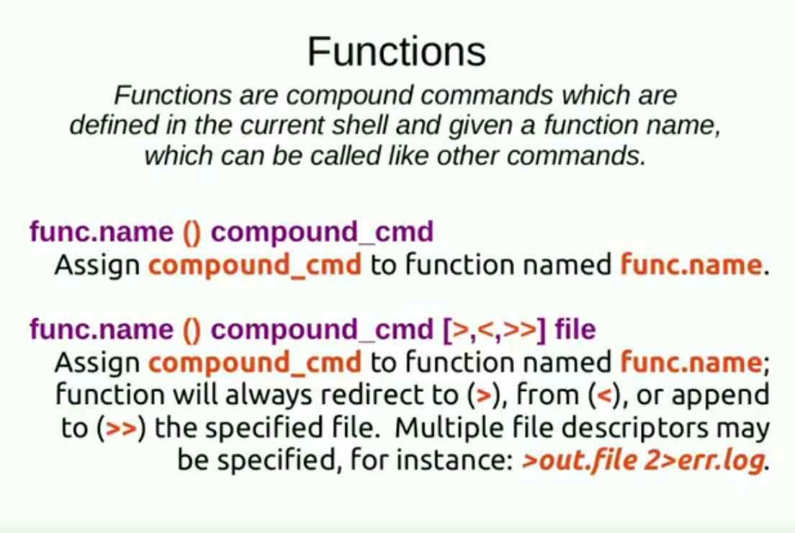
words ()
for word
do
echo “$word”
done

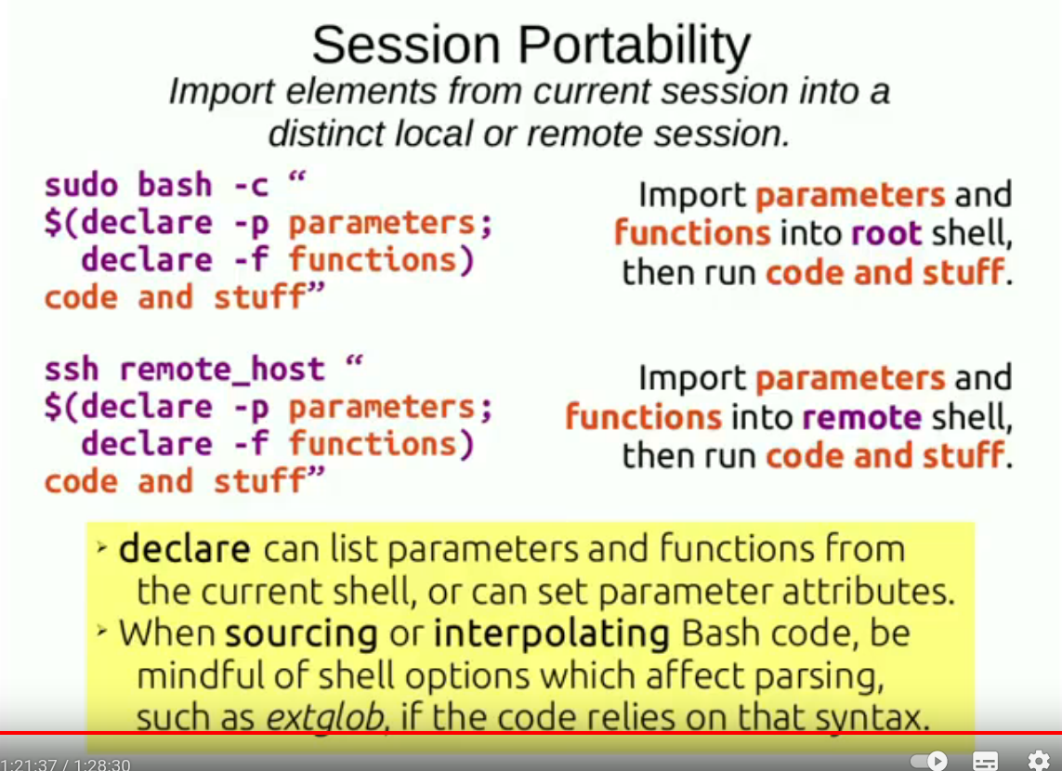
For host in $(
docker instpect -f “{{ .NetworkSettings.IPAdress }}” $(docker ps -q)); do
ssh $host \
“$(decare -f random_word); random_word; md5sum /proc/stat” | \
prepend_identifier shor
done
For host in $(
docker inspect -f “{{ .NetworkSettings.IPAdress }}” ${docker ps -q)); do
ssh $host \
“$(declare -f prepend_identifier random_word)
word=\$(random_word | cut -d\ -f 2)
fgrep \$word /usr/share/dict/cracklib-small | \
head -5 | \
prepend_identifier \$word” | \
prepend_identifier $host
done
For host in $(
docker inspect -f “{{ .NetworkSettings.IPAdress }}” $(docker ps -q));do
ssh $host \
“$(declare -f prepend_identifier random_word get_words_remote)
get_words_remote” | \
prepend_identifier $host &
dowe; wait

-a : 파일의 내용을 1byte ASCII 문자로 표현 할 때 사용
OD 명령어 옵션 : 지정된 파일의 내용을 8진수로 dump하여 보여주거나, 10진수, 16진수 등의 포맷으로 보여주는 명령어
참고 : https://blog.naver.com/ehdgns621/130056452544
-b : 파일의 내용을 1byte 부호 없는 8진수로 표시 할 때 사용
-c : 파일의 내용을 1byte ASCII 문자와 백슬래쉬(\)ESCAOES로 표시 할 때 사용
-d : 파일의 내용을 2bytes 부호없는 10진수로 표시 할 때 사용
-f : 파일의 내용을 4bytes 부동소수점수로 표시 할 때 사용
-h : 파일의 내용을 2bytes 부호 없는 16진수로 표시 할 때 사용
-i : 파일의 내용을 2bytes 부호 있는 10진수로 표시 할 때 사용
-l : 파일의 내용을 4bytes 부호 있는 10진수로 표시 할 때 사용
-o : 파일의 내용을 2bytes 부호 없는 8진수로 표시 할 때 사용
-x : 파일의 내용을 2bytes 16진수로 표시 할 때 사용
[출처] od 명령어|작성자 magic621

ip 명령어
ip address show
ip a
ip l
ip -br a
ip -br -c a
ip a | grep inet | sort -n
ip -oneline a | column -t
ip -j a >> ip.txt
ip -j -p a
ip a s | sed -ne 's,^ *inet6* \([^ /]*\)/.*$,\1,p' | sort -u
ip -o -4 a | awk ‘{print $4}’
ip -o -4 a | awk ‘{print $4}’ | cut -d/ -f1

ip r or ip route show or ip route
ip -c r | column -t
ip -c r | grep default

sudo ip r add default via 118.32.137.254 (kt공유기, 언제든 바뀔수 있음)
nmcli

Dockerfile 변경후 이미지 굽기

docker build -f Dockerfile -t 이미지이름 .

Display manager를 text login으로 바꾸기
$ systemctl get-default
$ sudo systemctl set-default multi-user.target
$ sudo systemctl reboot

text login을 GUI모드로 바꾸기
$ sudo systemctl enable multi-user.target
$ sudo systemctl set-default graphical.target
$ sudo reboot

도커 컨테이너 데이터 호스트에 저장하기

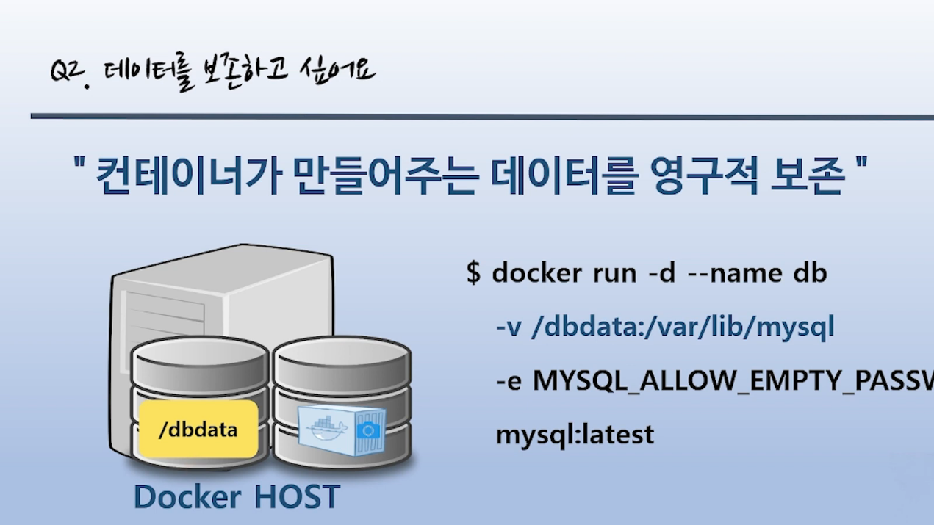

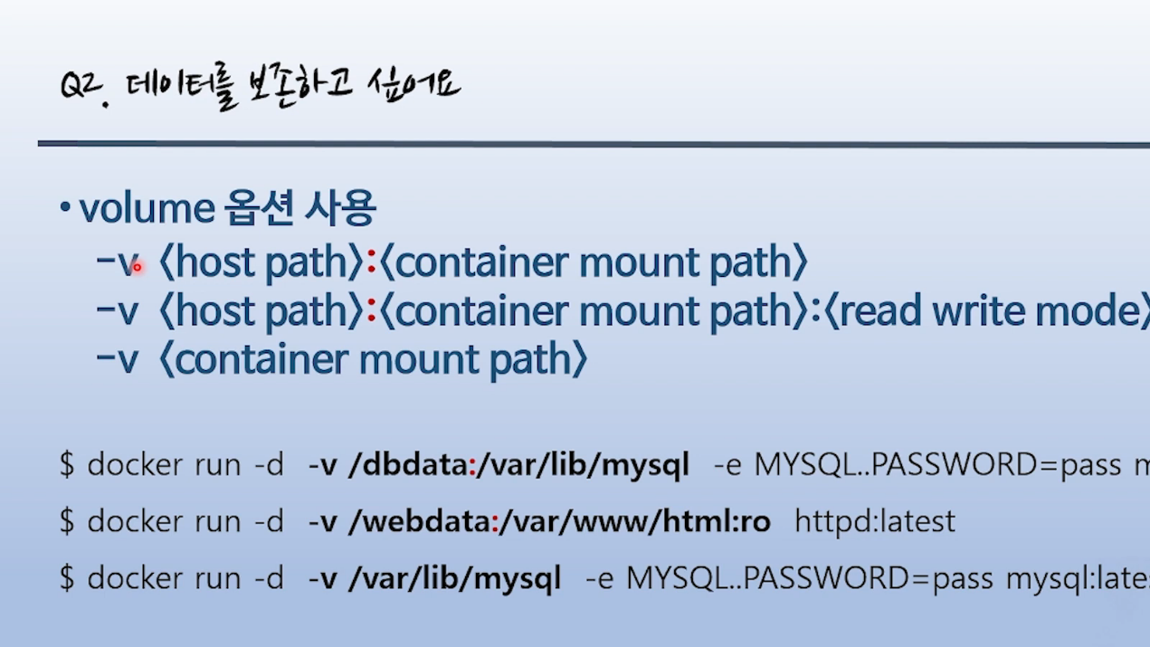

컨테이너들간 데이터 공유

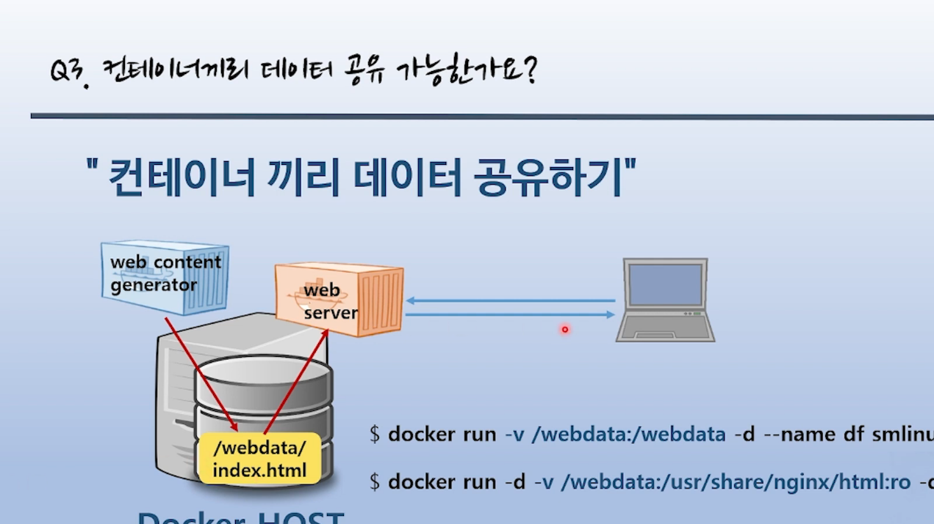

pc의 볼륨디렉토리 삭제 명령어
docker volume ls
docker volume rm <Volume name>

도커 CMD ENTRYPOINT 차이점

위에 만든 인사말 출력하기 스크립트를 도커를 통해 실행하도록 구성하는걸 해보겠다. 이미지를 따로 빌드하지 않고 실행시점에 재정의 하는 명령어의 예제이다. 샘플을 보면 알겠지만 ENTRYPOINT 의 인자값으로 CMD 를 사용한다는걸 알 수 있다.
즉, CMD 값이 없으면 ENTRYPOINT 만 실행되고, CMD 값이 있으면 ENTRYPOINT 실행시 인자값으로 사용된다는 말이다.
# CMD 값이 없으면 ENTRYPOINT 만 실행
% docker run --entrypoint ./script/hello.sh -v /home1/user:/script centos:latest
완료!!

# CMD 값이 있으면 ENTRYPOINT 의 인자값으로 전달후 실행
% docker run --entrypoint /script/hello.sh -v /home1/user:/script centos:latest 홍길동 토끼
안녕하세요! <홍길동> 님 반갑습니다.
안녕하세요! <토끼> 님 반갑습니다.
완료!!
명령어 | 설명
docker run | 도커 이미지를 실행한다는 의미
--entrypoint ./script/hello.sh | ENTRYPOINT 값을 의미한다
-v home1/user:/script | 로컬경로의 폴더를 컨테이너안에서 접근할 수 있도록 맵핑하는 명령어  : 기준으로 왼쪽이 로컬경로, 오른쪽이 이미지 안에서의 경로명이다
centos:latest | 사용할 이미지 이름과 버전
홍길동 토끼 | CMD 값을 의미한다

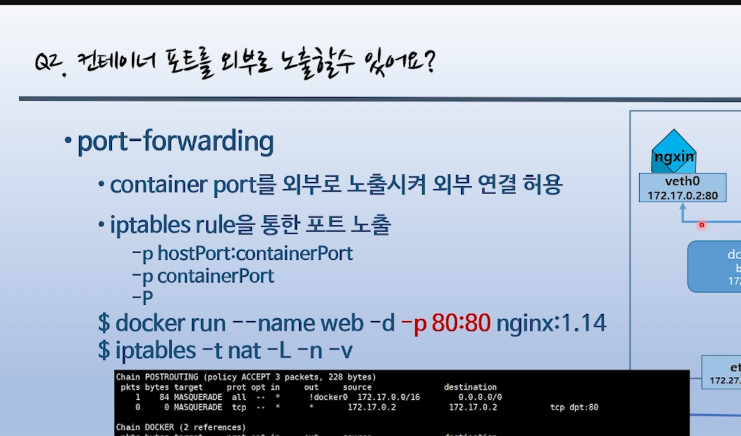

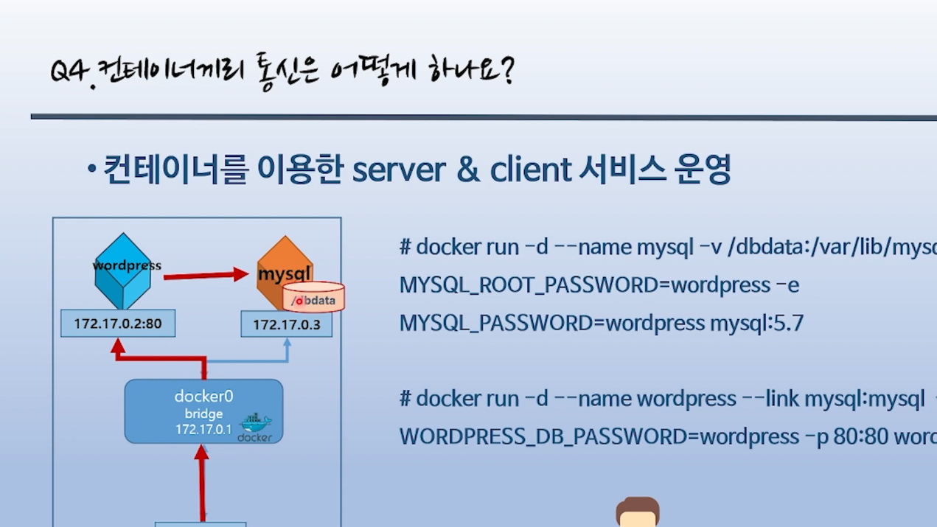
Keybase 설치
yay -S keybase-bin

GPG 키 들여오기
만약 Keybase에 등록된 GPG키가 존재하지 않는다면 새로운 GPG 키를 생성해야합니다.
$ keybase pgp gen --multi
키 생성이 완료되었거나, 이미 Keybase에 GPG 키가 등록되어 있었다면 아래 명령어로 시스템으로 들여옵니다.
$ keybase pgp export | gpg --import
$ keybase pgp export --secret | gpg --allow-secret-key-import --import

Git 설정
우선 방금 들여온 GPG 키의 ID를 확인합니다.
$ gpg --list-secret-keys --keyid-format LONG

...
----------------------------
sec rsa4096/XXXXXXXXXXXXXXXX 2018-02-23 [SC] [expires: 2034-02-19]
...
위와 같이 sec 부분의 XXXXXXXXXXXXXXXX 에 해당하는 값이 Git 설정에 사용할 ID 입니다. 키 알고리즘 등에 따라 ID의 길이는 다를 수도 있습니다.
위의 ID를 Git의 GPG 서명키로 등록합니다.

Hub.Docker.com 2FA recovery code : FT5VMDMJRCVRY

QZD4VUX4DS5KU2GK5WWAZDQIN45RS7PS

GPG 명령어

gpg --list-keys
gpg --keyid-format SHORT --list-keys
gpg --keyid-format LONG --list-keys
gpg --keyid-format 0xLONG --list-keys
gpg --list-secret-keys
# Subkeys are hidden if they have expired.
gpg --list-keys --list-options show-unusable-subkeys
# Show it all
gpg --list-keys --with-keygrip --with-fingerprint --with-subkey-fingerprints --keyid-format 0xlong --list-options show-unusable-subkeys

./docker/config/json 설정후 gpg로 키를 만들고 pass를 이용해 도커가 사용할수 있게끔 init한다.

$ gpg2 --gen-key
$ gpg --keyid-format LONG –list-keys (gpg가 생성하는 창에서 gpg비번 : 3067kkub)
ex) pub 2048R/A154BD21 2019-09-12
$ pass init A154BD21
$ docker login -u kimnux
password : 여기에 hub.docker.com에서 만든 토큰을 복사해서 붙이고 엔터.
➜ pass init kimnux@gmail.com
Password store initialized for kimnux@gmail.com
docker-credential-helpers/aHR0cHM6Ly9pbmRleC5kb2NrZXIuaW8vdjEv/kimnux: reencrypting to 832B84FD343B386C B8D27B526E4C0D10 D4418E002F79EFF5 E76B6D3A1B37153B
kimnux@gmail.com: reencrypting to 832B84FD343B386C B8D27B526E4C0D10 D4418E002F79EFF5 E76B6D3A1B37153B

gmail의 경우
1. pass init kimnux@gmail.com
2. mw -a kimnux@gmail.com 에서 비번 물어볼때 app password를 넣는다.
3. mbsync -a (메일 동기화)
4. neowmutt

Take the part after the / and init your pass with pass init <after-slash-part>, so in this example pass init A154BD21.
Add the line "credsStore":"pass" to your ~/.docker/config.json so that it looks something like
{
"credsStore":"pass"
}
pub ed25519/E5DDFCEB6B0F0184 2023-12-25 [SC] [expires: 2025-12-24]
23AAD72F710AE23448F2D4F3E5DDFCEB6B0F0184
uid [ultimate] Kim jong-sik (my key) <kimnux@gamil.com>
sub cv25519/D7EB9BF7EC1917A1 2023-12-25 [E] [expires: 2025-12-24]

Docker Cli loging with gpg

This is a rollup of the above information as I used it for pass with gpg2 on Kubuntu 20.04 (Ubuntu Linux v 20.04 with KDE desktop)
pass is the Linux CLI password manager.
High Level View: pass requires that you have a public gpg key. gpg is a Linux CLI encryption program. There are several versions. Kubuntu 20.04 uses gpg2 but just calls it "gpg".
You will first have to create a gpg key. Then you pass the key-id to pass as an argument. After which it should work.
Generate the key:
~$ gpg --gen-key
Have a look at your shiny new key:
~$ gpg --list-keys
pub rsa3072 2022-07-17 [SC] [expires: 2024-07-16]
YourKey (a bunch of letters and numbers)
uid [trust-level] yourName <yourAddress@email.com>
sub rsa3072 2022-07-17 [E] [expires: 2024-07-16]
You have to tell your machine to trust your new key:
gpg --edit-key yourName yourAddress@email.com, trust, 5, save)
(this step actually wasn't necessary for me, because the trust was automatically set to [ultimate] - but doing this step didn't hurt me.)
From this point forward you can move forward with the pass page at: https://www.passwordstore.org/
------ this is what it looked like for me setting up a password for docker in a folder called 'dev' -------------------
Initialize the password store:
~$ pass init yourAddress@email.com
Password store initialized for yourAddress@email.com
Create the password store:
~$ pass insert dev/docker
mkdir: created directory '/home/$USER/.password-store/dev'
Enter password for dev/docker:
Retype password for dev/docker:
Did I enter the correct password? -
~$ pass dev/docker
thisIsTheWrongPassword!
Remove the wrong password -
~$ pass rm dev/docker
Are you sure you would like to delete dev/docker? [y/N] y
removed '/home/$USER/.password-store/dev/docker.gpg'
Enter the correct password
~$ pass insert dev/docker
mkdir: created directory '/home/$USER/.password-store/dev'
Enter password for dev/docker:
Retype password for dev/docker:
Check if password is correct second time-
~$ pass dev/docker
doNotExposeYourPasswordOnStackExchange!
I can use pass to login to Docker Hub via CLI
pass dev/docker | login -u myUserName --password-stdin
This pipes the password directly to Docker Hub without printing it to screen.

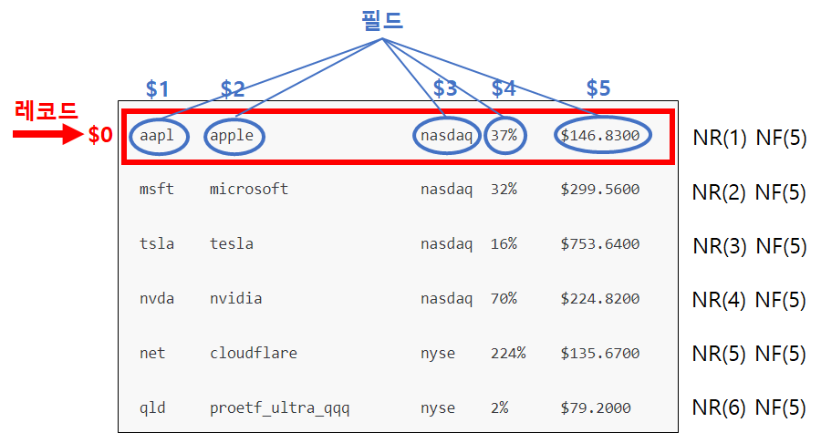

AWK의 레코드와 필드
(출처 : https://veneas.tistory.com/entry/Linux-%EB%A6%AC%EB%88%85%EC%8A%A4-%ED%8C%8C%EC%9D%BC%EC%9D%98-%EC%9B%90%ED%95%98%EB%8A%94-%ED%96%89%EA%B3%BC-%EC%97%B4-%EC%B6%9C%EB%A0%A5-awk )

awk 명령어 작업 방식
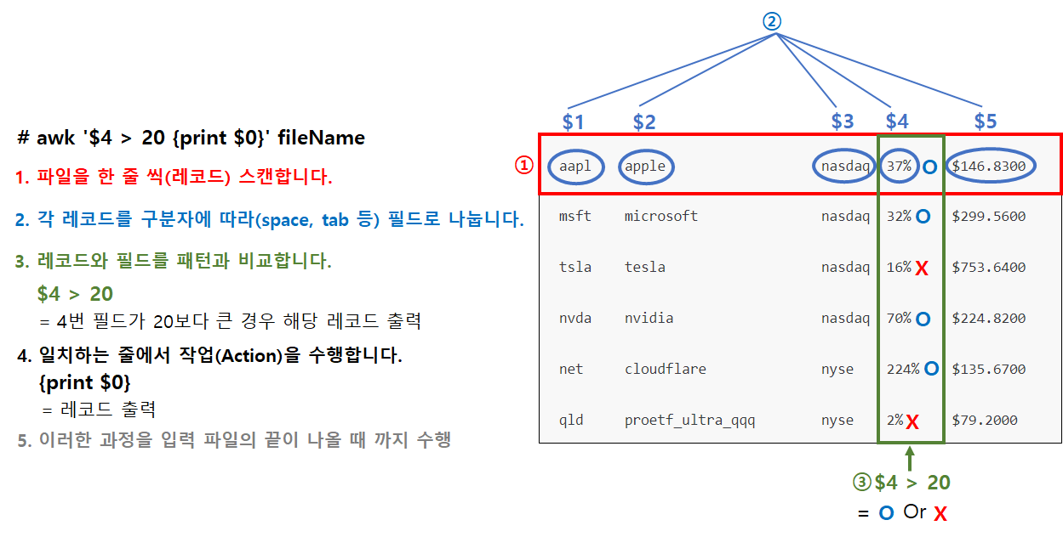

Relational Expressions in AWK
출처 : https://developer.apple.com/library/archive/documentation/OpenSource/Conceptual/ShellScripting/Howawk-ward/Howawk-ward.html
<poem.txt>

Mary had a little lamb,
its fleece was white as snow,
and everywhere that Mary went,
the lamb was sure to go.
A few more lines to confuse things:
Marylamb had a little.
This is a test. This is only a test.
Mary was married. A lamb was nearby.
Mary, a little lamb, and my grocer's freezer...
Mary a lamb.
Marry a lamb.
Mary had a lamb looked like a lamb.
I want chocolate for Valentine's day.
This line contains a slash (/).
This line contains a backslash (\).
This line contains brackets ([]).
Why is mary lowercase?
What about Mary, Mary, and Mary?
const people fox
constant turtles bear
constellation Libra
How about 9 * 9?
The quick brown fox jumped over the lazy dog.

In addition to regular expressions, AWK scripts support relational expressions. You can use relational expressions to perform more fine-grained matching, such as matching based on the content of a particular field or variable.
AWK scripts support four basic forms of relational expression:
- expression ~ /regexp/ —Expression matches the regular expression.
- expression !~ /regexp/ —Expression does not match the regular expression.
- expression comparison_operator expression —Basic string or numeric comparison between two expressions.
- expression in array_name —Expression is a key in the specified array. (See Working with Arrays in AWK for more information on working with arrays.)
The comparison_operator can be any of the standard C comparison operators, such as ==, !=, and so on.
The expression is generally either one of the fields or the result of an operation on one of the fields. For example, the following AWK filter rules show, respectively, how to compare the first field to “mary” in a case-insensitive fashion, how to match all records that do not contain “Mary”, and how to do an exact comparison of the first field against “Mary”:
tolower($1) ~ /mary/ { print "CI Record: " $0; }
$0 !~ /Mary/ { print "Not Mary: " $0; }
$1 == "Mary" { print "Mary Record: " $0; }
Save this file as 04_conditional_insensitive.awk, then run it with the awk interpreter by typing:
awk -f 04_conditional_insensitive.awk poem.txt
The script outputs a series of lines beginning with the following:
CI Record: Mary had a little lamb,
Mary Record: Mary had a little lamb,
Not Mary: its fleece was white as snow,
Mary Record: Mary fleece was white as snow,
Mary Record: Mary everywhere that Mary went,

6.3.2.2 Comparison Operators
출처 : https://www.gnu.org/software/gawk/manual/html_node/Comparison-Operators.html
Comparison expressions compare strings or numbers for relationships such as equality. They are written using relational operators, which are a superset of those in C. Table 6.3 describes them.
  Expression
  Result
  x < y
  True if x is less than y
  x <= y
  True if x is less than or equal to y
  x > y
  True if x is greater than y
  x >= y
  True if x is greater than or equal to y
  x == y
  True if x is equal to y
  x != y
  True if x is not equal to y
  x ~ y
  True if the string x matches the regexp denoted by y
  x !~ y
  True if the string x does not match the regexp denoted by y
 | True if the array array has an element with the subscript subscript (아래첨자 : 수학의 행렬표시에서 유래)
  subscript in array
Table 6.3: Relational operators
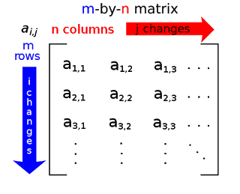
Comparison expressions have the value one if true and zero if false. When comparing operands of mixed types, numeric operands are converted to strings using the value of CONVFMT (see Conversion of Strings and Numbers).
Strings are compared by comparing the first character of each, then the second character of each, and so on. Thus, "10" is less than "9". If there are two strings where one is a prefix of the other, the shorter string is less than the longer one. Thus, "abc" is less than "abcd".
It is very easy to accidentally mistype the ‘==’ operator and leave off one of the ‘=’ characters. The result is still valid awk code, but the program does not do what is intended:
if (a = b) # oops! should be a == b
...
else
...
Unless b happens to be zero or the null string, the if part of the test always succeeds. Because the operators are so similar, this kind of error is very difficult to spot when scanning the source code.
The following list of expressions illustrates the kinds of comparisons awk performs, as well as what the result of each comparison is:
1.5 <= 2.0
Numeric comparison (true)
"abc" >= "xyz"
String comparison (false)
1.5 != " +2"
String comparison (true)
"1e2" < "3"
String comparison (true)
a = 2; b = "2"
a == b
String comparison (true)
a = 2; b = " +2"
a == b
String comparison (false)
In this example:
$ echo 1e2 3 | awk '{ print ($1 < $2) ? "true" : "false" }'
-| false
the result is ‘false’ because both $1 and $2 are user input. They are numeric strings—therefore both have the strnum attribute, dictating a numeric comparison. The purpose of the comparison rules and the use of numeric strings is to attempt to produce the behavior that is “least surprising,” while still “doing the right thing.”
String comparisons and regular expression comparisons are very different. For example:
x == "foo"
has the value one, or is true if the variable x is precisely ‘foo’. By contrast:
x ~ /foo/
has the value one if x contains ‘foo’, such as "Oh, what a fool am I!".
The righthand operand of the ‘~’ and ‘!~’ operators may be either a regexp constant (/…/) or an ordinary expression. In the latter case, the value of the expression as a string is used as a dynamic regexp (see How to Use Regular Expressions; also see Using Dynamic Regexps).
A constant regular expression in slashes by itself is also an expression. /regexp/ is an abbreviation for the following comparison expression:
$0 ~ /regexp/
One special place where /foo/ is not an abbreviation for ‘$0 ~ /foo/’ is when it is the righthand operand of ‘~’ or ‘!~’. See Using Regular Expression Constants, where this is discussed in more detail.

6.1.4.1 How awk Converts Between Strings and Numbers
출처 : https://www.gnu.org/software/gawk/manual/html_node/Strings-And-Numbers.html
Strings are converted to numbers and numbers are converted to strings, if the context of the awk program demands it. For example, if the value of either foo or bar in the expression ‘foo + bar’ happens to be a string, it is converted to a number before the addition is performed. If numeric values appear in string concatenation, they are converted to strings. Consider the following:
two = 2; three = 3
print (two three) + 4
This prints the (numeric) value 27. The numeric values of the variables two and three are converted to strings and concatenated together. The resulting string is converted back to the number 23, to which 4 is then added.
If, for some reason, you need to force a number to be converted to a string, concatenate that number with the empty string, "". To force a string to be converted to a number, add zero to that string. A string is converted to a number by interpreting any numeric prefix of the string as numerals: "2.5" converts to 2.5, "1e3" converts to 1,000, and "25fix" has a numeric value of 25. Strings that can’t be interpreted as valid numbers convert to zero.
The exact manner in which numbers are converted into strings is controlled by the awk predefined variable CONVFMT (see Predefined Variables). Numbers are converted using the sprintf() function with CONVFMT as the format specifier (see String-Manipulation Functions).
CONVFMT’s default value is "%.6g", which creates a value with at most six significant digits(유효숫자). For some applications, you might want to change it to specify more precision. On most modern machines, 17 digits is usually enough to capture a floating-point number’s value exactly.34
Strange results can occur if you set CONVFMT to a string that doesn’t tell sprintf() how to format floating-point numbers in a useful way. For example, if you forget the ‘%’ in the format, awk converts all numbers to the same constant string.
As a special case, if a number is an integer, then the result of converting it to a string is always an integer, no matter what the value of CONVFMT may be. Given the following code fragment:
CONVFMT = "%2.2f"
a = 12
b = a ""
b has the value "12", not "12.00". (d.c.)

Pre-POSIX awk Used OFMT for String Conversion
Prior to the POSIX standard, awk used the value of OFMT for converting numbers to strings. OFMT specifies the output format to use when printing numbers with print. CONVFMT was introduced in order to separate the semantics of conversion from the semantics of printing. Both CONVFMT and OFMT have the same default value: "%.6g". In the vast majority of cases, old awk programs do not change their behavior. See The print Statement for more information on the print statement.

Footnotes

(34)
Pathological cases can require up to 752 digits (!), but we doubt that you need to worry about this.

sprintf(format, expression1, …)
Return (without printing) the string that printf would have printed out with the same arguments (see Using printf Statements for Fancier Printing). For example:
pival = sprintf("pi = %.2f (approx.)", 22/7)
assigns the string ‘pi = 3.14 (approx.)’ to the variable pival.

Visual Sutudio Codium settings.json

{
"files.autoSave": "afterDelay",
"window.zoomLevel": 1,
"editor.fontFamily": "JetBrainsMono Nerd Font",
"editor.fontSize": 15,
"editor.fontWeight": "normal",
"editor.fontLigatures": true,
"terminal.integrated.fontFamily": "MesloLGM Nerd Font",
}

7. Using remote editor by exposing the port 22
출처: https://www.goglides.dev/roshan_thapa/how-to-edit-file-docker-container-or-edit-a-file-after-docker-container-ce
There is one more way by which you can expose the port 22 or in other words if I say enabling the SSH into the running container. I would certainly not recommend this approach because you will start many parallel processes along with your container.
But use this approach only when you are in the development phase and where you need to debug. For a production environment, it is highly discouraged.
So here are the things which we need to do -
- Install openssh-server
- run ssh process
- Expose port 22
- Build and run docker image on port 22 We will put all this inside the docker file. Here is the docker file -
FROM openjdk:8-jdk-alpine
ARG JAR_FILE=build/libs/*.jar
COPY ${JAR_FILE} app.jar

RUN mkdir destination-dir-for-add
ADD sample.tar.gz /destination-dir-for-add

RUN ["apt-get", "update"]
RUN ["apt-get", "install", "-y", "openssh-server"]
RUN echo 'root:lollol0' | chpasswd
RUN sed -i 's/#PermitRootLogin prohibit-password/PermitRootLogin yes/' /etc/ssh/sshd_config
RUN ["/etc/init.d/ssh", "start"]

EXPOSE 22

WORKDIR "/app"

CMD ["/usr/sbin/sshd", "-D"]

ENTRYPOINT ["java","-jar","/app.jar"]
7.1 Build the docker image
Now we need to build the docker image. Use the following command to build the docker image and substitute the image name as per your need -
docker build -t myimagewithopenssh .
7.2 Run docker image on port 22
Now in the previous two steps(Step 7, Step 7.1) we have created a dockerfile and build a docker file. Let's run the dockerfile on the port 22
Here is the command you should use for running the docker image -
docker run --rm -p 2222:22 -d --name=myimagewithopenssh myimagewithopenssh
After starting the container now you can edit the file remotely. Here is the vim command for editing the file present inside your docker container -
vim scp://root@localhost:2222//app/application.yaml
Here are some discussion threads which I found on the development forum -
Stackoverflow - How do I edit a file after I shell to a Docker container?
Docker Forum - How to edit a file in a running container?

[개발] cURL을 사용하여 이메일 보내기
출처 : https://velog.io/@jeongminji4490/cURL%EC%9D%84-%EC%82%AC%EC%9A%A9%ED%95%98%EC%97%AC-%EB%A9%94%EC%9D%BC-%EB%B3%B4%EB%82%B4%EA%B8%B0
Minji Jeong·2023년 2월 19일
개발

개발을 하다보면 개인적으로, 또는 동료들에게 어떤 새로운 내용에 대한 알림을 주고 싶을 때가 있다. 예를 들어 내 블로그에 댓글이 달렸다던지, 내가 개발한 앱에 새로운 리뷰가 등록되었다던지, 개발중인 앱이 어떠한 에러로 인해 빌드에 실패했을 때 등등. 나도 알림 기능을 구현하기 위해 어떤 플랫폼을 써야 할 지 고민하다가 다른 이의 ‘이메일’로 알림 내역을 전송할 수는 없는지 고민하게 되었고, 그렇게 cURL을 사용하여 이메일을 전송할 수 있다는 것을 알게 되었다. cURL은 정말 많이 사용되는 툴인데, 이번 포스팅에서 cURL을 사용해서 이메일을 전송하는 방법과 그 전에 몇가지 알고 넘어가면 좋을 이메일 프로토콜 몇가지에 대해 적어보고자 한다.

Email System
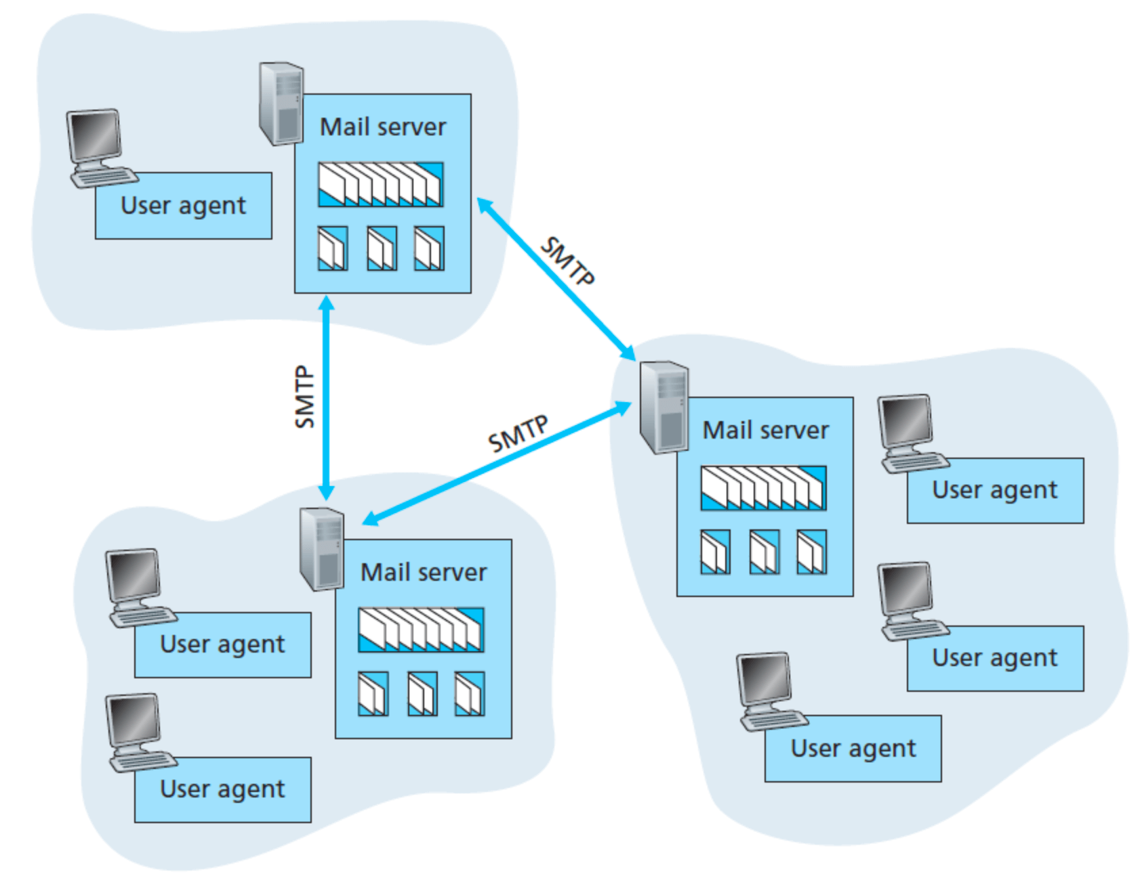
먼저 이메일 시스템이 어떤 구조로 이루어져 있는지 간단하게 살펴보자.
User agent
- 사용자가 메일을 읽고, 작성하고, 전송할 수 있도록 해주는 메일 플랫폼(ex Gmail, Outlook)이다.
Mail server
- 사용자가 작성한 메일이 저장되는 서버다. 발신자가 메일 작성을 끝내면 메일 플랫폼은 메세지를 발신자의 메일 서버로 보내게 되고, 메일은 메일 서버의 메세지큐에 들어가게 된다. 발신자의 메일 서버에서 인터넷을 통해 수신자의 메일 서버로 메세지가 전송되면, 메일들은 수신자의 메일 서버 안의 메일 박스안에 저장되고 유지된다. 이 메일 박스는 각각의 메일 주소에 대응하는데, 이 메일 박스를 바탕으로 한 메일 서버 간의 통신 덕에 원격지에서 시차를 두고 메일을 주고 받을 수 있는 것이다.
위 그림에서 SMTP라는 것이 보일 것이다. 이러한 이메일 시스템 구조에서 이메일을 주고받기 위해선 프로토콜이 필요한데, SMTP는 이메일 프로토콜 중 하나이다.
프로토콜(Protocal)
💡 컴퓨터나 원거리 통신 장비 사이에서 메세지를 주고 받는 양식과 규칙과 체계, 즉 통신 규약 및 약속

SMTP (Simple Mail Transfer Protocol)
SMTP는 메일 발신 시 사용되는 프로토콜이다. 주로 발신자가 작성한 메일을 서버로 보내거나 서버간 메일을 주고받을 때 사용된다.

POP3 (Post Office Protocol 3)
POP3는 메일 수신 시 사용되는 프로토콜로, 사용자의 기기로 메일을 다운로드하여 읽는 방식이다. POP3는 원래 컴퓨터 한 대에서만 사용하도록 설계된 프로토콜인데, 양방향 동기화를 지원하는 최신 프로토콜(IMAP)과는 달리 단방향 동기화만 지원하기 때문에 메일 서버에서 메일을 다운로드 하는 것만 할 수 있다. 즉 서버에 있는 메일을 확인할 경우 현재 사용하고 있는 기기에 다운로드 한 뒤 서버에서는 삭제하기 때문에 별도의 설정을 해주지 않을 경우 다른 기기에서는 동일한 메일을 확인할 수 없다. 예를 들어, PC에서 A메일을 확인했을 경우 스마트폰에선 A메일을 확인할 수 없다.

IMAP (Internet Message Access Protocol)
POP3와 마찬가지로 메일 수신 시 사용되는 프로토콜로, 서버에서 메일을 읽는 방식이다. IMAP은 POP3의 단점을 보완한 방식으로, 이메일이 수신자에게 전달된 후에도 서버에 보관된다. 따라서 PC에서 메일을 확인한 후에도 스마트폰이나 태블릿 등 다른 기기에서 동일한 이메일을 확인할 수 있으며, 한 기기에서 메일을 삭제한 경우 다른 기기에서도 메일이 삭제되었음을 확인할 수 있다.
IMAP의 경우 POP3와 다르게 메일의 모든 내용을 다운로드 하지 않고, 헤더 부분만 보여주고 수신자가 해당 메일을 클릭해야만 내용과 첨부파일 등의 본문을 다운로드 하기 때문에 보다 빠른 방법으로 메일을 확인할 수 있다. 하지만 빠른 대신 메일을 확인할 때마다 클라이언트와 서버가 통신해야만 하므로 통신 트래픽을 높이고, 개인 메일함의 용량이 곧 서버의 용량이기 때문에 주기적인 용량 관리가 필요하다는 단점도 존재한다.

cURL을 사용하여 메일 보내기
우리는 curl을 사용하여 메일 플랫폼에 메일을 보낼 수 있다.
cURL (Clients for URLs)
💡 서버와 통신할 수 있는 커맨드 명령어 툴로, 웹개발에 매우 많이 사용되고 있는 무료 오픈소스다. 다양한 프로토콜을 지원하며 SMTP, POP3, IMAP 또한 지원한다.
Basic command
curl --url 'smtp://mail.example.com' --ssl-reqd --mail-from 'myself@example.com' --mail-rcpt 'receiver@example.com' --upload-file email.txt --user 'myself@example.com:password'
smtp://mail.example.com : SMTP 서버
myself@example.com : 발신 메일 주소
receiver@example.com : 수신 메일 주소
email.txt : 이메일 (텍스트 파일)
Email text format
From: John Smith <john@example.com>
To: Joe Smith <smith@example.com>
Subject: an example.com example email

Dear Joe,
Welcome to this example email. What a lovely day.
나는 이번 테스트에서 sender, receiver email로 모두 지메일을 사용할 것이다.
curl --url 'smtps://smtp.gmail.com:465' --ssl-reqd --mail-from 'myself@example.com' --mail-rcpt 'receiver@example.com' --upload-file email.txt --user 'myself@example.com:password'
smtps://smtp.gmail.com:465 : Gmail SMTP 서버
다만 password 부분에는 해당 이메일의 비밀번호를 입력하는 것이 아닌, 지메일에서 로그인 2단계 인증 설정 시 제공되는 앱 비밀번호를 사용해야 한다. 처음에 로그인 시 사용하는 비밀번호를 사용했다가 자꾸 Login Denied 라는 에러가 발생해서 검색해보니 구글 축에서 보안 문제로 인해 써드파티 앱 사용 시 아이디와 비밀번호만 사용하여 로그인 하는 것을 막았다고 하더라.
can curl no longer send emails using gmail accounts?
앱 비밀번호 생성하기
- Google 계정 → 보안 메뉴로 이동
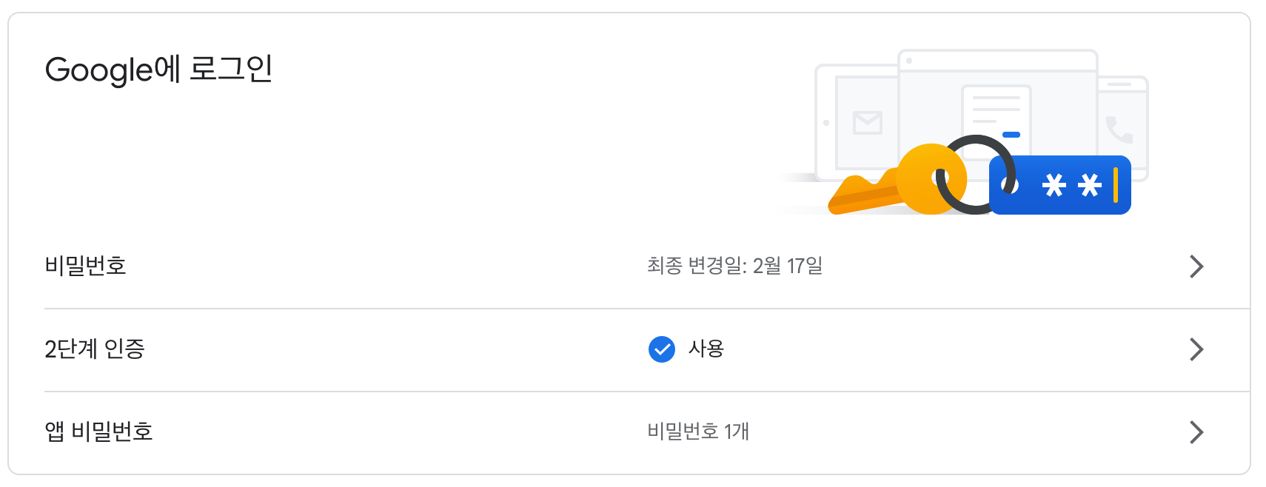
- Google에 로그인 메뉴에서 2단계 인증 후 앱 비밀번호 생성 (2단계 인증을 해야 앱 비밀번호 탭이 생성됨)
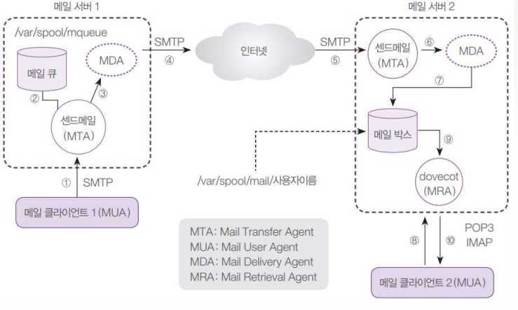
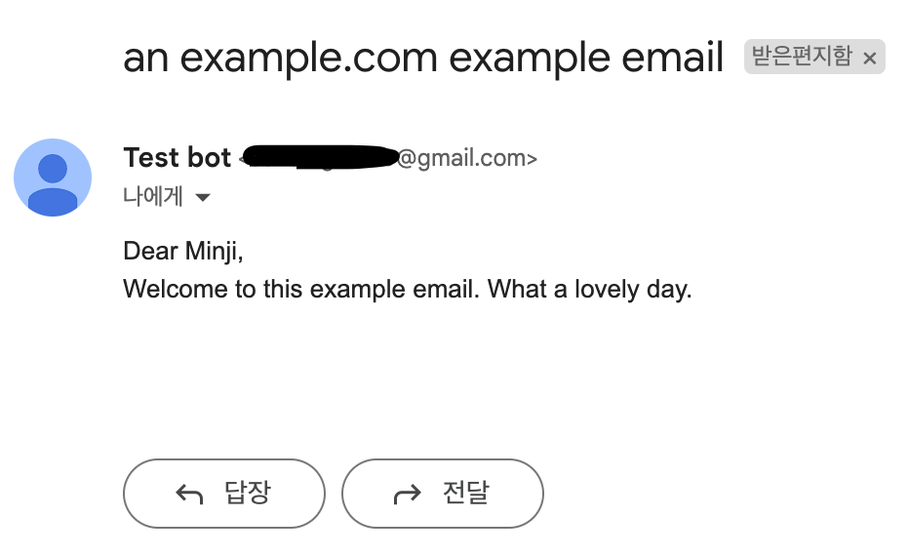
이제 cURL을 통해 터미널에서 명령어를 입력하면 메일을 보낼 수 있게 된다.

This Video is about sending E-Mails (Plain/HTML) From Centos Terminal to Gmail

출처 : https://www.youtube.com/watch?v=0FpcvgnNoQc

Sending Mails from CentOS using gmail config info: ==================================================
switch to root (sudo su - )
Step 1. yum update -y

Step 2. Install Postfix, the SASL authentication framework, and mailx. yum -y install postfix cyrus-sasl-plain mailx

Step 3. Restart Postfix to detect the SASL framework. systemctl restart postfix

Step 4. Start Postfix on boot systemctl enable postfix

Step 5. Open the /etc/postfix/main.cf file. vi /etc/postfix/main.cf append the following into the file: /etc/postfix/main.cf

relayhost = [smtp.gmail.com]:587
smtp_use_tls = yes
smtp_sasl_auth_enable = yes
smtp_sasl_password_maps = hash:/etc/postfix/sasl_passwd
smtp_tls_CAfile = /etc/ssl/certs/ca-bundle.crt
smtp_sasl_security_options = noanonymous
smtp_sasl_tls_security_options = noanonymous

Step 6. Configure Postfix SASL Credentials
Add the Gmail credentials for authentication. Create a "/etc/postfix/sasl_passwd" file
touch /etc/postfix/sasl_passwd

Add the following line to the file:

vi /etc/postfix/sasl_passwd

[smtp.gmail.com]:587 xyz:AppPassword (Note: xyz is from xyz@gmail.com,
password_app is from goog management app password )

Step 7. Create a Postfix lookup table from the sasl_passwd text file by running the following command: postmap /etc/postfix/sasl_passwd

Step 8. Sending mail Run the following command to send mail:
-plain-
echo "This is a test mail & Date $(date)" | mail -s "message" ubuntugtest@gmail.com

-html-
cat /tmp/demo.html | mailx -s "$(echo -e "This is the subject\nContent-Type: text/html")" ubuntugtest@gmail.com

또다른 방법
출처 : https://www.youtube.com/watch?v=GEfH07p95P4

Steps :

1. Install Mail Packages
yum install postfix mailx cyrus-sasl cyrus-sasl-plain -y

2. Create GMail Account
a) Generate App Password

3. Edit sasl_password file and add gmail account details
vi /etc/postfix/sasl_passwd
[smtp.gmail.com]:587 <emailid>@gmail.com:**********

4. Generate DB file
postmap /etc/postfix/sasl_passwd

5. Edit main.cf
relayhost = [smtp.gmail.com]:587
myhostname = oracle-vm.com

# Enable SASL authentication for postfix
smtp_use_tls = yes
smtp_sasl_auth_enable = yes
smtp_tls_security_level = encrypt
smtp_tls_CAfile = /etc/ssl/certs/ca-bundle.crt

# Disallow methods that allow anonymous authentication
smtp_sasl_security_options = noanonymous

# Location of sasl_passwd
smtp_sasl_password_maps = hash:/etc/postfix/sasl_passwd

6. Test EMAIL
echo "Test Email" | mail -s "Send Email from Linux" sendmailfromlinux@gmail.com

S-nail
출처: https://wiki.archlinux.org/title/S-nail

Arch Linux uses S-nail as its POSIX mailx incarnation(화신, 강생). S-nail is MIME capable and has extensions for line editing, S/MIME, SMTP, IMAP, POP3, and more. Mailx is the user side of the Unix mail system, whereas the system side was traditionally taken by sendmail. S-nail can also send directly to external SMTP servers, so no local MTA is required.

How to Email to gmail from cmd (s-nail)
출처 : https://medium.com/@abhi.in/how-to-email-to-gmail-from-cmd-125ff4a21bee
Abhishek Dubey
Follow
2 min read
Jul 24, 2023
To set the correct SMTP server and port in RHEL terminal, you need to configure the postfix service, which is the default SMTP server for RedHat or CentOS systems. Postfix is a program that can send and receive emails using the SMTP protocol. You can install it by running `sudo yum install postfix` on your terminal¹.
To configure postfix, you need to edit the `/etc/postfix/main.cf` file and append or modify the following parameters¹:
- `myhostname`: This is the hostname of your server, such as `example.com`.
- `relayhost`: This is the IP address or hostname of the relay server that you want to use to send emails, such as `[smtp.gmail.com]:587`.
- `smtp_use_tls`: This is a boolean value that indicates whether to use TLS encryption for SMTP connections. Set it to `yes` if your relay server supports TLS, or `no` otherwise.
- `smtp_sasl_auth_enable`: This is a boolean value that indicates whether to use SASL authentication for SMTP connections. Set it to `yes` if your relay server requires authentication, or `no` otherwise.
- `smtp_sasl_password_maps`: This is a file that contains the username and password for your relay server, such as `hash:/etc/postfix/sasl_passwd`.
- `smtp_sasl_security_options`: This is a string that specifies the security options for SASL authentication. Set it to `noanonymous` to prevent anonymous authentication.
For example, if you want to use Gmail as your relay server, you can use the following settings²:
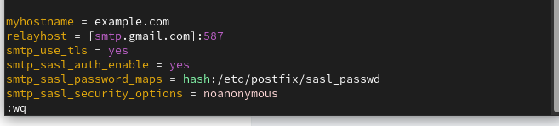
myhostname = example.com
relayhost = [smtp.gmail.com]:587
smtp_use_tls = yes
smtp_sasl_auth_enable = yes
smtp_sasl_password_maps = hash:/etc/postfix/sasl_passwd
smtp_sasl_security_options = noanonymous
You also need to create the /etc/postfix/sasl_passwd file and enter your Gmail username and password in the following format²:
[smtp.gmail.com]:587 username@gmail.com:password
Then, you need to run the following commands to update the postfix configuration and restart the service¹:
sudo postmap /etc/postfix/sasl_passwd
sudo chmod 600 /etc/postfix/sasl_passwd /etc/postfix/sasl_passwd.db
sudo systemctl restart postfix
To verify that your postfix service is working properly, you can use the s-nail command to send a test email from your terminal. For example:
echo "This is a test email" | s-nail -s "Test" recipient@example.com
sendmail recipient@elsewhere.com
From: you@example.com
Subject: Test mail
This is a test email
.

You should receive the email in ysour recipient’s inbox shortly. If not, you can check the `/etc/postfix/sasl_passwd` file for any errors or warnings.
Thankyou
------------------------------------------------------------------------------------------------

Configure Postfix to Use Gmail App Passwords
출처 : https://kifarunix.com/configure-postfix-to-use-gmail-app-passwords/

Follow through this tutorial to learn how to configure Postfix to use Gmail App Passwords. Previously, Gmail would allow you to use “third-party apps or devices which ask you to sign in to your Google Account using only your username and password“. For example, if you were configuring Postfix to use Gmail SMTP relay, then you may need to turn on Less Secure App Access so that the username/password authentication may work. However, this flexibility come to an end as from May 30, 2022.

Configure Postfix to Use Gmail App Passwords
So, how can you configure Postfix to use Gmail SMTP relay after less secure app access is disabled? Google, as a result of disabling less secure app access, recommends the use of more secure apps with your account.
Therefore, as an alternative to the use of less secure apps with Postfix Gmail SMPT relay configuration, you can configure Postfix to use Gmail App Passwords (Please also note that Gmail do not recommend the use of App password, “App Passwords aren’t recommended and are unnecessary in most cases. To help keep your account secure, use “Sign in with Google” to connect apps to your Google Account“).
So, how can you configure Postfix to use Gmail App Passwords as an alternative to the use of former less secure apps access method?

2. Login to your Google Account
Login to your Gmail account that you want to use with Postfix for relay.

2. Enable 2-Step Verification
If not already enabled, navigate to Security section > Signing in to Google and enable 2-Step verification for your account.
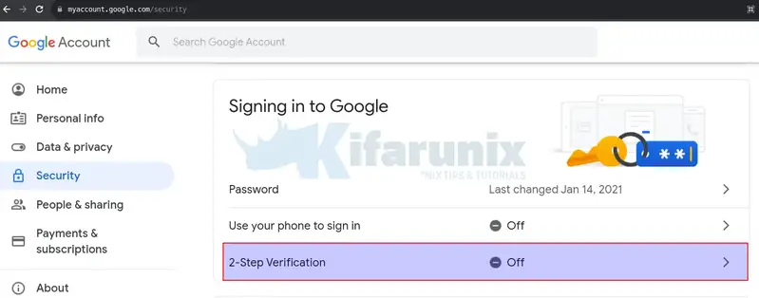
- Click on 2-Step Verification > Get Started.
- You will be prompted to enter your account password to confirm that the account is actually yours, -:).
- Continue to add your phone number and click SEND to get the verification code.
- Enter the code that you receive on your phone number to confirm that 2-Step verification works.
- Once done, click TURN ON to enable 2-Step Verification on your account.

3. Create App Passwords
- Next, go back to Security section > Signing in to Google. Just below the 2-Step Verification option is App Passwords setting.
- Seems the app password option is no longer available as an option. But you can access it directly using via https://myaccount.google.com/apppasswords.
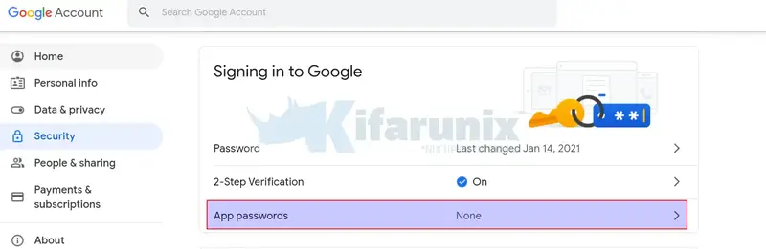
- Click App Passwords to create and use app passwords.
- If prompted, enter your account password. You will then proceed to App Passwords settings page.
- Select your specific app from the available list. If using Postfix, then you can select Other (Custom name)
- Enter the name of the App, e.g Posfix and click GENERATE to create App password.
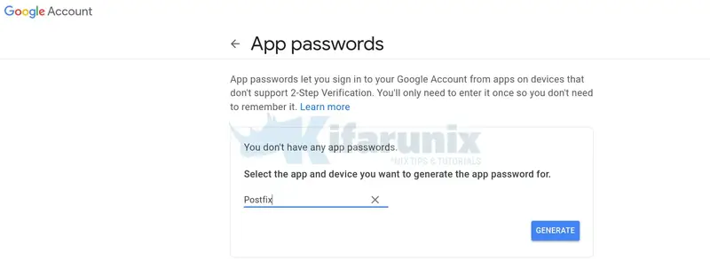
- Copy the 16-character password and click DONE.
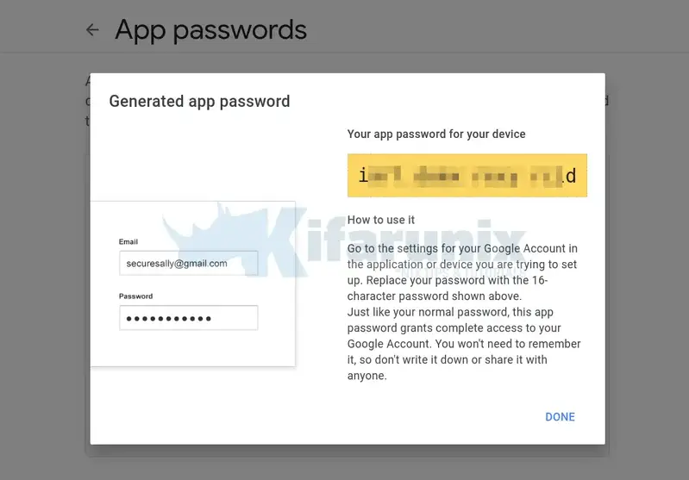
- This is the password that you will use for your account on Postfix.

4. Install Gmail Account App Password on Postfix
Next, edit the Postfix SMTP SASL credentials and replace the password with the 16-character password created above.
vim /etc/postfix/sasl_passwd
[smtp.gmail.com]:587 kimnux@gmail.com:ixxxxxxxxxxxxxxd
Replace the userid@gmail and password accordingly.
Save and exit the file.
Regenerate SASL password DB file.
postmap /etc/postfix/sasl_passwd

5. Restart Postfix Service
Once that is done, run Postfix configuration check;
postfix check
If there is any error, then the command will print it to standard output. Otherwise it exits with no output and exit status of 0.
Then restart it;
systemctl restart postfix

6. Test Postfix Email Relay via Gmail SMTP
You can now test if all is okay as follows;
echo "Test Postfix Gmail SMTP Relay" | mail -s "Postfix Gmail SMTP Relay" userid@gmail.com
sendmail recipient@elsewhere.com
From: you@example.com
Subject: Test mail
This is a test email
.

You can tail the logs to check the delivery status;
tail /var/log/mail.log ( sudo journalctl -u postfix > ~/postfix.log )
Sample output;

...
Aug 27 22:42:10 debian11 postfix/pickup[14560]: 2EAFD653BB: uid=0 from=<root@node01.kifarunix-demo.com>
Aug 27 22:42:10 debian11 postfix/cleanup[14579]: 2EAFD653BB: message-id=<20220827194210.2EAFD653BB@kifarunix-demo.com>
Aug 27 22:42:10 debian11 postfix/qmgr[14561]: 2EAFD653BB: from=<root@node01.kifarunix-demo.com>, size=371, nrcpt=1 (queue active)
Aug 27 22:42:12 debian11 postfix/smtp[14581]: 2EAFD653BB: to=<username@gmail.com>, relay=smtp.gmail.com[142.250.147.109]:587, delay=2.8, delays=0.02/0.02/2/0.78, dsn=2.0.0, status=sent (250 2.0.0 OK 1661629332 14-20020a170906308e00b0073bdb2f6f28sm2340234ejv.217 - gsmtp)
Aug 27 22:42:12 debian11 postfix/qmgr[14561]: 2EAFD653BB: removed
...
And that is how you can configure Postfix to use Gmail App Passwords instead of the now deprecated less secure app access option.
That brings us to our guide on how to configure Postfix to use Gmail App Passwords.
------------------------------------------------------------------------------------------------

mutt

Installation
Install the mutt package. Alternatively consider using the #NeoMutt package.
Optionally install external helper applications for an IMAP setup, such as isync or OfflineIMAP.
Or (if using POP3) getmailAUR, mpop, fetchmail or fdm and procmailAUR.
Note: About authentication setups:
- If you just need the methods LOGIN and PLAIN, these are satisfied with the dependency libsasl
- If you want to (or have to) use CRAM-MD5, GSSAPI or DIGEST-MD5, install the package cyrus-sasl-gssapi
- If you are using Gmail as your SMTP server, you may need to install the package cyrus-sasl

NeoMutt
This article or section is a candidate for moving to NeoMutt.
Notes: Is it a drop-in replacement for Mutt? Do all configurations on this page apply to it as well? (Discuss in Talk:Mutt#Neomutt)
The NeoMutt project aims to bring together all the patches for Mutt. It adds a large set of features. Lots of old Mutt patches have been brought up-to-date, tidied and documented.
While there are many different packages of Mutt in the AUR, each of them providing another set of patches, NeoMutt aims to replace them in the future by implementing appropriate compile options.
NeoMutt can be installed with the neomutt package or alternatively from the AUR at neomutt-gitAUR for the development version.

OpenSMTPD: How to receive emails sent by remote hosts to OS local users
출처 : https://dev.to/nabbisen/opensmtpd-how-to-receive-emails-sent-by-remote-hosts-to-os-local-users-48oj
#opensmtpd #openbsd #email #server

OpenBSD Mail Server (4 Part Series)
1 OpenSMTPD: How to receive emails sent by remote hosts to OS local users
2 Rspamd installation and OpenSMTPD configuration on it on OpenBSD
3 Rspamd monitoring with OpenBSD relayd
4 DKIM Migration: Rpamd instead of DKIMproxy out on OpenBSD / OpenSMTPD
* The cover image is originally by Foto-Rabe and edited with great appreciation.

Summary
OpenSMTPD is a free implementation of the Simple Mail Transfer Protocol aka SMTP, which is developed by The OpenBSD Project.
It is available as daemon in not only BSD operating systems such as FreeBSD and macOS but also Linux distributions. For example, Arch Linux and Debian have their own manual pages about OpenSMTPD: Arch Linux's, Debian's.
This post shows how to receive emails from remote hosts, other service, to your server with OpenSMTPD for quick use of it.
What is necessary is a little configuration of DNS (A/MX) records and smtpd.conf in /etc/mail, and a few commands.

Environment
- OS: OpenBSD 6.7
- SMTP Server: OpenSMTPD 6.7

Tutorial
- Configure DNS server
- Edit smtpd.conf
- Set a local user (optional)
- Receive messages and read them
✿ ✿ ✿

Configure DNS server
First, access your DNS server or service, and add A/MX records pointing to your domain (named $DOMAIN here).
As a side note, a MX record was not mandatory in my case when the $DOMAIN was completely unique.

Edit smtpd.conf
You can find the original configuration file named smtpd.conf in /etc/mail.
# nvim /etc/mail/smtpd.conf
Add just two lines to it:
[...]
table aliases file:/etc/mail/aliases

listen on socket
[...]
listen on lo0
+ listen on egress
[...]
action "local_mail" mbox alias <aliases>
[...]
match from local for local action "local_mail"
match from local for any action "outbound"
+ match from any for domain "$DOMAIN" action "local_mail"
The first listen on egress enables egress traffic to let the daemon to listen on external IP addresses. Alternatively, listen on all may be used: all = lo0 + egress.
The second and the last match statement declares messages for $DOMAIN will be dealed with by the "local_mail" action and written to mbox files. Besides, for domain "$DOMAIN" in it is an option for safety. It also works with for any instead.
Restart smtpd daemon after changing smtpd.conf:
# rcctl restart smtpd

Set a local user (optional)
If you are supposed to accept messages for root, this section is skippable.
You can receive messages for "root@$DOMAIN".
Additionally, "postmaster@$DOMAIN", "operator@$DOMAIN" and so on are able to accept their messages. They will be found in root's mbox.
This is because these settings are in the default aliases file in /etc/mail:
postmaster: root
[...]
operator: root
www: root
Well, when you want to receive messages for a local user, edit /etc/mail/aliases, which is used as aliases table in smtpd.conf. It is the database file and used in the "local_mail" action to do mbox alias <aliases>.
Add a line to the bottom of:
# nvim /etc/mail/aliases
in this way:
[...]
+ someuser: someuser
The left value is alias name and the right is the destination.
Then, update the database:
# newaliases
/etc/mail/aliases: 69 aliases
There is no need to restart smtpd daemon at changing only aliases.
Now you can receive messages for someuser@$DOMAIN.
Besides, you may add a user with adduser, of course, to use as an email receiver beforehand.

Receive messages and read them
Let's send an email with your Gmail or another service to root@$DOMAIN, postmaster@$DOMAIN or someuser@$DOMAIN.
By the way, execute doas su - to act as root if necessary.
Then run mail:
# mail
Mail version 8.1.2 01/15/2001. Type ? for help.
"/var/mail/root": 1 message 1 new
>N 1 root@$DOMAIN Fri Jun 5 18:22 44/2379 subject
&
The messages will be listed.
In this interactive shell, various [command]s are available such as [?] for [help], go to the [n]ext message, [r]eply, et al.

Checking email in terminal: neomutt + notmuch + lieer
November 16, 2019
Gmail이 나온 지 이제 15년이 넘었습니다. 2004년 만우절에 1GB 라는 깜짝 놀랄만 한 용량을 들고 나오면서 이메일을 더이상 지울 필요 없다고 소개를 했었죠. 그때 당시 한메일 100MB였나요? 아니면 20MB였나요. 아무튼 그 작디 작은 용량의 메일함을 가지고 오래된 메일을 지워가며 옥신각신했던 기억이 납니다. 그 때에 그 작은 용량을 메꾸기 위해 메일은 오프라인으로 다운로드해두고 썼었죠. 다운로드는 POP을 이용해서 다운로드 했던 걸로 기억해요. 메일 클라이언트를 무엇을 썼는지는 기억이 나질 않는데 GUI가 덧입혀져있는 단순한 클라이언트로 기억을 합니다.
Gmail이 나오고 난 이후로 패러다임이 바뀌고 대부분의 메일 서비스가 1GB를 지원하기 시작하고, Gmail은 점점 메일함 용량을 키워가더니 이젠 15GB 용량을 통합해서 Gmail, Google Drive, Google Photo (원본 사진)로 나눠 쓰게되었네요.
그때 당시 hanmail을 쓰다가 초대장을 받아서 gmail로 옮기고 지금까지 잘 써오고 있습니다. 메일 주소는 처음 쓰던 메일에서 조금 바뀌어서 이젠 개인 도메인 메일을 쓰지만 여전히 Gmail 서비스 위에서 (GSuite) 운영하고 있죠.
2013년 맥북프로를 구입하기 전 까지는 Gmail WebApp을 계속 써 오다 구입 후 Apple Mail을 이용헤 이메일을 사용해 왔습니다. Apple Mail을 쓰면서 GnuPG signed email을 알게 되고 GPG Mail 플러그인을 이용해서 이메일을 서명해서 보내고 있습니다. 많은 사람들이 Apple Mail을 마음에 들어하지 않지만, 제가 써본 여러 메일앱 중에서 맥에서 쓸만한 앱은 Apple Mail 앱인 것 같네요. MailMate 외에는 거의 써본 것 같은데, 어떤 것은 이메일 credential을 자체 서버에 저장하는 앱도 있고 GnuPG 지원이 미흡한 앱도 있고, Gmail WebUI에 몇가지 기능을 추가만 한 앱도 있고, 결국은 다시 Apple Mail앱으로 돌아오더군요.
그러다 작년부터인가, GPG Mail 플러그인이 유료화 되었네요. 오랜기간 오픈소스로 잘 지원되어 왔으나 금액을 지불하지 않으면 GnuPG 기능을 Apple Mail app에서 못 사용하게 되어, 다른 방안을 물색했네요. GPG Mail이 오픈소스라 Paywall 부분만 삭제해서 내놓은 플러그인도 있었는데, 그걸 써오다 이번에 좀 색다른 시도를 하게 되었네요.

Mutt
서론이 좀 길었는데, 결국 색다른 시도는 터미널에서 이메일을 사용하는 것입니다. 매일 대부분의 일과가 터미널에서 이뤄지는데, 이메일이라고 그러지 못할 이유가 없더군요. 이메일의 태생이 사실 터미널에서 이뤄진 것이기도 하구요. 일을 하다보면 이메일을 자동화 해서 보낼 때가 있는데 그것 또한 sendmail을 이용해서 보내곤 했으니, 그다지 어렵지는 않을 것 같았습니다.
그런데, 이메일 세팅으로 이주일 가까이를 쓰게될 줄은 몰랐네요. -_-
먼저 가장 메인이 되는 프로그램은 Mutt라는 터미널에서 동작하는 메일 관리 앱입니다.
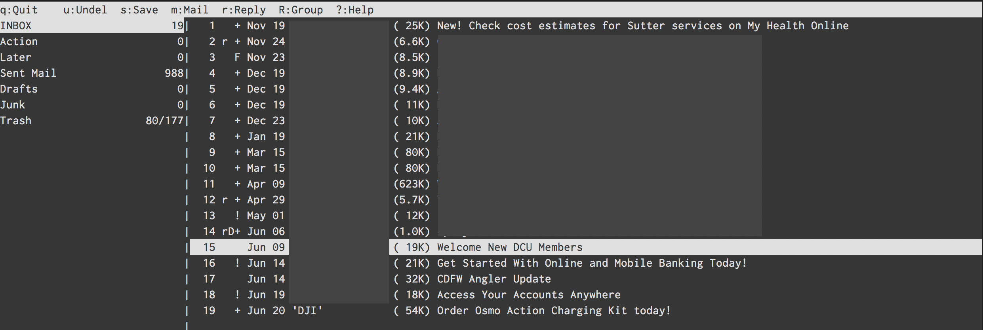
공돌이들만 쓸 것 같은 디자인 (터미널 앱에서 디자인을 따지는 게 우습긴 하지만)에 기능은 엄청 많아서 파고들면 한도 끝도 없을 것 같은 모습의 이메일 앱 Mutt입니다. 처음엔 mutt를 설치해서 사용하다 Notmuch 인덱싱 앱을 같이 쓰면서 좀 더 기능이 추가된, 안그래도 많은 기능에 더 추가된, neomutt을 설치해서 사용하고 있습니다.
사실 mutt만으로도 터미널에서 이메일을 사용하는데에 문제는 없습니다. 오래 전 메일 관리 방식인 Maildir부터해서 IMAP도 지원하고, IMAP 중 인증 방식을 Gmail 최신 인증 방식인 OAUTH까지 지원해서 구지 아래에서 언급 할 다른 앱을 연동해서 사용할 필요가 없어요.
다만, 이 후에 이야기할 것은 모두, 인터넷이 연결되지 않았을 때에도 이메일을 작성하거나, 이메일을 검색할 수 있도록 하고, mutt가 직접 인터넷 연결을 하지 않고 백그라운드에서 알아서 메일을 동기화 시킬 수 있게 하는 방법에 관한 것입니다. mutt에서 직접 IMAP 폴더에 접속하면 반응성이 조금은 떨어지더라구요. 약간씩 반박자 느린 것 같은 느낌에 다른 방법을 조금씩 찾아보다보니 많이 곁다리로 흐르게 되었네요.

OAUTHBEARER 인증
일단, Gmail을 쓰게되면 mutt 환경 설정시 가장 처음 겪게 되는 어려움이 있다면 바로 IMAP, SMTP 인증일 것 같네요. 사실 이게 거의 시작이자 끝입니다. Gmail이 보안성을 향상하고자 IMAP, SMTP는 SSL 보안 채널로만 통신하게 했는데, 거기에 더해서 비밀번호조차 사용할 수 없게 바꿔놓았습니다. 예전엔 계정을 보안에 취약한 계정으로 옵션을 바꾸면 로그인 비밀번호를 이용해 IMAP, SMTP를 쓸수 있었다고 하는데, 이젠 그것도 안되고 AppPassword나 아니면 OAuth2를 이용해서만 로그인 할 수 있는 걸로 압니다.
AppPassword는 이미 Apple Mail에서 써왔는데, 곧 사라질지도 모른다는 소문이 있어서 OAuth2를 이용해서 로그인 하는 방법을 썼네요.
먼저 구글 개발자 콘솔에서 Credential 토큰을 만들어야 합니다. 아마 터미널에서 이메일을 사용하고자 하는 사람이라면 어느정도는 이해하실거라 봅니다. 이해가 안되면 사실 터미널에서 이메일 쓰는 걸 권장하지 않아요. 정말 이건 Nerd만을 위한 세팅이니까요…
Google Developer Console 에 들어가셔서 프로젝트가 없다면 만드신 후 Credential에서 Oauth 2.0 Client ID를 하나 만듭니다. 여기서 나오는 Client ID와 Client Secret는 잘 보관해 둡시다.
Google에서 제공하는 oauth2.py 파일을 받아서 실행파일 옵션을 줍시다. 이 파일이 일정시간마다 새로운 접속 토큰을 구글 서버에서 받아오는 일을 합니다. help option을 보면 어떻게 사용하는 지 나오는데, 일단 Auth token을 생성합니다.
$ oauth2.py --generate_oauth2_token --client_id={ID} --client_secret={SECRET}
커맨드를 실행하면 웹브라우저가 열리면서 verification code를 생성하고 refresh token과 access token을 만듭니다. 여기서 refresh token을 잘 보관합니다. 이 토큰은 다음에도 다시 access token을 만들어내는데 쓰입니다. 그러면 .muttrc에서 $imap_oauth_refresh_command, $smtp_oauth_refresh_command에 아래 항목을 추가하면 mutt가 IMAP에 접근할 때나 메일을 보내려할 때 oauth2.py를 실행해서 토큰을 만들어냅니다.
"oauth2.py --quiet --client_id={ID} \
--client_secret={SECRET} \
--refresh_token={TOKEN}"

MSMTP
여기서 좀 더 발전해서 메일을 관리하는 mutt와 메일을 주고 받는 SMTP, IMAP을 분리하려고 했습니다. 먼저 SMTP를 보면, 대세는 MSMTP더군요. MSMTP는 인증을 LOGIN 인증 (ID, Password)만 지원했으나 1.8.4 버전에서 OAUTH를 지원하기 시작했습니다. 뭐 그래봤자 그냥 로그인 할 때 AUTH OAUTHBEARER {PASSWORD}를 보내는 것 밖에 없더군요. 그래서 저 Password 부분에 무었을 넣어야 할 지 정말 헤맸습니다.
결국 OAUTHBEARER spec을 찾아본 뒤에야 아래의 포맷으로 보내야 되는 걸 알게 되었네요.
n,a=user@gmail.com,\001host=smtp.gmail.com\001port=465\001auth=bearer\001
{access_token}\001\001
위의 access_token은 refresh token을 이용해서 만들어지는 토큰으로 oauth2.py를 사용하면 얻어낼 수 있으나, oauthbearer 인증 문자열은 oauth2.py에서는 만들어내질 않더군요. 조금 더 오래 된 XOAUTH2 방식만 만들어냅니다. 그래서 일단 oauth2.py를 이용해 access_token을 얻어낸 후 위의 문자열에 치환해서 base64 encoding을 하게 하는 쉘 스크립트를 만들어 msmtp의 passwordeval 값에 넣게 했습니다.
한 문단에 끝날 내용을 알아내기위해 거의 하루를 허비했죠. :)
덤으로, 보안을 좀 더 높이기 위해 client_id, client_secret, refresh_token을 gpg encrypt 해서 파일로 보관했습니다. 그래서 shell script에서 gpg -d 명령을 이용해 파일에서부터 decrypt합니다. 덕분에 주기적으로 gpg 암호를 입력해야 하긴 하지만 보안이 조금은 올라가게 되어 불편함은 감수할 만 했네요.

IMAP
사실 이 부분에서 가장 시간을 많이 허비했네요. 너무 많은 IMAP 클라이언트 앱이 있어서 그 중에 어떤 것을 써야 할 지 테스트 해보고 적용하느라 많이 시간을 썼습니다.
가장 처음 시도했던 것은 OfflineIMAP입니다. 가장 널리 알려져 있는 프로그램이기도 하고 세팅하는 데 가장 시간이 덜 걸렸던 앱이기도 합니다. oauth2가 이미 잘 지원되어 id, secret, refresh token만 넣어주면 알아서 억세스 토큰을 만들어 gmail에 접속합니다.
다만 사용하면서 좀 문제가 된 부분은, Gmail의 Label을 잘 지원하지 못한다는 점입니다. 태생이 Maildir은 파일 단위로 이메일을 관리하는 방식이고 Gmail은 Tagging 방식이라 서로 잘 섞이지 못하는게 어찌 보면 당연해 보이긴 하지만, 오프라인으로 이메일을 관리하다가 gmail web 에 접속하면 읽었던 메일이 여전히 인박스에 있고 (읽으면 archive를 보통합니다) 지운 메일이 잘 안지워지는 등 웹앱과 혼용하기가 조금 어렵더군요. 스마트폰으로 이메일을 보는 경우도 잦아서 두개가 싱크가 잘 맞았으면 했지만 그건 좀 어려워 보였습니다.
게다가 IMAP 싱크하는 데에 시간이 꽤 많이 걸리는 부분도 문제였죠. Label별로 폴더가 만들어지고 서로 중복되기도 해서 메일이 새로 왔는지 확인하는 시간이 꽤 걸립니다. 어찌 저찌 세팅은 다 맞춰서 동작하는 데에 무리가 없었지만, CPU도 잡아먹고 시간도 걸리고 해서 다른 방법이 있을까? 하고 좀 더 검색해 보았네요.
다음 후보는 mbsync (isync) 였는데, 이 앱은 하루를 허비하고는 포기했네요. Oauth2를 이용해서 접속하는 게 매우 까다로웠습니다. app password를 쓰는 게 가장 속편한데 app password는 쓰지 않기로 해서 건너뛰었네요. 대신 싱크 속도는 OfflineIMAP보다 매우 빨랐습니다.
그리고 마지막으로 시도한 프로그램이 gmailieer입니다. 이젠 이름이 lieer로 바뀌었더군요. 이 앱은 Gmail 전용 프로그램입니다. Google Gmail API를 이용해서 이메일을 받아와서 무척 속도도 빠르지만 Gmail에만 종속되어있죠. 뭐 제 이메일이 gmail만 사용하고 있어서 이 부분은 문제가 되지 않았네요.
개발자 콘솔에서 Gmail API를 활성화 시켜주고 나면 같은 Oauth를 이용해 접근할 수 있습니다. gmailieer에서 알아서 refresh_token까지 생생하는 것을 도와주니 이전에 썼던 토큰을 써도 되고 따로 써도 되더군요.

Notmuch
gauteh/lieer 프로그램을 쓰기 위해선 반드시 하나의 프로그램이 더 필요한데 notmuch 라는 프로그램입니다. Notmuch는 이메일을 인덱싱하고 tag를 관리해 주는 프로그램인데, gauteh/lieer 프로그램이 Gmail API를 이용해 메일을 긁어와서 이 notmuch 용 태그로 변환을 시켜줍니다. 태그라서 이메일 중복 걱정도 없더군요. 그러나 기존 세팅과는 다르게 mutt에서 virtual spool file을 써야합니다. 게다가 폴더 개념도 없어져서, 기존에 만들어 두었던 모든 단축키가 무용지물이 되더군요. 그 모든 것을 다 수정하고 설청하고 나니 gauteh/lieer와 찰떡궁합의 세팅이 되었네요.
결국 neomutt + notmuch + lieer + msmtp 조합으로 완성되었습니다. notmuch는 lieer와 neomutt을 이어주는 역할을 하고 msmtp는 순전히 메일을 보내는 용도로만 사용합니다.

afew
notmuch를 쓰게되면, Gmail에서 라벨을 관리하는 것과 비슷한 방식으로 콘솔에서 메일을 관리할 수 있게 됩니다. 이 라벨을 메일을 받아올 때 처리할 수 있는 방법이 있습니다. $NOTMUCHDATADIR/.notmuch/hooks/post-new 스크립트에 필요한 명령어를 입력하면 되는데요. 예를 들면 아래와 같은 커맨드를 넣어두면 특정 주소에서 보낸 메일을 따로 라벨을 추가할 수 있습니다.
#!/usr/bin/env bash
# post-new
notmuch tag:+boss -- from:myboss@example.com
이게 한 두개면 되는데, 점점 많아지면 관리가 점점 힘들어지더군요. 그래서 다른 프로그램이 없나 봤더니 afew가 notmuch 의 new 태그를 가지고 필터링을 할 수 있게 해주는 프로그램이더군요. 이것으로 많은 필터링을 자동화 하고 있습니다.

GnuPG
가장 중요하게 생각했던, 그러나 encryption기능은 일년에 한번 쓸까 말까한 GnuPG는 이미 mutt에서부터 지원합니다. PGP sign key ID만 지정해 두면 메일을 보낼 때 p -> s 키를 이용해 메일을 서명해서 보낼 수 있습니다. Apple Mail에서는 설정이 무척 까다로웠는데 한방에 끝나서 허탈하기까지 합니다.
gpg.rc를 https://gitlab.com/muttmua/mutt/blob/stable/contrib/gpg.rc 에서 다운 받은 후 ~/.mutt/ 폴더에 넣은 후 .muttrc에서 source ~/.mutt/gpg.rc 후 pgp_default_key와 pgp_sign_as 를 각각 기본 Key ID와 Sign Key ID로 지정해주면 세팅이 끝납니다.

Multi Account
(추가: 2019-11-15) 이메일 계정이 두개가 되면서 배운 사실을 기록해 볼까 합니다. 이메일 계정이 두개가 되면 메일을 받아오는 lieer는 각각의 계정마다 따로 실행되어야 합니다. 그런데 notmuch는 필터링 규칙도 있다보니 한방에 실행되는게 좋구요. neomutt도 한 곳에서만 쓰니 아무래도 notmuch는 한곳에 있는게 낫더군요.
그래서 고심하면서 구글링을 하다보니, 아래와 같은 디렉토리 구조가 나오게 되었습니다.
~/Maildir/
.notmuch/ # Notmuch
hooks/post-new # afew 프로그램 실행 스크립트
work/ # Work email 계정
.gmaileer.conf # lieer config
home/ # Personal email 계정
.gmaileer.conf # lieer config
~/.notmuch-config 에서 디렉토리를 ~/Maildir로 정해주어야 하고, 이메일도 두 계정의 이메일을 모두 추가합니다. neomutt 또한 mailbox 디렉토리를 ~/Maildir 로 지정해서 두 계정의 이메일을 한번에 불러올 수 있도록 설정해야 클라이언트 하나에서 볼 수 있습니다.
work/, home/ 을 섞어쓰면 문제점이 메일을 작성할 때 from 부분이 항상 primary 이메일 주소로 지정이 되더군요. 이 부분을 항상 유심히 보고 고쳐주어야 합니다. 아니면 아예 neomutt에서 각 계정에 해당하는 메일 작성 단축키를 따로 지정하는 것도 유용합니다.
답변을 할 때에는, neomutt 설정 파일에 alternates 에 이메일을 추가로 기입해 주고 set envelope_from=yes 와 set reverse_name=yes를 추가하면, 받은 사람 주소를 from으로 사용합니다. 즉 work@example.com으로 이메일이 오면 그 이메일이 alternates에 있을 경우 해당 이메일을 from 으로 설정해서 답변메일을 작성합니다.

Conclusion
장황하게 복잡한 내용을 이해를 바라지않고 써내려가긴 했지만, 몇몇 분에게는 유용한 팁이 되길 바라는 마음에 글을 써봅니다. 저 조차도 이 세팅을 해 가면서 OAuth2에 대한 자료가 너무 없어서 힘들었었는데, 누군가는 이 글을 보고 일주일동한 파고들었어야 할 일을 10분안에 끝낼 수 있었으면 좋겠네요.

postfix와 dovecot port 충돌하는 경우

/etc/dovecat/conf.d/10-master.conf 파일을 열어서
안쓰는 서비스의 포트를 0으로 정하거나,
submission같은 경우 포트넘버를 (특히 587번 포트) 다른 걸로 바꾸면 됨.

service imap-login {
inet_listener imap {
port = 143
}
inet_listener imaps {
#port = 993
#ssl = yes
}
# Number of processes to always keep waiting for more connections.
#process_min_avail = 0
# If you set service_count=0, you probably need to grow this.
#vsz_limit = $default_vsz_limit
}
service pop3-login {
inet_listener pop3 {
#port = 110
port = 0
}
inet_listener pop3s {
#port = 995
#ssl = yes
port = 0
}
}
service submission-login {
inet_listener submission {
#port = 587
port = 110
}
inet_listener submissions {
#port = 465
port = 995
ssl = yes
}
}
service lmtp {
unix_listener lmtp {
#mode = 0666
--------------------------------------------------------------
Thank you so much. For anyone else struggling with this in the future: I went into my dovecot file 10-master.conf and added the following lines:
service pop3-login { inet_listener pop3 { port = 110 } inet_listener pop3s { port = 995 ssl = yes } } NB
, in dovecot.conf, I only set the protocols to imap and pop -- Dovecot threw a warning when I added pop3s.
So in dovecot.conf I have: protocols = pop3 imap In Gmail, I just entered my username/pw, mail.example.com, set the port to 995, and checked the "always use SSL" checkbox, and everything worked
IMAP, POP, SMTP에서는 기본 IMAP AUTHENTICATE, POP AUTH, SMTP AUTH 명령어를 사용하는 표준 단순 인증 및 보안 레이어 (SASL)를 사용하여 사용자를 인증합니다. SASL XOAUTH2 메커니즘을 사용하면 클라이언트가 인증을 위한 OAuth 2.0 자격 증명을 제공할 수 있습니다. SASL XOAUTH2 프로토콜 문서는 SASL XOAUTH2 메커니즘을 자세히 설명하며, 프로토콜을 구현한 라이브러리 및 샘플을 사용할 수 있습니다.
IMAP 서버(imap.gmail.com:993) 및 POP 서버(pop.gmail.com:995)에 수신되는 연결은 SSL이 필요합니다. 발신 SMTP 서버(smtp.gmail.com)에서 TLS를 지원합니다. 클라이언트가 일반 텍스트로 시작되는 경우, STARTTLS 명령어를 실행하기 전에 포트 465 (SSL용) 또는 포트 587 (TLS용)을 사용하세요.
-$ openssl s_client -connect imap.mydomain.com:993 -crlf -quiet
b64mb13873418jai uvutgdxblishucxs

Cyrus SASL
https://www.cyrusimap.org/sasl/
Welcome to Cyrus SASL.

What SASL is
SASL, the Simple Authentication and Security Layer, is a generic mechanism for protocols to accomplish authentication. Since protocols (such as SMTP or IMAP) use SASL, it is a natural place for code sharing between applications. Some notable applications that use the Cyrus SASL library include Sendmail, Cyrus imapd, and OpenLDAP.
Applications use the SASL library to tell them how to accomplish the SASL protocol exchange, and what the results were.
SASL is only a framework: specific SASL mechanisms govern the exact protocol exchange. If there are n protocols and m different ways of authenticating, SASL attempts to make it so only n plus m different specifications need be written instead of n times m different specifications. With the Cyrus SASL library, the mechanisms need only be written once, and they’ll work with all servers that use it.

What is Cyrus SASL?
Simple Authentication and Security Layer (SASL) is a specification that describes how authentication mechanisms can be plugged into an application protocol on the wire. Cyrus SASL is an implementation of SASL that makes it easy for application developers to integrate authentication mechanisms into their application in a generic way.
The latest stable version of Cyrus SASL is 2.1.28.
Cyrus IMAP uses Cyrus SASL to provide authentication support to the mail server, however it is just one project using Cyrus SASL.

Features
Cyrus SASL provides a number of authentication plugins out of the box.
LMDB, GDBM, or NDBM (sasldb), PAM, MySQL, PostgreSQL, SQLite, LDAP, Active Directory (LDAP), DCE, Kerberos 5, proxied IMAP auth, getpwent, shadow, SIA, Courier Authdaemon, httpform, APOP and SASL mechanisms: ANONYMOUS, EXTERNAL, GSSAPI, OTP, PASSDSS, PLAIN, SCRAM, SRP
This document is an introduction to Cyrus SASL. It is not intended to be an exhaustive reference for the SASL Application Programming Interface (API), which is detailed in the SASL manual pages, and the libsasl.h header file.

Quickstart Guide
- Introduction to Cyrus IMAP
  - What is IMAP?

Quick install
A quick guide to getting a basic installation of Cyrus up and running in 5 minutes.
The first place to start with a new installation of Cyrus IMAP is with your OS distribution of choice and their packaging, where available.
If there is no Cyrus IMAP 3.8.1 package available yet from your distro, download the official source tarball from GitHub. The Compiling guide will help you get it built and installed.

1. Install Cyrus package(s)
Install the Cyrus IMAP package(s), either from your distribution's package manager, or from a release tarball.
Your distribution might have split Cyrus IMAP into several packages. Check their documentation if you're not sure what you need.

2. Setup the cyrus:mail user and group
Now let's create a special user account just for the Cyrus server to sandbox Cyrus: called cyrus. We'll also create a mail group as well. This allows Cyrus to give other programs some permissions if they are run under the mail group, again, without causing a Cyrus bug to delete all of your cat pictures. Disaster!
If you have installed from packages, your package vendor may have already done this for you. To check, use these commands:
$ getent group mail
mail:x:8:
$ getent passwd cyrus
cyrus:x:999:8:Cyrus IMAP Server:/var/lib/imap:/bin/bash
Example group and user creation commands for GNU/Linux:
groupadd -fr mail
useradd -c "Cyrus IMAP Server" -d /var/lib/imap -g mail -s /bin/bash -r cyrus
The var/lib/imap directory above is an example. Use the same directory specified in the configdirectory option in imapd.conf(5).
configdirectory
This shows the default value: change it in imapd.conf to suit your needs.
configdirectory: <none>
The pathname of the IMAP configuration directory. This field is required.
If your installation uses system locations for things like SSL certificates (i.e. /etc/ssl/certs /etc/ssl/private), then you should also add the cyrus user to the appropriate group to gain access to the PKI files. On Debian/Ubuntu systems, for example, this group is ssl-cert:
usermod -aG ssl-cert cyrus

3. Setting up authentication with SASL
Now, let's set up SASL. This will allow you to connect to your local IMAP server and login, just like any IMAP user would before checking for new emails.
Create a saslauth group and add the cyrus user to the group, so Cyrus can access SASL. (on Debian, this group is called 'sasl': adjust the following commands to suit.)
groupadd -fr saslauth
usermod -aG saslauth cyrus
Change the default SASL configuration in /etc/default/saslauthd.
- Make sure that the START option is set to yes (START=yes) and
- Set the``MECHANISMS`` option to sasldb (MECHANISMS="sasldb").
Start the SASL auth daemon:
/etc/init.d/saslauthd start
Now, we'll create the IMAP user inside SASL. This is the user you'll use to login to the IMAP server later on.
echo 'secret' | saslpasswd2 -p -c imapuser
You can replace secret with a more suitable password you want and imapuser with the username you want. Once this is done, check that the user exists and is set up correctly:
testsaslauthd -u imapuser -p secret -f /var/run/saslauthd/mux
You should get an 0: OK "Success." message.

4. Setup mail delivery from your MTA
Your Cyrus IMAP server will want to receive the emails accepted by your SMTP server (ie Sendmail, Postfix, Exim). See Mail delivery from your MTA.

5. Protocol ports
The Cyrus IMAP server provides service interfaces via either TCP/IP ports or Unix domain sockets. For the former, Cyrus requires that there are proper entries in the host's /etc/services file. The following are required for any host using the listed services:
pop3 110/tcp # Post Office Protocol v3
nntp 119/tcp # Network News Transport Protocol
imap 143/tcp # Internet Mail Access Protocol rev4
nntps 563/tcp # NNTP over TLS
imaps 993/tcp # IMAP over TLS
pop3s 995/tcp # POP3 over TLS
kpop 1109/tcp # Kerberized Post Office Protocol
lmtp 2003/tcp # Lightweight Mail Transport Protocol service
smmap 2004/tcp # Cyrus smmapd (quota check) service
csync 2005/tcp # Cyrus replication service
mupdate 3905/tcp # Cyrus mupdate service
sieve 4190/tcp # timsieved Sieve Mail Filtering Language service
Make sure that these lines are present or add them if they are missing.

6. Configuring Cyrus
(Nearly there)
Set up a simple directory structure for Cyrus to store emails, owned by the cyrus user and group mail:
sudo mkdir -p /var/lib/cyrus /var/spool/cyrus
sudo chown -R cyrus:mail /var/lib/cyrus /var/spool/cyrus
sudo chmod 750 /var/lib/cyrus /var/spool/cyrus
The /var/spool/cyrus directory is the partition where Cyrus will store mail and must be allocated sufficient storage. The exact location can be configured in imapd.conf(5) in the partitions options.
Following installation, a fairly comprehensive set of sample configuration files may be found in /usr/share/doc/cyrus-doc/examples/. Select one from each of the cyrus_conf and imapd_conf directories, and install as /etc/cyrus.conf and /etc/imapd.conf respectively.
A basic description of these files:
- Stand-alone server configurations (pick one):
  - small.conf
A simple small server
  - normal.conf
A more typical server
  - prefork.conf
As above, but with several server processes pre-forked for faster connection initialization.
Note
The normal.conf file in the imapd_conf directory is intended to work with any of the above files from the cyrus_conf directory.
- Cyrus Aggregation - Murder -- configurations (these constitute a set, with at least one of each required):
  - murder-mupdate.conf
The Mupdate Master server; holds the canonical copy of the mailboxes.db database.
  - murder-backend.conf
A backend server which holds the actual mailboxes and interacts with frontend proxies and/or clients.
  - murder-frontend.conf
A frontend server which holds no mailboxes, but either refers clients to the proper backend server for each requests, or proxies those requests directly.
- Replication configurations (these constitute a set, with one master and at least one replica required):
  - normal-master.conf
The master server which uses the sync_client program to send mailbox updates to each replica on a rolling or periodic basis.
  - normal-replica.conf
A typical replica server, which accepts updates from the master.
Note
When working with replication or aggregation (Murder), the example files in cyrus_conf and imapd_conf of the same name are intended to be used together.
You should review each of these and then install as desired to /etc/, making changes as needed. In particular, you'll need to set passwords for the various users used to authenticate between instances in a Murder or Replication environment.
For example:
install -m 600 doc/examples/cyrus_conf/normal.conf /etc/cyrus.conf
install -m 600 doc/examples/imapd_conf/normal.conf /etc/imapd.conf
vi /etc/imapd.conf
...
vi /etc/cyrus.conf
...

7. Launch Cyrus
If using a distribution package, you probably now have an init script installed, that you can invoke with your system's usual service control mechanism.
If you built from source, you will need to write your own init script. The simplest one will simply start/stop the master(8) binary, with suitable options, as root (master will drop root privileges itself as soon as it possibly can).

SASL authentication in the Postfix SMTP client

Postfix and sbcglobal/yahoo/att
출처 : https://wiki.debian.org/PostfixAndSASL
- SBC global block port 25 on its DSL users:
http://help.sbcglobal.net/article.php?item=4640
- We will use sbc smtp server via authentication to send emails. Do this:
apt-get install libsasl2-modules
- ADD to main.cf by using postconf. Just type (smtp.att.yahoo.com requires the port 587 otherwise you don't need it):
postconf -e "relayhost = [smtp.sbcglobal.yahoo.com]:587"
postconf -e "smtp_sasl_auth_enable = yes"
postconf -e "smtp_sasl_password_maps = hash:/etc/postfix/sasl_passwd"
postconf -e "smtp_sasl_security_options = noanonymous"
- Create a file called sasl_passwd in /etc/postfix/sasl_passwd. Inside type in
[smtp.sbcglobal.yahoo.com]:587 username@sbcglobal.net:mypassword
- Now change permissions so others can't read it:
chmod 600 /etc/postfix/sasl_passwd
- Now postmap it. (It creates a database-like file so postfix can read it.)
postmap /etc/postfix/sasl_passwd
- Restart postfix
postfix reload
- Done. You can use "mutt" to send emails outside. Check /var/log/mail.log to see if everything is working.
- After a switch from sbcglobal to att you need to verify you email address in your yahoo email options. If you have 100s of mailing lists you will need to unblock your port 25 since it is impossible to use att yahoo smtp servers without verifying each email address.
- To opt out of your port 25 (get it unfiltered) leave a request here:Unfilter port 25 on smtp.att.yahoo.com

How To Use Journalctl to View and Manipulate Systemd Logs
출처 : https://www.digitalocean.com/community/tutorials/how-to-use-journalctl-to-view-and-manipulate-systemd-logs

SSL VS SSH
출처 : https://devdebin.tistory.com/132
목차
- 1. SSH
- 2. SSL
이번 UMC Sever 파트 AWS EC2 인스턴스 실습을 하면서 유독 자주 보인 이 두 단어에 대해 정리해보겠습니다.
만약 안보셨다면 이 게시글 부터 쭈욱 정주행하시는 것을 추천..!!ㅎㅎ
https://devdebin.tistory.com/129?category=1010886

2주차 실습 : AWS EC2 인스턴스 생성
솔직히 고해하자면 저번주에 여자친구와 1주년, 고등학교 친구들과 MT로 인해 너무나도 바쁜 나머지....(핑계) AWS EC2 인스턴스 생성에 대해 그냥 넘어가버렸다. 3주차 실습은 ec2 인스턴스 생성을
devdebin.tistory.com

무튼 ...생긴 것도 매우 비슷하게 생겼네.... 먼저 SSH에 대해 정리해보겠습니다.

1. SSH

SSH란?
SSH는 Secure Shell의 줄임말로, 원격 호스트에 접속하기 위해 사용되는 보안 프로토콜이다. 포트 번호는 22번이다.
쉘은 CLI 환경을 떠올리면 되겠다. 기존 원격 접속은 텔넷(Telnet)이라는 방식을 사용했는데, 암호화를 제공하지 않기 때문에 보안상 취약했다. 누구나 쉽게 원격 접속 과정에서 옮겨지는 비밀번호나 파일 내용 등의 데이터를 탈취할 수 있었다고 한다.
그래서 등장한 것이 SSH 프로토콜이다. 현재는 클라우드 서비스에서 제공하는 서버는 기본적으로 원격 접속을 해서 접근하고 사용한다.
그래서 AWS, MS azure 같은 클라우드 서비스 제공 회사들은 서버 생성시 필수적으로 SSH 보안 과정을 거친다.
SSH는 통신 과정에서 모든 것이 암호화 되어, 통신이 노출된다고 하더라도 이해할 수 없는 암호화된 문자로 보인다!

SSH 작동 방식
SSH를 구성하는 가장 핵심 키워드는 KEY(열쇠)다. 사용자(클라이언트)와 서버(호스트)는 각각의 키를 보유하고 있으며, 이 키를 이용해 연결 상대를 인증하고 안전하게 데이터를 주고 받는다. 여기서 키를 생성하는 방식이 두 가지가 있다.
바로 대칭키와 비대칭키(공개 키) 방식이다. 이제 각각의 방식들에 대해 알아보자.

비대칭키
비대칭키 방식에서는 서버 또는 사용자가 Key pair(키 쌍)을 생성한다. 키 페어는 공개 키와 개인키의 두 가지로 이루어진다.
공개 키와 개인 키는 서로 다른 키로 서로 페어인 키들로만 암호화한 메시지를 복호화가 가능하다.
다른 페어의 키들과는 이런 과정을 진행할 수 없다.

쉽게 예시를 가지고 생각을 해보자!
사용자가 키 페어를 생성했고, 서버에게 공개 키를 주었다.
공개 키는 말 그대로 '공개' 키므로 누구나 가질 수 있다.
개인 키는 말 그대로 개인이 소장하며 누구한테도 보여주면 안되는 중요한 키(파일)이다. 사용자가 가지고 있다.

서버의 공개 키를 사용해 암호화된 인증 메시지를 클라이언트에게 보낸다.
공개 키를 사용해 암호화된 메시지는 오직 페어인 개인 키를 사용해 복호화할 수 있다.
이런 논리를 사용해 서버와 클라이언트 간 사이를 증명할 수 있다.

암호화된 메시지를 받으면 클라이언트는 개인키를 이용해 그것을 풀고 서버에게 제출한다.
서버는 사용자에게 전송받은 값을 자신이 암호화하기 전 원본 메시지와 비교한다.
만약 두 값이 맞다면, 서버는 사용자를 페어 키의 주인으로 인지하고 접속을 허용한다.
이렇게 최초 접속 시 사용자와 서버 간의 인증 절차가 비대칭키 방식을 이용해 완료된다.
이러면 SSH 세션이 시작된다!!!

참고
- 보통 공개 키의 경우 .pub, 개인 키의 경우 .pem의 파일 형식을 띄운다.
- 우리는 AWS Ec2 인스턴스를 생성하면서 .pem 파일을 다운받았다.
대칭키
사용자 또는 서버는 하나의 대칭 키를 만들어 서로 공유한다.
공유된 대칭 키를 이용해 보낼 메시지를 암호화하면, 받은 쪽에서 동일한 대칭 키로 메시지의 복호화를 진행해 정보를 습득한다.
결론적으로 암호화, 복호화 할 때 사용하는 키가 동일하기 때문에 대칭 키라고 하는 것이다.
이 키를 안전하게 전달하는 것이 제일 중요한 포인트라고 한다.

보통 정보 교환이 완료되면 교환 당시 썼던 대칭 키는 폐기되고, 나중에 다시 접속할 때마다 새로운 대칭 키를 생성해서 사용한다.
또한 비대칭키 방식으로 서로를 인증하면 대칭 키 방식을 사용해 정보를 주고 받는다.
이러한 방식들을 이용해 원격 접속 과정이 SSH를 통해 안전하게 이루어진다.

2. SSL
SSL에 대해 알아보자.
- SSL(Secure Sockets Layer)은 암호화 기반 인터넷 보안 프로토콜이다.
- SSL은 기밀성, 데이터 무결성, 서버 인증과 클라이언트 인증을 통해 TCP를 향상시켰다고 한다.
- SSL/TLS을 적용하는 웹사이트는 HTTPS 프로토콜을 사용한다.
- HTTPS는 HTTP를 SSL/TLS를 적용해서 통신 과정에 암호화를 더해 보안성을 높인 프로토콜다..
- TLS는 SSL의 좀 더 발전한 모습이라고 이해할 수 있겠다.

우리가 저번 AWS 실습에서 많이 본 SSL 인증서란 무엇일까??
SSL 인증서는 클라이언트와 서버간의 통신을 제3자가 보증해주는 전자화된 문서다.
우리의 경우는 Let's Encrypt 가 3자다. 즉 CA(certificate authority), 인증기관이다.
SSL 인증서에는 서버 공개키와 서비스의 정보가 들어가 있다.

클라이언트가 서버에 접속한 직후에 서버는 클라이언트에게 이 인증서 정보를 전달한다.
클라이언트는 이 인증서 정보가 신뢰할 수 있는 것인지를 검증 한 후에 다음 절차를 수행하게 된다.
SSL과 SSL 디지털 인증서를 이용했을 때의 이점은 아래와 같다.
- 통신 내용이 공격자에게 노출되는 것을 막을 수 있다.
- 클라이언트가 접속하려는 서버가 신뢰 할 수 있는 서버인지를 판단할 수 있다.
- 통신 내용의 악의적인 변경을 방지할 수 있다.
SSL 인증서는 공개 키와 개인 키라는 키 쌍을 갖고 있다. 이 키들이 함께 작용하여 암호화된 연결을 수립한다.
SSL의 통신 과정은 크게 3가지로 이루어진다.
- 핸드 셰이킹
- 세션
- 세션 종료
SSL 핸드셰이크는 암호화를 사용하는 통신 세션을 실행하는 프로세스다.
먼저 SSL 핸드셰이크에 대해 알아보자.
핸드 셰이크는 대칭 키 방식, 비 대칭키 방식을 모두 사용한다.

첫 번째 단계 : TCP 연결
먼저 SSL은 TCP 바탕으로 TCP 3 way hand shaking 으로 TCP 연결이 만들어지면 SSL 핸드셰이크가 시작된다.

두 번째 단계 : 클라이언트 헬로 메시지
클라이언트가 서버로 헬로 메시지를 전송하면서 SSL 핸드셰이크를 시작한다.
이 메시지에는 클라이언트가 지원하는 SSL/TLS 버전, 지원하는 암호화 알고리즘의 목록과 랜덤한 바이트 문자열을 보낸다.

세 번째 단계 : 서버 헬로 메시지
서버가 클라이언트에게 헬로 메시지를 전송한다. 즉 응답이라고 볼 수 있겠다.
서버는 클라이언트가 지원하는 암호화 알고리즘 목록에서 한 가지 알고리즘을 선택하고, 서버의 SSL 인증서, 그리고 서버에서 생성한 또 다른 무작위 바이트 문자열을 모두 담아 클라이언트에게 전송한다. (선택 알고리즘, SSL 인증서, 무작위 문자열 전송)

네 번째 단계 : 인증과 예비 마스터 암호
이를 통해 서버가 인증서에 명시된 서버인지, 그리고 클라이언트가 상호 작용 중인 서버가 실제 해당 도메인의 소유자인지를 확인한다.

클라이언트가 서버의 SSL 인증서를 인증서 내장된 CA(발행 기관) 리스트를 통해 검증한다.
만약 CA리스트에 인증서가 없다면 사용자에게 경고 메시지를 출력한다.
인증서가 CA에 의해서 발급된 것인지 확인하기 위해서 클라이언트에 내장된 CA의 공개키를 이용해서 인증서를 복호화한다.
복호화에 성공한다면 인증서는 CA의 개인키로 암호화된 문서임이 보증된 것이다.
왜냐면 CA의 개인키로 암호화 된 것을 CA 공개키로 복호화 했기 때문이다!!!!!

클라이언트는 SSL 인증서를 통해 서버의 공개 키를 알아 낸다.
이제 PMS(Pre-Master-Secret)를 생성한다.
PMS는 서버의 무작위 바이트 문자열과 클라이언트의 무작위 바이트 문자열을 바탕으로 만들어진다.
PMS는 서버의 공개키를 통해 암호화되어 서버에게 전달된다.
PMS는 이후에 세션 단계 에서 암호화하기 위해 사용할 것이며 암호화 기법이 대칭키이므로 절대로 노출되어서는 안된다.

다섯 번째 단계 : 서버의 개인 키 사용
클라이언트는 서버의 공개키로 암호화된 PMS를 서버로 보낸다.
그러면 서버는 자신의 개인키를 사용해 PMS를 복호화한다. 이제 서버와 클라이언트는 PMS를 공유하게 되었다.

여섯 번째 단계 : 세션 키 생성
서버와 클라이언트는 일련의 과정(SSL 표준에 지정된 키 유도 함수)을 거쳐 PMS를 Master Secret 값으로 만든다.
그리고 Master Secretf를 사용해 Session Key를 만든다.

일곱 번째 단계 : 클라이언트, 서버 준비 완료 후 안전한 대칭 암호화 성공
클라이언트가 세션 키로 암호화된 완료 메시지를 보내고, 서버가 세션 키로 암호화된 완료 메시지를 보낸다.
이제 서버와 클라이언트는 데이터를 대칭키 방식으로 암호화한 후에 주고 받는다.
이렇게 해서 세션키를 클라이언트와 서버가 모두 공유하게 되었다. SSL 핸드셰이킹을 완료한 것이다.

이번에는 핸드 셰이킹 다음 단계인 셰션 단계다.
세션은 실제로 서버와 클라이언트가 데이터를 주고 받는 단계다.
이 단계에서 핵심은 정보를 상대방에게 전송하기 전에 세션 키 값을 이용해서 대칭키 방식으로 암호화 한다는 점이다.
암호화된 정보는 상대방에게 전송되고, 상대방도 세션키 값을 알고 있기 때문에 암호를 복호화할 수 있다.

대칭키를 사용하는 이유는 무엇일까? 공개키(비대칭키) 방식은 많은 비용이 들기 때문이다. 사용자의 트래픽이 많은 서버일 수록 엄청난 비용을 지불하게 된다. 반대로 대칭키는 암호를 푸는 열쇠인 대칭키를 상대에게 전송해야 하는데, 암호화가 되지 않은 인터넷을 통해서 키를 전송하는 것은 위험하다.
따라서 데이터를 안전하게 주고 받을 수 있는 공개 키 방식으로 대칭 키를 암호화하고, 실제 데이터를 주고 받을 때는 대칭키를 이용한다.

마지막 세션 종료 단계는 데이터의 전송이 끝나면 SSL 통신이 끝났음을 서로에게 알려주고 대칭 키인 세션 키를 폐기한다.

이상으로 SSH VS SSL 포스팅을 마칩니다.
부족하거나 틀린 부분이 있다면 알려주시면 감사드리겠습니다!

How can i view mail using doveadm?
출처 : https://superuser.com/questions/1523594/how-can-i-view-mail-using-

I have mail sent to my dovecot inbox and I can see that there are unread emails. If I run:
doveadm -f table mailbox status -u bob all INBOX
I get:
mailbox messages recent uidnext uidvalidity unseen highestmodseq vsize guid firstsaved
INBOX 2 2 3 1581074875 2 3 37815 26782a22bb493d5e3e070000fb112bbd 1581074773
How can i read these unread messages?
- postfix
- dovecot

1 Answer
Normally you'd use an IMAP client to access mail, as Dovecot is an IMAP server...
mutt -f imap://bob@localhost/INBOX
As a trick, it is possible with some IMAP clients to talk directly to Dovecot, bypassing authentication:
mutt -e 'set tunnel="sudo doveadm exec imap -u bob"' -f imap://nothing/INBOX

But if you need to extract the messages directly, use doveadm fetch or doveadm search:
doveadm fetch -u bob "text" MAILBOX INBOX UNSEEN
Parameters are similar to IMAP – text is a fetch field that contains the entire RFC822 message, the rest are a search query that finds unread messages in the INBOX folder.
/var/log/mail.log 대응 arch linux 명령어

journalctl -u postfix

네임서버 확인 명령어
➜ sudo resolvectl status
[sudo] kimnux 암호:
Global
Protocols: +LLMNR +mDNS -DNSOverTLS DNSSEC=no/unsupported
resolv.conf mode: foreign
Fallback DNS Servers: 1.1.1.1#cloudflare-dns.com 9.9.9.9#dns.quad9.net 8.8.8.8#dns.google
2606:4700:4700::1111#cloudflare-dns.com 2620:fe::9#dns.quad9.net
2001:4860:4860::8888#dns.google
DNS Domain: ~.

Link 2 (enp8s0)
Current Scopes: DNS LLMNR/IPv4 LLMNR/IPv6 mDNS/IPv4 mDNS/IPv6
Protocols: +DefaultRoute +LLMNR +mDNS -DNSOverTLS DNSSEC=no/unsupported
Current DNS Server: 168.126.63.1
DNS Servers: 168.126.63.1 168.126.63.2

/etc/hosts
Note that there may be differences in documentation due to the requirements of a "regular" system versus on servers.
For "regular" systems (e.g., your desktop/laptop/media-center PC/kerosene-powered cheese grater) the requirements are fairly lax: there are a lot of ways to set up /etc/hosts what will work just fine.
For web servers you need to be a bit more strict. For email servers (in my experience) you need to be even more strict. I don't know what exactly is "right" nor what the logic is - but I've learned through the experience of setting up a few servers what actually works or doesn't - and in contrast to web/email servers it really feels like nearly "anything goes" for /etc/hosts for home computers. For my web and mail server I need the following:
127.0.0.1 localhost.localdomain localhost
45.NN.NNN.NNN MyHostName.domain.org MyHostName www Subdomain Subdomain2
::1 localhost.localdomain localhost
2600:XXXX::XXXX:XXXX:XXXX:XXXX MyHostName.domain.org MyHostName www Subdomain Subdomain2
where Ns are decimal digits and X's hex digits. Any deviation from this format that I've tried leads to a failure of the mail and/or web server (the mail fails first). An exception is that the subdomains may be unneccesary ... which I've only just realized as I've added more subdomains without adding them to /etc/hosts and everything still seems fine.

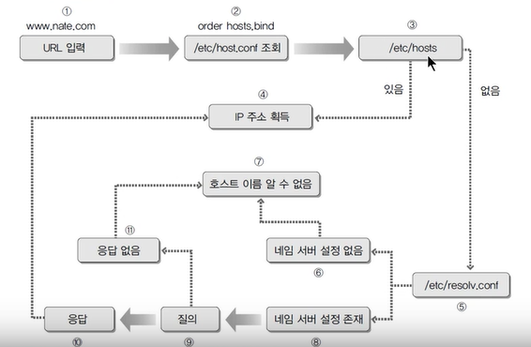
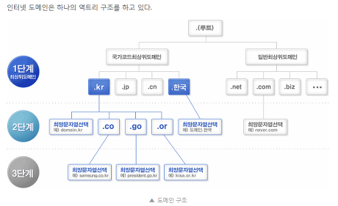

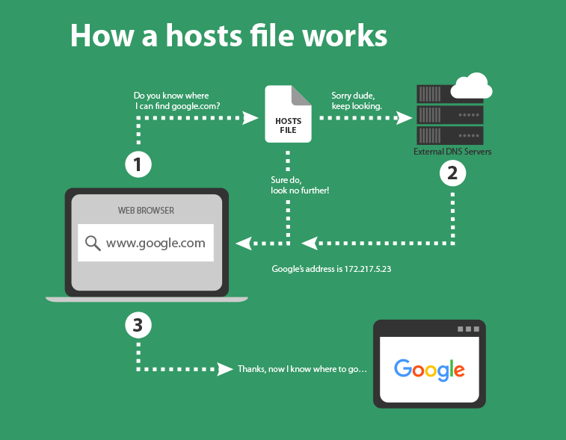
출처 : https://www.freshjones.com/blog/editing-hosts-file-for-web-development
--------------------------------------------------------------------------------------------------------------------

Anatomy of a Linux DNS Lookup – Part I
zwischenzugs Uncategorized 6 Minutes
Since I work a lot with clustered VMs, I’ve ended up spending a lot of time trying to figure out how DNS lookups work. I applied ‘fixes’ to my problems from StackOverflow without really understanding why they work (or don’t work) for some time.
Eventually I got fed up with this and decided to figure out how it all hangs together. I couldn’t find a complete guide for this anywhere online, and talking to colleagues they didn’t know of any (or really what happens in detail)
So I’m writing the guide myself.
Turns out there’s quite a bit in the phrase ‘Linux does a DNS lookup’…

Other posts in the series:
Anatomy of a Linux DNS Lookup – Part II
Anatomy of a Linux DNS Lookup – Part III
Anatomy of a Linux DNS Lookup – Part IV
Anatomy of a Linux DNS Lookup – Part V – Two Debug Nightmares

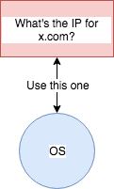
“How hard can it be?”

These posts are intended to break down how a program decides how it gets an IP address on a Linux host, and the components that can get involved. Without understanding how these pieces fit together, debugging and fixing problems with (for example) dnsmasq, vagrant landrush, or resolvconf can be utterly bewildering.
It’s also a valuable illustration of how something so simple can get so very complex over time. I’ve looked at over a dozen different technologies and their archaeologies so far while trying to grok what’s going on.
I even wrote some automation code to allow me to experiment in a VM. Contributions/corrections are welcome.
Note that this is not a post on ‘how DNS works’. This is about everything up to the call to the actual DNS server that’s configured on a linux host (assuming it even calls a DNS server – as you’ll see, it need not), and how it might find out which one to go to, or how it gets the IP some other way.

1) There is no such thing as a ‘DNS Lookup’ call

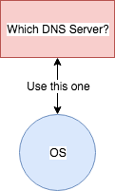
This is NOT how it works

The first thing to grasp is that there is no single method of getting a DNS lookup done on Linux. It’s not a core system call with a clean interface.
There is, however, a standard C library call called which many programs use: getaddrinfo. But not all applications use this!
Let’s just take two simple standard programs: ping and host:
root@linuxdns1:~# ping -c1 bbc.co.uk | head -1
PING bbc.co.uk (151.101.192.81) 56(84) bytes of data.
root@linuxdns1:~# host bbc.co.uk | head -1
bbc.co.uk has address 151.101.192.81
They both get the same result, so they must be doing the same thing, right?
Wrong.
Here’s the files that ping looks at on my host that are relevant to DNS:
root@linuxdns1:~# strace -e trace=open -f ping -c1 google.com
open("/etc/ld.so.cache", O_RDONLY|O_CLOEXEC) = 3
open("/lib/x86_64-linux-gnu/libcap.so.2", O_RDONLY|O_CLOEXEC) = 3
open("/lib/x86_64-linux-gnu/libc.so.6", O_RDONLY|O_CLOEXEC) = 3
open("/etc/resolv.conf", O_RDONLY|O_CLOEXEC) = 4
open("/etc/resolv.conf", O_RDONLY|O_CLOEXEC) = 4
open("/etc/nsswitch.conf", O_RDONLY|O_CLOEXEC) = 4
open("/etc/ld.so.cache", O_RDONLY|O_CLOEXEC) = 4
open("/lib/x86_64-linux-gnu/libnss_files.so.2", O_RDONLY|O_CLOEXEC) = 4
open("/etc/host.conf", O_RDONLY|O_CLOEXEC) = 4
open("/etc/hosts", O_RDONLY|O_CLOEXEC) = 4
open("/etc/ld.so.cache", O_RDONLY|O_CLOEXEC) = 4
open("/lib/x86_64-linux-gnu/libnss_dns.so.2", O_RDONLY|O_CLOEXEC) = 4
open("/lib/x86_64-linux-gnu/libresolv.so.2", O_RDONLY|O_CLOEXEC) = 4
PING google.com (216.58.204.46) 56(84) bytes of data.
open("/etc/hosts", O_RDONLY|O_CLOEXEC) = 4
64 bytes from lhr25s12-in-f14.1e100.net (216.58.204.46): icmp_seq=1 ttl=63 time=13.0 ms
[...]
and the same for host:
$ strace -e trace=open -f host google.com
[...]
[pid 9869] open("/usr/share/locale/en_US.UTF-8/LC_MESSAGES/libdst.cat", O_RDONLY) = -1 ENOENT (No such file or directory)
[pid 9869] open("/usr/share/locale/en/libdst.cat", O_RDONLY) = -1 ENOENT (No such file or directory)
[pid 9869] open("/usr/share/locale/en/LC_MESSAGES/libdst.cat", O_RDONLY) = -1 ENOENT (No such file or directory)
[pid 9869] open("/usr/lib/ssl/openssl.cnf", O_RDONLY) = 6
[pid 9869] open("/usr/lib/x86_64-linux-gnu/openssl-1.0.0/engines/libgost.so", O_RDONLY|O_CLOEXEC) = 6[pid 9869] open("/etc/resolv.conf", O_RDONLY) = 6
google.com has address 216.58.204.46
[...]
You can see that while my ping looks at nsswitch.conf, host does not. And they both look at /etc/resolv.conf.
We’re going to take these two .conf files in turn.

2) NSSwitch, and /etc/nsswitch.conf
We’ve established that applications can do what they like when they decide which DNS server to go to. Many apps (like ping) above can refer (depending on the implementation (*)) to NSSwitch via its config file /etc/nsswitch.conf.

(*) There’s a surprising degree of variation in
ping implementations. That’s a rabbit-hole I
didn’t want to get lost in.
NSSwitch is not just for DNS lookups. It’s also used for passwords and user lookup information (for example).
NSSwitch was originally created as part of the Solaris OS to allow applications to not have to hard-code which file or service they look these things up on, but defer them to this other configurable centralised place they didn’t have to worry about.
Here’s my nsswitch.conf:
passwd: compat
group: compat
shadow: compat
gshadow: files
hosts: files dns myhostname
networks: files
protocols: db files
services: db files
ethers: db files
rpc: db files
netgroup: nis
The ‘hosts’ line is the one we’re interested in. We’ve shown that ping cares about nsswitch.conf so let’s fiddle with it and see how we can mess with ping.

Set nsswitch.conf to only look at ‘files’
If you set the hosts line in nsswitch.conf to be ‘just’ files:
hosts: files
Then a ping to google.com will now fail:
$ ping -c1 google.com
ping: unknown host google.com
but localhost still works:
$ ping -c1 localhost
PING localhost (127.0.0.1) 56(84) bytes of data.
64 bytes from localhost (127.0.0.1): icmp_seq=1 ttl=64 time=0.039 ms
and using host still works fine:
$ host google.com
google.com has address 216.58.206.110
since, as we saw, it doesn’t care about nsswitch.conf

Set nsswitch.conf to only look at ‘dns’
If you set the hosts line in nsswitch.conf to be ‘just’ dns:
hosts: dns
Then a ping to google.com will now succeed again:
$ ping -c1 google.com
PING google.com (216.58.198.174) 56(84) bytes of data.
64 bytes from lhr25s10-in-f174.1e100.net (216.58.198.174): icmp_seq=1 ttl=63 time=8.01 ms
But localhost is not found this time:
$ ping -c1 localhost
ping: unknown host localhost
Here’s a diagram of what’s going on with NSSwitch by default wrt hosts lookup:

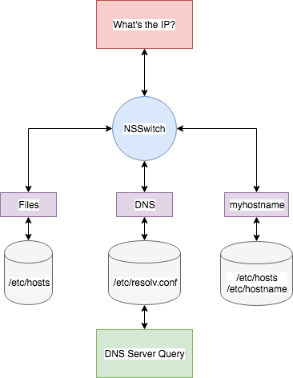
My default ‘hosts:‘ configuration in nsswitch.conf

3) /etc/resolv.conf
We’ve seen now that host and ping both look at this /etc/resolv.conf file.
Here’s what my /etc/resolv.conf looks like:
# Dynamic resolv.conf(5) file for glibc resolver(3) generated by resolvconf(8)
# DO NOT EDIT THIS FILE BY HAND -- YOUR CHANGES WILL BE OVERWRITTEN
nameserver 10.0.2.3
Ignore the first two lines – we’ll come back to those (they are significant, but you’re not ready for that ball of wool yet).
The nameserver lines specify the DNS servers to look up the host for.
If you hash out that line:
#nameserver 10.0.2.3
and run:
$ ping -c1 google.com
ping: unknown host google.com
it fails, because there’s no nameserver to go to (*).

* Another rabbit hole: host appears to fall back to
127.0.0.1:53 if there’s no nameserver specified.
This file takes other options too. For example, if you add this line to the resolv.conf file:
search com
and then ping google (sic)
$ ping google
PING google.com (216.58.204.14) 56(84) bytes of data.
it will try the .com domain automatically for you.

End of Part I
That’s the end of Part I. The next part will start by looking at how that resolv.conf gets created and updated.
Here’s what you covered above:
- There’s no ‘DNS lookup’ call in the OS
- Different programs figure out the IP of an address in different ways
  - For example, ping uses nsswitch, which in turn uses (or can use) /etc/hosts, /etc/resolv.conf and its own hostname to get the result
- /etc/resolv.conf helps decide:
  - which addresses get called
  - which DNS server to look up
If you thought that was complicated, buckle up…

Anatomy of a Linux DNS Lookup – Part II
출처 : https://zwischenzugs.com/2018/06/18/anatomy-of-a-linux-dns-lookup-part-ii/
zwischenzugs Uncategorized 5 Minutes
In Anatomy of a Linux DNS Lookup – Part I I covered:
- nsswitch
- /etc/hosts
- /etc/resolv.conf
- ping vs host style lookups
and determined that most programs reference /etc/resolv.conf along the way to figuring out which DNS server to look up.
That stuff was more general linux behaviour (*) but here we move firmly into distribution-specific territory. I use ubuntu, but a lot of this will overlap with Debian and even CentOS-based distributions, and also differ from earlier or later Ubuntu versions.

(*) in fact, it’s subject to a POSIX standard, so
is not limited to Linux (I learned this from
a fantastic comment on the previous post)
In other words: your host is more likely to differ in its behaviour in specifics from here.
In Part II I’ll cover how resolv.conf can get updated, what happens when systemctl restart networking is run, and how dhclient gets involved.

Other posts in the series:
Anatomy of a Linux DNS Lookup – Part I
Anatomy of a Linux DNS Lookup – Part III
Anatomy of a Linux DNS Lookup – Part IV
Anatomy of a Linux DNS Lookup – Part V – Two Debug Nightmares

1) Updating /etc/resolv.conf by hand
We know that /etc/resolv.conf is (highly likely to be) referenced, so surely you can just add a nameserver to that file, and then your host will use that nameserver in addition to the others, right?
If you try that:
$ echo nameserver 10.10.10.10 >> /etc/resolv.conf
it all looks good:
# Dynamic resolv.conf(5) file for glibc resolver(3) generated by resolvconf(8)
# DO NOT EDIT THIS FILE BY HAND -- YOUR CHANGES WILL BE OVERWRITTEN
nameserver 10.0.2.3
search home
nameserver 10.10.10.10
until the network is restarted:
$ systemctl restart networking
$ cat /etc/resolv.conf
# Dynamic resolv.conf(5) file for glibc resolver(3) generated by resolvconf(8)
# DO NOT EDIT THIS FILE BY HAND -- YOUR CHANGES WILL BE OVERWRITTEN
nameserver 10.0.2.3
search home
our 10.10.10.10 nameserver has gone!
This is where those comments we ignored in Part I come in…

2) resolvconf
You see the phrase generated by resolvconf in the /etc/resolv.conf file above? This is our clue.
If you dig into what systemctl restart networking does, among many other things, it ends up calling a script: /etc/network/if-up.d/000resolvconf. Within this script is a call to resolvconf:
/sbin/resolvconf -a "${IFACE}.${ADDRFAM}"
A little digging through the man pages reveals that the -a flag allows us to:
Add or overwrite the record IFACE.PROG then run the update scripts
if updating is enabled.
So maybe we can call this directly to add a nameserver:
echo 'nameserver 10.10.10.10' | /sbin/resolvconf -a enp0s8.inet
Turns out we can!
$ cat /etc/resolv.conf | grep nameserver
nameserver 10.0.2.3
nameserver 10.10.10.10
So we’re done now, right? This is how /etc/resolv.conf gets updated? Calling resolvconf adds it to a database somewhere, and then updates (if configured, whatever that means) the resolv.conf file
No.
$ systemctl restart networking
root@linuxdns1:/etc# cat /etc/resolv.conf
# Dynamic resolv.conf(5) file for glibc resolver(3) generated by resolvconf(8)
# DO NOT EDIT THIS FILE BY HAND -- YOUR CHANGES WILL BE OVERWRITTEN
nameserver 10.0.2.3
search home
Argh! It’s gone again.
So systemctl restart networking does more than just run resolvconf. It must be getting the nameserver information from somewhere else. Where?

3) ifup/ifdown
Digging further into what systemctl restart networking does tells us a couple of things:
cat /lib/systemd/system/networking.service
[...]
[Service]
Type=oneshot
EnvironmentFile=-/etc/default/networking
ExecStartPre=-/bin/sh -c '[ "$CONFIGURE_INTERFACES" != "no" ] && [ -n "$(ifquery --read-environment --list --exclude=lo)" ] && udevadm settle'
ExecStart=/sbin/ifup -a --read-environment
ExecStop=/sbin/ifdown -a --read-environment --exclude=lo
[...]
First, the networking ‘service’ restart is actually a ‘oneshot’ script that runs these commands:
/sbin/ifdown -a --read-environment --exclude=lo
/bin/sh -c '[ "$CONFIGURE_INTERFACES" != "no" ] && [ -n "$(ifquery --read-environment --list --exclude=lo)" ] && udevadm settle'
/sbin/ifup -a --read-environment
The first line with ifdown brings down all the network interfaces (but excludes the local interface). (*)

(*) I’m unclear why this doesn’t boot me out of my
vagrant session in my example code (anyone know?).
The second line makes sure the system has done all it needs to do regarding the bringing of network interfaces down before going ahead and bringing them all back up with ifup in the third line. So the second thing we learn is that ifup and ifdown are what the networking service ‘actually’ runs.
The --read-environment flag is undocumented, and is there so that systemctl can play nice with it. A lot of people hate systemctl for this kind of thing.
Great. So what does ifup (and its twin, ifdown) do? To cut another long story short, it runs all the scripts in etc/network/if-pre-up.d/ and /etc/network/if-up.d/. These in turn might run other scripts, and so on.
One of the things it does (and I’m still not quite sure how – maybe udev is involved?) dhclient gets run.

4) dhclient
dhclient is a program that interacts with DHCP servers to negotiate the details of what IP address the network interface specified should use. It also can receive a DNS nameserver to use, which then gets placed in the /etc/resolv.conf.
Let’s cut to the chase and simulate what it does, but just on the enp0s3 interface on my example VM, having first removed the nameserver from the /etc/resolv.conf file:
$ sed -i '/nameserver.*/d' /run/resolvconf/resolv.conf
$ cat /etc/resolv.conf | grep nameserver
$ dhclient -r enp0s3 && dhclient -v enp0s3
Killed old client process
Internet Systems Consortium DHCP Client 4.3.3
Copyright 2004-2015 Internet Systems Consortium.
All rights reserved.
For info, please visit https://www.isc.org/software/dhcp/
Listening on LPF/enp0s8/08:00:27:1c:85:19
Sending on LPF/enp0s8/08:00:27:1c:85:19
Sending on Socket/fallback
DHCPDISCOVER on enp0s8 to 255.255.255.255 port 67 interval 3 (xid=0xf2f2513e)
DHCPREQUEST of 172.28.128.3 on enp0s8 to 255.255.255.255 port 67 (xid=0x3e51f2f2)
DHCPOFFER of 172.28.128.3 from 172.28.128.2
DHCPACK of 172.28.128.3 from 172.28.128.2
bound to 172.28.128.3 -- renewal in 519 seconds.

$ cat /etc/resolv.conf | grep nameserver
nameserver 10.0.2.3
So that’s where the nameserver comes from…
But hang on a sec – what’s that /run/resolvconf/resolv.conf doing there, when it should be /etc/resolv.conf?
Well, it turns out that /etc/resolv.conf isn’t always ‘just’ a file.
On my VM, it’s a symlink to the ‘real’ file stored in /run/resolvconf. This is a clue that the file is constructed at run time, and one of the reasons we’re told not to edit the file directly.
If the sed command above were to be run on the /etc/resolv.conf file directly then the behaviour above would be different and a warning thrown about /etc/resolv.conf not being a symlink (sed -i doesn’t handle symlinks cleverly – it just creates a fresh file).
dhclient offers the capability to override the DNS server given to you by DHCP if you dig a bit deeper into the supersede setting in /etc/dhcp/dhclient.conf…

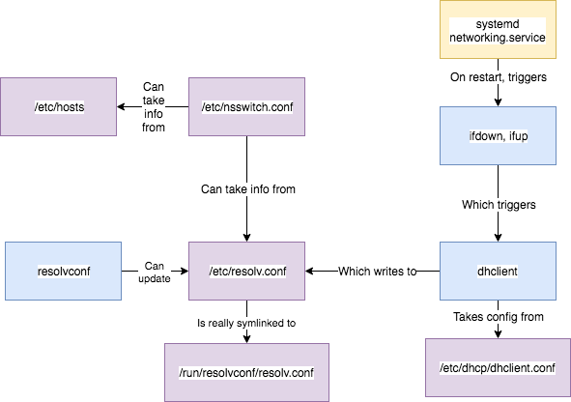
A (roughly) accurate map of what’s going on

End of Part II
That’s the end of Part II. Believe it or not that was a somewhat simplified version of what goes on, but I tried to keep it to the important and ‘useful to know’ stuff so you wouldn’t fall asleep. Most of that detail is around the twists and turns of the scripts that actually get run.
And we’re still not done yet. Part III will look at even more layers on top of these.
Let’s briefly list some of the things we’ve come across so far:
- nsswitch
- /etc/hosts
- /etc/resolv.conf
- /run/resolvconf/resolv.conf
- systemd and its networking service
- ifup and ifdown
- dhclient
- resolvconf
Anatomy of a Linux DNS Lookup – Part III
zwischenzugs Uncategorized 5 Minutes
In Anatomy of a Linux DNS Lookup – Part I I covered:
- nsswitch
- /etc/hosts
- /etc/resolv.conf
- ping vs host style lookups
and in Anatomy of a Linux DNS Lookup – Part II I covered:
- systemd and its networking service
- ifup and ifdown
- dhclient
- resolvconf
and ended up here:

A (roughly) accurate map of what’s going on
Unfortunately, that’s not the end of the story. There’s still more things that can get involved. In Part III, I’m going to cover NetworkManager and dnsmasq and briefly show how they play a part.

Other posts in the series:
Anatomy of a Linux DNS Lookup – Part I
Anatomy of a Linux DNS Lookup – Part II
Anatomy of a Linux DNS Lookup – Part IV
Anatomy of a Linux DNS Lookup – Part V – Two Debug Nightmares

1) NetworkManager
As mentioned in Part II, we are now well away from POSIX standards and into Linux distribution-specific areas of DNS resolution management.
In my preferred distribution (Ubuntu), there is a service that’s available and often installed for me as a dependency of some other package I install called NetworkManager. It’s actually a service developed by RedHat in 2004 to help manage network interfaces for you.
What does this have to do with DNS? Install it to find out:
$ apt-get install -y network-manager
In my distribution, I get a config file.
$ cat /etc/NetworkManager/NetworkManager.conf
[main]
plugins=ifupdown,keyfile,ofono
dns=dnsmasq

[ifupdown]
managed=false
See that dns=dnsmasq there? That means that NetworkManager will use dnsmasq to manage DNS on the host.

2) dnsmasq
The dnsmasq program is that now-familiar thing: yet another level of indirection for /etc/resolv.conf.
Technically, dnsmasq can do a few things, but is primarily it acts as a DNS server that can cache requests to other DNS servers. It runs on port 53 (the standard DNS port), on all local network interfaces.
So where is dnsmasq running? NetworkManager is running:
$ ps -ef | grep NetworkManager
root 15048 1 0 16:39 ? 00:00:00 /usr/sbin/NetworkManager --no-daemon
But no dnsmasq process exists:
$ ps -ef | grep dnsmasq
$
Although it’s configured to be used, confusingly it’s not actually installed! So you’re going to install it.
Before you install it though, let’s check the state of /etc/resolv.conf.
$ cat /etc/resolv.conf
# Dynamic resolv.conf(5) file for glibc resolver(3) generated by resolvconf(8)
# DO NOT EDIT THIS FILE BY HAND -- YOUR CHANGES WILL BE OVERWRITTEN
nameserver 10.0.2.2
search home
It’s not been changed by NetworkManager.
If dnsmasq is installed:
$ apt-get install -y dnsmasq
Then dnsmasq is up and running:
$ ps -ef | grep dnsmasq
dnsmasq 15286 1 0 16:54 ? 00:00:00 /usr/sbin/dnsmasq -x /var/run/dnsmasq/dnsmasq.pid -u dnsmasq -r /var/run/dnsmasq/resolv.conf -7 /etc/dnsmasq.d,.dpkg-dist,.dpkg-old,.dpkg-new --local-service --trust-anchor=.,19036,8,2,49AAC11D7B6F6446702E54A1607371607A1A41855200FD2CE1CDDE32F24E8FB5
And /etc/resolv.conf has changed again!
root@linuxdns1:~# cat /etc/resolv.conf
# Dynamic resolv.conf(5) file for glibc resolver(3) generated by resolvconf(8)
# DO NOT EDIT THIS FILE BY HAND -- YOUR CHANGES WILL BE OVERWRITTEN
nameserver 127.0.0.1
search home
And netstat shows dnsmasq is serving on all interfaces at port 53:
$ netstat -nlp4
Active Internet connections (only servers)
Proto Recv-Q Send-Q Local Address Foreign Address State PID/Program name
tcp 0 0 127.0.0.1:53 0.0.0.0:* LISTEN 15286/dnsmasq
tcp 0 0 10.0.2.15:53 0.0.0.0:* LISTEN 15286/dnsmasq
tcp 0 0 172.28.128.11:53 0.0.0.0:* LISTEN 15286/dnsmasq
tcp 0 0 0.0.0.0:22 0.0.0.0:* LISTEN 1237/sshd
udp 0 0 127.0.0.1:53 0.0.0.0:* 15286/dnsmasq
udp 0 0 10.0.2.15:53 0.0.0.0:* 15286/dnsmasq
udp 0 0 172.28.128.11:53 0.0.0.0:* 15286/dnsmasq
udp 0 0 0.0.0.0:68 0.0.0.0:* 10758/dhclient
udp 0 0 0.0.0.0:68 0.0.0.0:* 10530/dhclient
udp 0 0 0.0.0.0:68 0.0.0.0:* 10185/dhclient

3) Unpicking dnsmasq
Now we are in a situation where all DNS queries are going to 127.0.0.1:53 and from there what happens?
We can get a clue from looking again at the /var/run folder. The resolv.conf in resolvconf has been changed to point to where dnsmasq is being served:
$ cat /var/run/resolvconf/resolv.conf
# Dynamic resolv.conf(5) file for glibc resolver(3) generated by resolvconf(8)
# DO NOT EDIT THIS FILE BY HAND -- YOUR CHANGES WILL BE OVERWRITTEN
nameserver 127.0.0.1
search home
while there’s a new dnsmasq folder with its own resolv.conf.
$ cat /run/dnsmasq/resolv.conf
nameserver 10.0.2.2
which has the nameserver given to us by DHCP.
We can reason about this without looking too deeply, but what if we really want to know what’s going on?

4) Debugging Dnsmasq
Frequently I’ve found myself wondering what dnsmasq’s state is. Fortunately, you can get a good amount of information out of it if you set change this line in /etc/dnsmasq.conf:
#log-queries
to:
log-queries
and restart ​dnsmasq
Now, if you do a simple:
$ ping -c1 bbc.co.uk
you will see something like this in /var/log/syslog (the [...] indicates that the line’s start is the same as the previous one):
Jul 3 19:56:07 ubuntu-xenial dnsmasq[15372]: query[A] bbc.co.uk from 127.0.0.1
[...] forwarded bbc.co.uk to 10.0.2.2
[...] reply bbc.co.uk is 151.101.192.81
[...] reply bbc.co.uk is 151.101.0.81
[...] reply bbc.co.uk is 151.101.64.81
[...] reply bbc.co.uk is 151.101.128.81
[...] query[PTR] 81.192.101.151.in-addr.arpa from 127.0.0.1
[...] forwarded 81.192.101.151.in-addr.arpa to 10.0.2.2
[...] reply 151.101.192.81 is NXDOMAIN
which shows what dnsmasq received, where the query was forwarded to, and what reply was received.
If the query is returned from the cache (or, more exactly, the local ‘time-to-live’ for the query has not expired), then it looks like this in the logs:
[...] query[A] bbc.co.uk from 127.0.0.1
[...] cached bbc.co.uk is 151.101.64.81
[...] cached bbc.co.uk is 151.101.128.81
[...] cached bbc.co.uk is 151.101.192.81
[...] cached bbc.co.uk is 151.101.0.81
[...] query[PTR] 81.64.101.151.in-addr.arpa from 127.0.0.1
and if you ever want to know what’s in your cache, you can provoke dnsmasq into sending it to the same log file by sending the USR1 signal to the dnsmasq process id:
$ kill -SIGUSR1 <(cat /run/dnsmasq/dnsmasq.pid)
and the output of the dump looks like this:
Jul 3 15:08:08 ubuntu-xenial dnsmasq[15697]: time 1530630488
[...] cache size 150, 0/5 cache insertions re-used unexpired cache entries.
[...] queries forwarded 2, queries answered locally 0
[...] queries for authoritative zones 0
[...] server 10.0.2.2#53: queries sent 2, retried or failed 0
[...] Host Address Flags Expires
[...] linuxdns1 172.28.128.8 4FRI H
[...] ip6-localhost ::1 6FRI H
[...] ip6-allhosts ff02::3 6FRI H
[...] ip6-localnet fe00:: 6FRI H
[...] ip6-mcastprefix ff00:: 6FRI H
[...] ip6-loopback : 6F I H
[...] ip6-allnodes ff02: 6FRI H
[...] bbc.co.uk 151.101.64.81 4F Tue Jul 3 15:11:41 2018
[...] bbc.co.uk 151.101.192.81 4F Tue Jul 3 15:11:41 2018
[...] bbc.co.uk 151.101.0.81 4F Tue Jul 3 15:11:41 2018
[...] bbc.co.uk 151.101.128.81 4F Tue Jul 3 15:11:41 2018
[...] 151.101.64.81 4 R NX Tue Jul 3 15:34:17 2018
[...] localhost 127.0.0.1 4FRI H
[...] <Root> 19036 8 2 SF I
[...] ip6-allrouters ff02::2 6FRI H
In the above output, I believe (but don’t know, and ‘?’ indicates a relatively wild guess on my part) that:
- ‘4’ means IPv4
- ‘6’ means IPv6
- ‘H’ means address was read from an /etc/hosts file
- ‘I’ ? ‘Immortal’ DNS value? (ie no time-to-live value?)
- ‘F’ ?
- ‘R’ ?
- ‘S’?
- ‘N’?
- ‘X’

Alternatives to dnsmasq
dnsmasq is not the only option that can be passed to dns in NetworkManager. There’s none which does nothing to /etc/resolv,conf, default, which claims to ‘update resolv.conf to reflect currently active connections’, and unbound, which communicates with the unbound service and dnssec-triggerd, which is concerned with DNS security and is not covered here.

End of Part III
That’s the end of Part III, where we covered the NetworkManager service, and its dns=dnsmasq setting.
Let’s briefly list some of the things we’ve come across so far:
- nsswitch
- /etc/hosts
- /etc/resolv.conf
- /run/resolvconf/resolv.conf
- systemd and its networking service
- ifup and ifdown
- dhclient
- resolvconf
- NetworkManager
- dnsmasq

NetworkManager
출처 : https://wiki.archlinux.org/title/NetworkManager#DHCP_client
5 languages

- Page
- Discussion

- Read
- View source
- View history
Tools

NetworkManager is a program for providing detection and configuration for systems to automatically connect to networks. NetworkManager's functionality can be useful for both wireless and wired networks. For wireless networks, NetworkManager prefers known wireless networks and has the ability to switch to the most reliable network. NetworkManager-aware applications can switch from online and offline mode. NetworkManager also prefers wired connections over wireless ones, has support for modem connections and certain types of VPN. NetworkManager was originally developed by Red Hat and now is hosted by the GNOME project.
Related articles
- Network configuration
- Wireless network configuration
Warning: By default, secrets (e.g. WiFi passwords) are accessible to the root user in the filesystem and to users with access to settings via the GUI (e.g. nm-applet). see #Encrypted Wi-Fi passwords.

Installation
NetworkManager can be installed with the package networkmanager, which contains a daemon, a command line interface (nmcli) and a curses‐based interface (nmtui).

Enable NetworkManager
After installation, you should start/enable NetworkManager.service. Once the NetworkManager daemon is started, it will automatically connect to any available "system connections" that have already been configured. Any "user connections" or unconfigured connections will need nmcli or an applet to configure and connect.
Note:
This article or section is a candidate for merging with Network configuration.
Notes: Conflicting networking services is a generic issue not specific to NetworkManager. (Discuss in Talk:NetworkManager)
- You must ensure that no other service that wants to configure the network is running; in fact, multiple networking services will conflict. You can find a list of the currently running services with systemctl --type=service and then stop them. See #Configuration to enable the NetworkManager service.
- If systemd-resolved is not started, an error message will start flooding your logs. See #Unit dbus-org.freedesktop.resolve1.service not found for more info.

DHCP client
By default NetworkManager uses its internal DHCP client. The internal DHCPv4 plugin is based on the nettools' n-dhcp4 library, while the internal DHCPv6 plugin is made from code based on systemd-networkd.
To use a different DHCP client install one of the alternatives:
- dhclient - dhclient.
- dhcpcd - dhcpcd.
To change the DHCP client backend, set the option main.dhcp=dhcp_client_name with a configuration file in /etc/NetworkManager/conf.d/. E.g.:
/etc/NetworkManager/conf.d/dhcp-client.conf
[main]
dhcp=dhclient
Note:
- NetworkManger does not support using dhcpcd for IPv6. See NetworkManager issue #5. If dhcpcd is set as the DHCP client, NetworkManager will use the internal DHCP client for DHCPv6.
- Do not enable the systemd units shipped with the dhclient and dhcpcd packages. They will conflict with NetworkManager, see the note in #Installation for details.

DNS management
NetworkManager's DNS management is described in the GNOME project's wiki page—Projects/NetworkManager/DNS.

DNS caching and conditional forwarding
NetworkManager has a plugin to enable DNS caching and conditional forwarding (previously called "split DNS" in NetworkManager's documentation) using dnsmasq or systemd-resolved. The advantages of this setup is that DNS lookups will be cached, shortening resolve times, and DNS lookups of VPN hosts will be routed to the relevant VPN's DNS servers. This is especially useful if you are connected to more than one VPN.
Note: If /etc/resolv.conf is a symlink to /run/systemd/resolve/stub-resolv.conf, /run/systemd/resolve/resolv.conf,/lib/systemd/resolv.conf or /usr/lib/systemd/resolv.conf, NetworkManager will choose systemd-resolved automatically. To use dnsmasq, you must first remove that symlink, then restart NetworkManager.

dnsmasq
Make sure dnsmasq has been installed. Then set main.dns=dnsmasq with a configuration file in /etc/NetworkManager/conf.d/:
/etc/NetworkManager/conf.d/dns.conf
[main]
dns=dnsmasq
Now run nmcli general reload as root. NetworkManager will automatically start dnsmasq and add 127.0.0.1 to /etc/resolv.conf. The original DNS servers can be found in /run/NetworkManager/no-stub-resolv.conf. You can verify dnsmasq is being used by doing the same DNS lookup twice with drill example.com and verifying the server and query times.
Note:
- You do not need to start dnsmasq.service or edit /etc/dnsmasq.conf. NetworkManager will start dnsmasq without using the systemd service and without reading the dnsmasq's default configuration file(s).
- The dnsmasq instance started by NetworkManager will bind to 127.0.0.1:53, you cannot run any other software (including dnsmasq.service) on the same address and port.

Custom dnsmasq configuration
Custom configurations can be created for dnsmasq by creating configuration files in /etc/NetworkManager/dnsmasq.d/. For example, to change the size of the DNS cache (which is stored in RAM):
/etc/NetworkManager/dnsmasq.d/cache.conf
cache-size=1000
You can check the configuration file syntax with:
$ dnsmasq --test --conf-file=/dev/null --conf-dir=/etc/NetworkManager/dnsmasq.d
See dnsmasq(8) for all available options.

IPv6
The factual accuracy of this article or section is disputed.
Reason: This does not solve the issue because NetworkManager does not add ::1 to /etc/resolv.conf. Unless @::1 is manually passed to drill, it will still fail with Error: error sending query: No (valid) nameservers defined in the resolver. (Discuss in Talk:NetworkManager)
Enabling dnsmasq in NetworkManager may break IPv6-only DNS lookups (i.e. drill -6 [hostname]) which would otherwise work. In order to resolve this, creating the following file will configure dnsmasq to also listen to the IPv6 loopback:
/etc/NetworkManager/dnsmasq.d/ipv6-listen.conf
listen-address=::1
In addition, dnsmasq also does not prioritize upstream IPv6 DNS. Unfortunately NetworkManager does not do this (Ubuntu Bug). A workaround would be to disable IPv4 DNS in the NetworkManager config, assuming one exists.

DNSSEC
The dnsmasq instance started by NetworkManager by default will not validate DNSSEC since it is started with the --proxy-dnssec option. It will trust whatever DNSSEC information it gets from the upstream DNS server.
For dnsmasq to properly validate DNSSEC, thus breaking DNS resolution with name servers that do not support it, create the following configuration file:
/etc/NetworkManager/dnsmasq.d/dnssec.conf
conf-file=/usr/share/dnsmasq/trust-anchors.conf
dnssec

systemd-resolved
This article or section needs expansion.
Reason: NetworkManager 1.16 adds a new setting main.systemd-resolved[5] (enabled by default). It unconditionally sends DNS configuration to systemd-resolved. Related to "Preserving resolv.conf" from systemd-resolved#DNS? (Discuss in Talk:NetworkManager)
NetworkManager can use systemd-resolved as a DNS resolver and cache. Make sure that systemd-resolved is properly configured and that systemd-resolved.service is started before using it.
systemd-resolved will be used automatically if /etc/resolv.conf is a symlink to /run/systemd/resolve/stub-resolv.conf, /run/systemd/resolve/resolv.conf or /usr/lib/systemd/resolv.conf.
You can enable it explicitly by setting main.dns=systemd-resolved with a configuration file in /etc/NetworkManager/conf.d/:
/etc/NetworkManager/conf.d/dns.conf
[main]
dns=systemd-resolved

DNS resolver with an openresolv subscriber
If openresolv has a subscriber for your local DNS resolver, set up the subscriber and configure NetworkManager to use openresolv.
Because NetworkManager advertises a single "interface" to resolvconf, it is not possible to implement conditional forwarding between two NetworkManager connections. See NetworkManager issue 153.
This can be partially mitigated if you set private_interfaces="*" in /etc/resolvconf.conf[6]. Any queries for domains that are not in search domain list will not get forwarded. They will be handled according to the local resolver's configuration, for example, forwarded to another DNS server or resolved recursively from the DNS root.

Custom DNS servers

Setting custom global DNS servers
To set DNS servers for all connections, specify them in NetworkManager.conf(5) using the syntax servers=serveripaddress1,serveripaddress2,serveripaddress3 in a section named [global-dns-domain-*]. For example:
/etc/NetworkManager/conf.d/dns-servers.conf
[global-dns-domain-*]
servers=::1,127.0.0.1
Note:
- If you use NetworkManager's dnsmasq or systemd-resolved plugin or openresolv subscribers, then do not specify loopback addresses with the servers= option, it can break DNS resolution.
- The specified servers do not get sent to systemd-resolved, the connection's DNS servers are used instead.

Setting custom DNS servers in a connection

Setting custom DNS servers in a connection (GUI)
Setup will depend on the type of front-end used; the process usually involves right-clicking on the applet, editing (or creating) a profile, and then choosing DHCP type as Automatic (specify addresses). The DNS addresses will need to be entered and are usually in this form: 127.0.0.1, DNS-server-one, ....

Setting custom DNS servers in a connection (nmcli / connection file)
To setup DNS Servers per connection, you can use the dns field (and the associated dns-search and dns-options) in the connection settings.
If method is set to auto (when you use DHCP), you need to set ignore-auto-dns to yes.

/etc/resolv.conf
NetworkManager's /etc/resolv.conf management mode is configured with the main.rc-manager setting. networkmanager sets it to symlink as opposed to the upstream default auto. The setting and its values are documented in the NetworkManager.conf(5) man page.
Tip: Using openresolv allows NetworkManager to coexist with other resolvconf supporting software or, for example, to run a local DNS caching and split-DNS resolver for which openresolv has a subscriber. Note that conditional forwarding is not yet fully supported when using NetworkManager with openresolv.
NetworkManager also offers hooks via so called dispatcher scripts that can be used to alter the /etc/resolv.conf after network changes. See #Network services with NetworkManager dispatcher and NetworkManager(8) for more information.
Note:
- If NetworkManager is configured to use either dnsmasq or systemd-resolved, then the appropriate loopback addresses will be written to /etc/resolv.conf.
- The resolv.conf file NetworkManager writes or would write to /etc/resolv.conf can be found at /run/NetworkManager/resolv.conf.
- A resolv.conf file with the acquired name servers and search domains can be found at /run/NetworkManager/no-stub-resolv.conf.

Unmanaged /etc/resolv.conf
To stop NetworkManager from touching /etc/resolv.conf, set main.dns=none with a configuration file in /etc/NetworkManager/conf.d/:
/etc/NetworkManager/conf.d/dns.conf
[main]
dns=none
Tip: You might also want to set main.systemd-resolved=false, so that NetworkManager does not send the DNS configuration to systemd-resolved.
Note: See #DNS caching and conditional forwarding, to configure NetworkManager using other DNS backends like dnsmasq and systemd-resolved, instead of using main.dns=none.
After that /etc/resolv.conf might be a broken symlink that you will need to remove. Then, just create a new /etc/resolv.conf file.

Use openresolv
Note: NetworkManager does not support using systemd-resolved's resolvconf interface (resolvectl(1) § COMPATIBILITY WITH RESOLVCONF(8)) which is provided by systemd-resolvconf.
- Do not set main.rc-manager=resolvconf when using systemd-resolved, instead make sure to correctly create the /etc/resolv.conf symlink or configure NetworkManager to use systemd-resolved explicitly.
- Make sure the systemd-resolvconf package is not installed when systemd-resolved is not used. Unless systemd-resolved.service started, it will break all networking software (not just NetworkManager) that use resolvconf.
To configure NetworkManager to use openresolv, set main.rc-manager=resolvconf with a configuration file in /etc/NetworkManager/conf.d/:
/etc/NetworkManager/conf.d/rc-manager.conf
[main]
rc-manager=resolvconf

